UNITED STATES
SECURITIES AND EXCHANGE COMMISSION
Washington, D.C. 20549
SCHEDULE 14A
Proxy Statement Pursuant to Section 14(a) of the
Securities Exchange Act of 1934 (Amendment No. )
☑ |  |  | Filed by the Registrant |  |  | o |  |  | Filed by a party other than the Registrant
CHECK THE APPROPRIATE BOX:
o |  |  | Preliminary Proxy Statement
o |  |  | Confidential, for Use of the Commission Only (as permitted by Rule 14a-6(e)(2))
☑ |  |  | Definitive Proxy Statement
o |  |  | Definitive Additional Materials
o |  |  | Soliciting Material under §240.14a-12
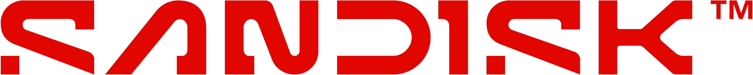
Sandisk Corp.
(Name of Registrant as Specified In Its Charter)
(Name of Person(s) Filing Proxy Statement, if other than the Registrant)

PAYMENT OF FILING FEE (CHECK ALL BOXES THAT APPLY):
o |  |  | No fee required
o |  |  | Fee paid previously with preliminary materials
o |  |  | Fee computed on table in exhibit required by Item 25(b) per Exchange Act Rules 14a-6(i)(1) and 0-11



