UNITED STATES
SECURITIES AND EXCHANGE COMMISSION
Washington, D.C. 20549
SCHEDULE 14A
Proxy Statement Pursuant to Section 14(a) of the
Securities Exchange Act of 1934 (Amendment No. )
☑ |  |  | Filed by the Registrant |  |  | o |  |  | Filed by a party other than the Registrant
CHECK THE APPROPRIATE BOX:
o |  |  | Preliminary Proxy Statement
o |  |  | Confidential, for Use of the Commission Only (as permitted by Rule 14a-6(e)(2))
☑ |  |  | Definitive Proxy Statement
o |  |  | Definitive Additional Materials
o |  |  | Soliciting Material under §240.14a-12

Sandisk Corp.
(Name of Registrant as Specified In Its Charter)
(Name of Person(s) Filing Proxy Statement, if other than the Registrant)

PAYMENT OF FILING FEE (CHECK ALL BOXES THAT APPLY):
o |  |  | No fee required
o |  |  | Fee paid previously with preliminary materials
o |  |  | Fee computed on table in exhibit required by Item 25(b) per Exchange Act Rules 14a-6(i)(1) and 0-11

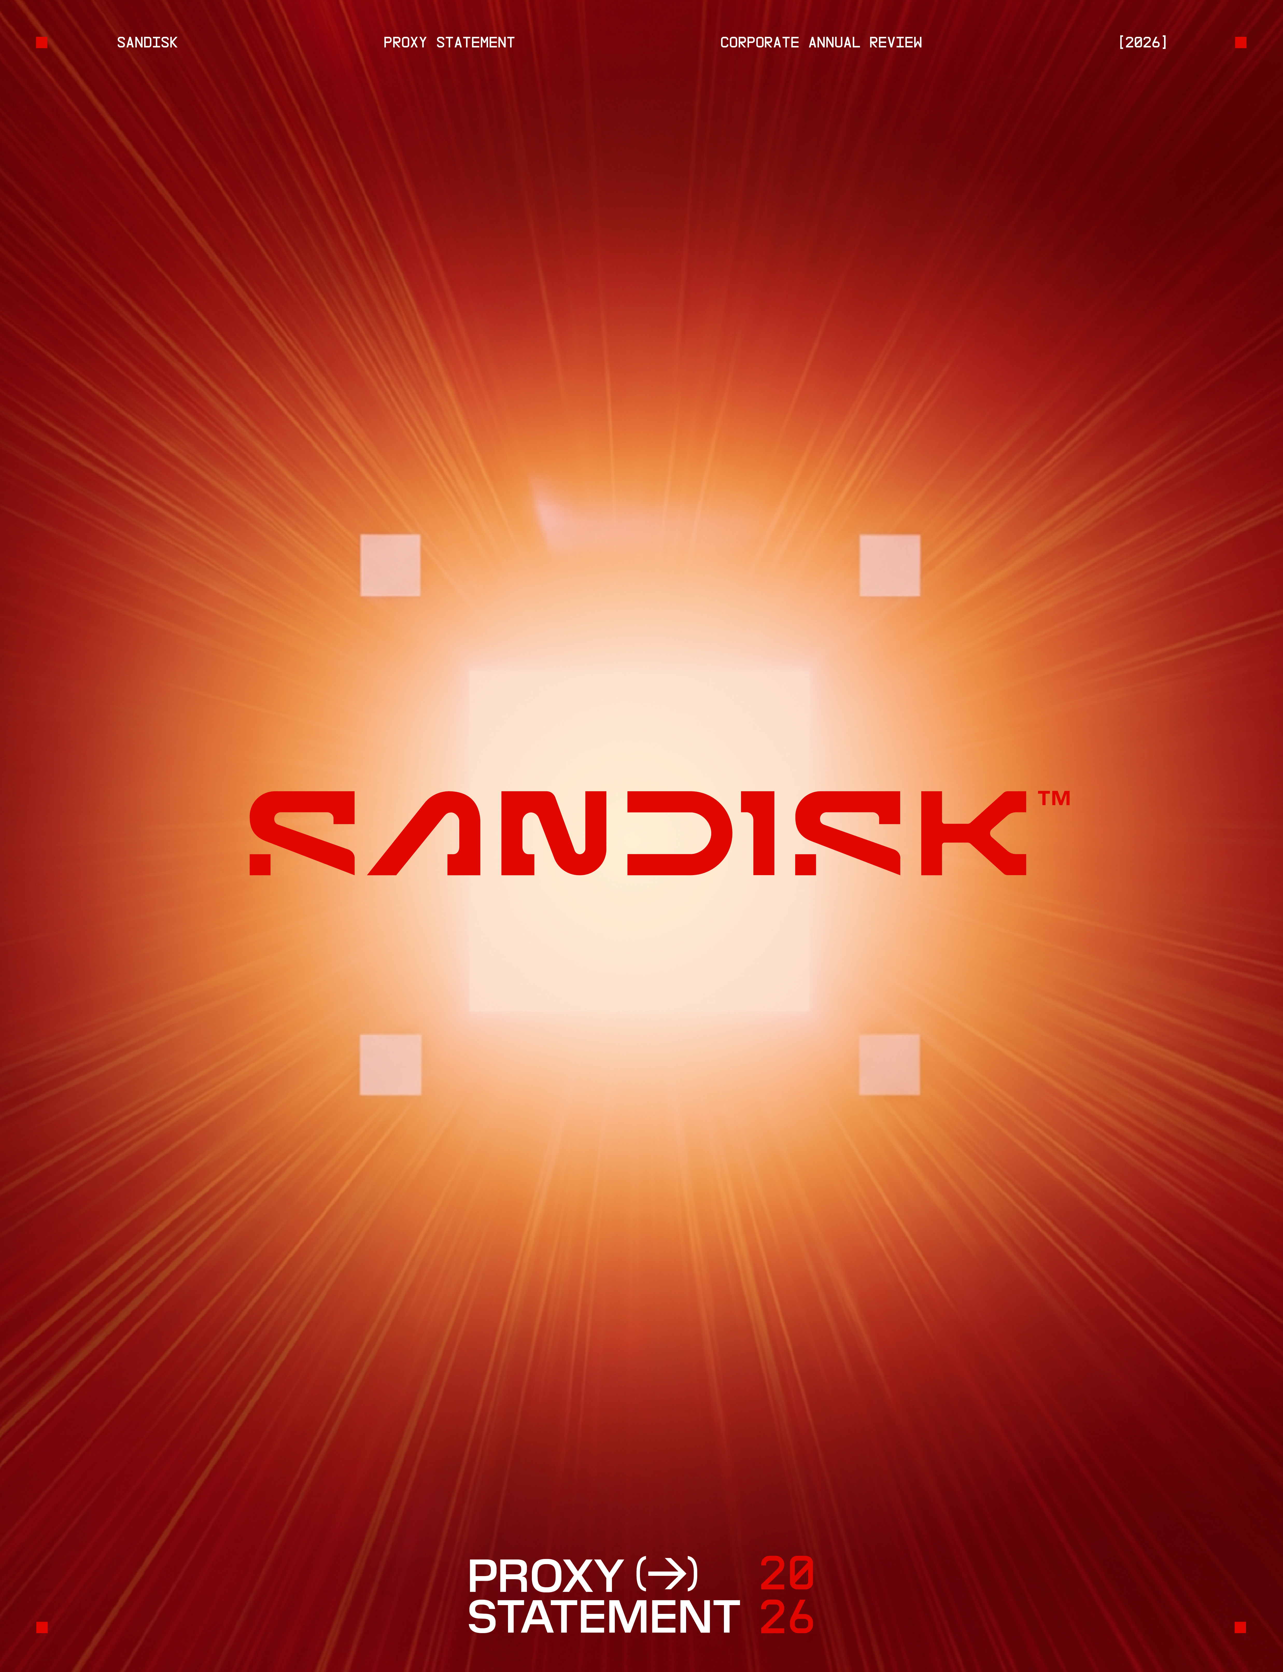


INSPIRATION AND
INNOVATION IN MOTION (→)
Sandisk delivers innovative Flash solutions and advanced memory technologies that meet people and businesses at the intersection of their aspirations and the moment, enabling them to keep moving and pushing possibility forward.
 |  |  | WHO WE ARE |  |  | Our vast portfolio of Flash products enables a seamless and simplified world of resilient data expression and storage. We believe that everyone should be inspired by their data – to move, create, discover, share, and unlock their potential.
 |  |  | OUR VALUES |  |  | Our values of innovation, collaboration, winning, agility, and openness focus our vision, inspire what we build, and drive our ambitions, shaping our path, and defining what success looks like across everything we do.

PG. 001
LETTER FROM OUR CHAIR AND LEAD INDEPENDENT DIRECTOR
Dear Fellow Stockholders:
We are pleased to invite you to the 2026 Annual Meeting of Stockholders.
This past year marked an inflection point for Sandisk. We are leveraging decades of technology leadership to advance innovation, deepen customer relationships, and capture the significant opportunities created by artificial intelligence ("AI") and the rapidly growing demand for high-performance flash storage. With our sharpened focus on high-performance flash storage, we took decisive steps to strengthen our margins and our technology roadmap, and to enhance the long-term value we deliver to you, our stockholders.
Our strong performance across key financial and operational metrics reflects the successful execution of our strategy, the strength of our technology leadership, and our trusted position as a leading provider of innovative flash storage solutions for the AI era.
Executing on Our Strategy for Long-Term Value Creation
Fiscal 2026 has been a year of remarkable momentum and exceptional execution. We generated record revenue of $20.25 billion, up 175% year-over-year, driven in part by our shift toward higher-value customers and the expanding role of flash storage in AI-enabled data infrastructure. The rapid growth of AI is driving an unprecedented increase in data creation and storage requirements. As a result, high-performance NAND flash is becoming an increasingly critical and cost-effective solution, expanding the long-term market opportunity for advanced flash storage. We are confident that our world-class product portfolio and technology leadership will continue to drive datacenter customers to see Sandisk as a partner of choice over the long term.
This year, we advanced to a new business model built on multi-year customer engagements backed by firm financial commitments, and this transformation is driving structurally higher and more durable earnings power. Additionally, we achieved our net cash milestone ahead of plan, reached a zero-debt balance sheet by year-end, and authorized a share repurchase program. These actions reflect the strength of our financial position and the disciplined execution of the strategy established by our Board and management team. Building on this foundation, we believe we are positioned to continue delivering substantial long-term value creation for our stockholders.
Our Board Is Purpose Built for Our Strategic Needs
Our Board has been thoughtfully and intentionally constructed to reflect the strategic priorities of Sandisk as a leading independent flash memory company. We believe our directors bring a valuable mix of experiences and qualifications, pairing extensive institutional understanding of Sandisk's business, technology, and people with new viewpoints that strengthen our oversight in an evolving industry. Our Board members’ deep expertise across essential areas maps directly to our business priorities and the opportunities on the horizon for Sandisk. We believe this breadth of experience enables the Board to provide informed oversight of our strategy, opportunities, and risks while supporting the Company's continued growth and innovation.
Our recurring board evaluation and refreshment process resulted in the appointment of Alexander Bradley to our Board in December 2025. Mr. Bradley brings exceptional operational finance expertise and strategic insights to our Board, with a unique understanding of how to successfully navigate the demands of a capital-intensive industry.
Our Ongoing Commitment to Good Governance and Our Stockholders
We view governance as a top priority, anchored in integrity, accountability, and transparency. Our Board places a premium on strong, independent oversight, and we remain committed to regularly evaluating and refining our governance structures to align with stockholder expectations and long-term value creation. As part of this, we have an ongoing, dedicated stockholder engagement program to solicit feedback, which serves as a key input in Board deliberations on governance, strategy, and compensation.
On behalf of the entire Board and executive team, we thank you for the confidence you have placed in Sandisk. It has been a remarkable year, and the backing and input of our investors have been vital throughout. We look forward to continuing this journey together.
Sincerely,
 |  |  |   David V. Goeckeler  Chair of the Board
 |  |  | 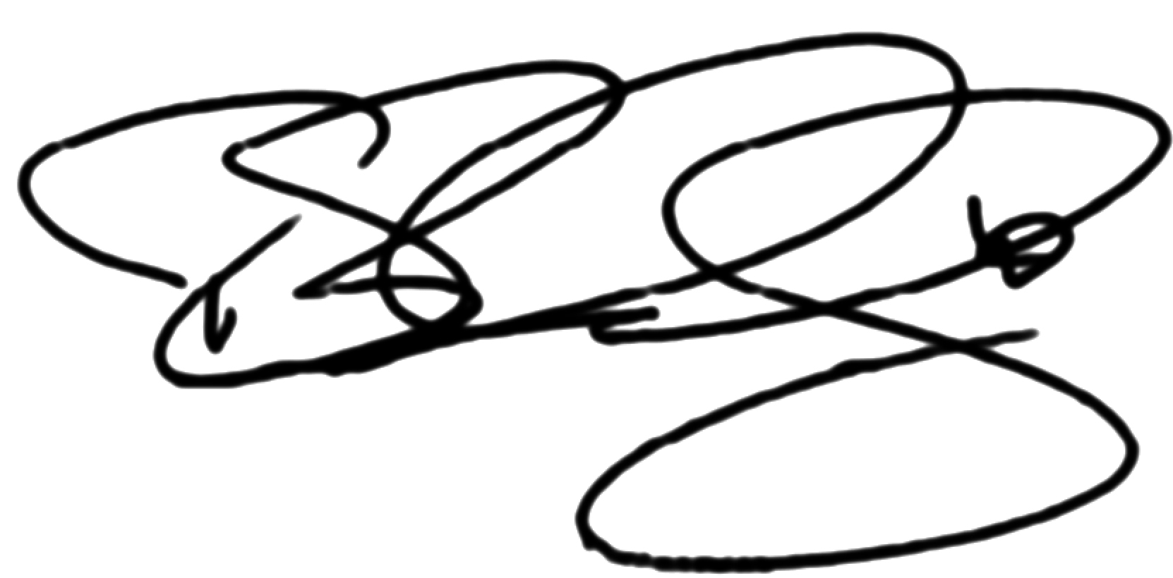  Richard B. Cassidy II  Lead Independent Director

PG. 002
NOTICE OF ANNUAL MEETING OF STOCKHOLDERS
 |  |  |  |  |  | Date  November 17, 2026
 |  |  |  |  |  | Time  Online check-in begins:  7:45 a.m. Pacific Time  Meeting begins:  8:00 a.m. Pacific Time
 |  |  |  |  |  | Location  Our annual meeting will be a completely virtual meeting of stockholders that will provide stockholders with comparable rights and opportunities to participate as they would have at an in-person meeting. To participate, vote or submit questions during the annual meeting via webcast, please visit: www.virtualshareholdermeeting.com/SNDK2026. Please see the section entitled “Additional Information— General Information About the Annual Meeting—Virtual Annual Meeting” for additional information.
 |  |  |  |  |  | Who Can Vote  Holders of record of shares of our common stock at the close of business on September 21, 2026 will be entitled to notice of and to vote, together as a single class, at our annual meeting and any postponements or adjournments of the meeting.
Voting Shares in Advance of The Meeting
Your vote is very important. Please submit your proxy as soon as possible via the Internet, telephone, or mail. Submitting your proxy by one of these methods will ensure your vote will be counted regardless of whether you attend the annual meeting.
 |  |  |  |  |  |  |  |  |  |  |  | 
Via the Internet  Visit the website listed on your notice, proxy card or voting instruction form |  |  |  |  |  | By Phone  Call the phone number listed on your proxy card or voting instruction form |  |  |  |  |  | By Mail  Complete, sign, date, and return your proxy card or voting instruction form in the envelope provided
Matters to Be Voted On and Board Recommendations
Proposal 1 |  |  | 
Election of the eight director nominees named in the attached Proxy Statement to serve until our next annual meeting of stockholders and until their respective successors are duly elected and qualified
Proposal 2
Approval on an advisory basis of the named executive officer compensation disclosed in the attached Proxy Statement
Proposal 3
Ratification of the appointment of KPMG LLP as our independent registered public accounting firm for fiscal 2027
At the meeting, we will also consider any other business that may properly come before our annual meeting and any postponements or adjournments of the meeting.
By Order of our Board of Directors,

Bernard Shek
Chief Legal Officer and Secretary
October 6, 2026
Important notice regarding the availability of proxy materials for our annual meeting of stockholders to be held on November 17, 2026:
On or about October 6, 2026, proxy materials for the annual meeting, including the attached Proxy Statement and our Annual Report for the fiscal year ended July 3, 2026, are being furnished to stockholders entitled to vote at the annual meeting. The Proxy Statement and 2026 Annual Report are available on our Investor Relations website at investor.sandisk.com. You can also view these materials at www.proxyvote.com by using the control number provided on your proxy card or Notice of Internet Availability of Proxy Materials.

PG. 003
DISCLAIMERS
Cautionary Note Regarding Forward-Looking Statements
This Proxy Statement contains forward-looking statements within the meaning of the federal securities laws. These forward-looking statements include, but are not limited to, statements regarding Sandisk Corporation’s (the “Company’s”) business strategy and strategic priorities, including expectations regarding opportunities, demand, the new business model and long-term agreements, product and technology developments, and all statements regarding the Company’s expected future position, results of operations, cash flows, dividends, financing plans, business strategy, budgets, capital expenditures, competitive positions, growth opportunities, plans and objectives of management, our efforts to deliver sustainable growth and long-term stockholder value, the Company’s executive compensation philosophy, program design and anticipated outcomes, corporate governance practices, board composition and refreshment, sustainability and corporate responsibility initiatives, future financial and operational performance as described herein, and long-term stockholder value and statements containing the use of forward-looking words, such as “may,” “will,” “could,” “would,” “should,” “project,” “believe,” “anticipate,” “expect,” “estimate,” “continue,” “potential,” “plan,” “forecast,” “approximate,” “intend,” “target”, and the like, or the use of the future tense of these or similar words. These forward-looking statements are based on management’s current expectations, represent the most current information available to the Company as of the date of this Proxy Statement and are subject to a number of risks, uncertainties and other factors that could cause actual results or performance to differ materially from those expressed or implied in the forward-looking statements. These risks and uncertainties include, but are not limited to: adverse changes in global or regional economic conditions, including the impact of evolving trade policies, tariff regimes and trade wars; volatility in demand for the Company’s products; pricing trends and fluctuations in average selling prices; inflation; changes in interest rates and a potential economic recession; future responses to and effects of global health crises; the impact of business and market conditions; the impact of competitive products and pricing; the Company’s development and introduction of products based on new technologies and management of technology transitions; risks associated with strategic initiatives, including restructurings, acquisitions, divestitures,
cost saving measures, and joint ventures; risks related to product defects; difficulties or delays in product ramps, manufacturing, or other supply chain disruptions; the Company’s reliance on strategic relationships with key partners, including Kioxia Corporation; risks related to the Company’s long-term agreements; fluctuation of the Company’s operating results, including due to changes in demand, industry cycle and timing of customer deployments, and the Company’s ability to accurately forecast demand; the attraction, retention, and development of skilled management and technical talent; risks associated with the use of artificial intelligence in the Company’s business operations; changes to the Company’s relationships with key customers or consolidation among the Company’s customer base; compromise, damage, or interruption from cybersecurity incidents or other data system security risks; the Company’s reliance on intellectual property; fluctuations in currency exchange rates; actions by competitors; risks related to the Company’s share repurchase program; risks associated with compliance with changing legal and regulatory requirements; and other risks and uncertainties listed in the Company’s filings with the Securities and Exchange Commission (the “SEC”), including the Company’s Annual Report on Form 10-K filed with the SEC on August 27, 2026 (the “2026 Annual Report on Form 10-K”), to which your attention is directed. You are cautioned not to place undue reliance on these forward-looking statements, which speak only as of the date hereof. We do not intend and undertake no obligation to update or revise these forward-looking statements to reflect new information or events after the date of this document or to reflect the occurrence of unanticipated events, except as required by law.
Website References
You may also access additional information about Sandisk at investor.sandisk.com. References to our website throughout this Proxy Statement are provided for convenience only, and the content on our website does not constitute a part of, and shall not be deemed incorporated by reference into, this Proxy Statement.

PG. 004
TABLE OF CONTENTS
Letter from Our Chair and Lead Independent Director |  |  | 1
Notice of Annual Meeting of Stockholders |  |  | 2
Disclaimers |  |  | 3
Proxy Summary |  |  | 5
Corporate Governance Matters |  |  | 8
Proposal 1: Election of Directors |  |  | 8
Nominees for Election |  |  | 9
Director Nominee Skills and Experience |  |  | 17
Director Nominations and Board Refreshment |  |  | 20
Board’s Role and Responsibilities |  |  | 22
Risk Oversight and Compensation Risk Assessment |  |  | 22
Sustainability and Corporate Responsibility |  |  | 23
Stockholder Engagement |  |  | 24
Board Structure |  |  | 25
Board Processes and Policies |  |  | 28
Board and Committee Evaluations |  |  | 29
Director Compensation |  |  | 32
Executive Officers |  |  | 35
Executive Compensation |  |  | 36
Proposal 2: Advisory Vote on Named Executive Officer Compensation |  |  | 36
A Message From the Compensation and Talent Committee |  |  | 37
Report of the Compensation and Talent Committee |  |  | 38
Compensation and Talent Committee Interlocks and Insider Participation |  |  | 38
Compensation Discussion and Analysis |  |  | 38
Fiscal 2026 Overview |  |  | 39
Executive Compensation Philosophy; Policies, Practices, and Design |  |  | 40
Fiscal 2026 Executive Compensation Program Decisions and Outcomes |  |  | 46
Fiscal 2027 Compensation Program Design and Decisions |  |  | 52
Other Program Features and Policies |  |  | 54
Executive Compensation Tables and Narratives |  |  | 56
Fiscal 2026 Summary Compensation Table |  |  | 56
Fiscal 2026 Grants of Plan-Based Awards Table |  |  | 57
Description of Compensation Arrangements for Named Executive Officers |  |  | 58
Outstanding Equity Awards at Fiscal 2026 Year-End Table |  |  | 58
Fiscal 2026 Option Exercises and Stock Vested Table |  |  | 59
Potential Payments upon Termination or Change in Control |  |  | 60
Pay Versus Performance |  |  | 62
Equity Compensation Plan Information |  |  | 65
Stock Ownership Information |  |  | 66
Audit Committee Matters |  |  | 68
Proposal 3: Ratification of Appointment of Our Independent Registered Public Accounting Firm |  |  | 68
Report of the Audit Committee |  |  | 69
Additional Information |  |  | 70
General Information About the Annual Meeting |  |  | 70
Virtual Annual Meeting |  |  | 70
Availability of Annual Report |  |  | 73
Communication with our Company |  |  | 73
Appendix A—Non-GAAP Financial Measures |  |  | A-1

PG. 005
PROXY SUMMARY
This summary highlights information contained elsewhere in this Proxy Statement. This summary does not contain all of the information that you should consider. We encourage you to read this entire Proxy Statement for more information about these topics prior to voting.
Sandisk at a Glance
We are a leading developer, manufacturer, and provider of data storage devices and solutions based on NAND flash technology. With a differentiated innovation engine driving advancements in storage and semiconductor technologies, our broad and ever-expanding portfolio delivers powerful flash storage solutions for artificial intelligence workloads in datacenters, edge devices, and consumers. Our technologies enable everyone from students, gamers, and home offices to the largest enterprises and public clouds to produce, analyze, and store data. Our solutions include a broad range of solid-state drives (“SSD”), embedded products, removable cards, universal serial bus drives and wafers, and components. Our broad portfolio of technology and products addresses our multiple end markets of “Datacenter”, “Edge”, and “Consumer”.

PG. 006 |  |  | 2026 PROXY STATEMENT
Our Director Nominees
 |  |  |  |  |  |  |  |  |  |  |  | 
Alexander Bradley, 45  CFO, First Solar, Inc.  Director Since: 2025  Other Current Public  Directorships: None  Committee Membership:   |  |  |  |  |  | Richard B. Cassidy II, 75  Lead Independent Director  Former Chairman and CEO, Taiwan Semiconductor Manufacturing Company (“TSMC”) Arizona Corporation.  Director Since: 2025  Other Current Public  Directorships: Microchip Technology  Committee Membership: |  |  |  |  |  | Thomas Caulfield, 67  Former CEO, GlobalFoundries Inc.  Director Since: 2025  Other Current Public  Directorships: GlobalFoundries Inc.; USA Rare Earth, Inc.  Committee Membership:  
 |  |  |  |  |  |  |  |  |  |  |  | 
David V. Goeckeler, 64  CEO, Sandisk Corporation  Chair of the Board  Director Since: 2025  Other Current Public  Directorships: Automatic Data Processing, Inc.  Committee Membership:   |  |  |  |  |  | Devinder Kumar, 71  Former CFO, Advanced Micro Devices, Inc.  Director Since: 2025  Other Current Public  Directorships: Ciena Corporation  Committee Membership:   |  |  |  |  |  | Necip Sayiner, 61  Former executive vice president and general manager, Renesas Electronics Corporation.  Director Since: 2025  Other Current Public  Directorships: Rambus Inc.; Axcelis Technologies, Inc.; Teradyne, Inc.  Committee Membership:  
 |  |  |  |  |  | 
Ellyn J. Shook, 63  Former chief leadership and human resources officer, Accenture plc  Director Since: 2025  Other Current Public  Directorships: The Baldwin Insurance Group, Inc.; Schneider Electric SE  Committee Membership:   |  |  |  |  |  | Miyuki Suzuki, 66  Former president, Asia Pacific, Japan and China, Cisco Systems, Inc.  Director Since: 2025  Other Current Public  Directorships: Twilio Inc.; Mitsubishi UFJ Financial Group, Inc. (“MUFG”).  Committee Membership:  
 |  |  | Audit |  |  |  |  |  |  |  |  | Compensation  and Talent |  |  |  |  |  |  |  |  | Governance |  |  |  |  |  |  |  |  | Committee Chair |  |  |  |  |  |  |  |  | Chair of the Board |  |  |  |  |  |  |  |  | Independent

 |  |  | PROXY SUMMARY |  |  | PG. 007
A Board Purpose-Built for Sandisk
Our Board has been thoughtfully and intentionally constructed to reflect the strategic priorities of Sandisk as a standalone public company. The collective experience of our directors aligns with the capabilities most critical to our long-term success, including semiconductor technology, manufacturing, data infrastructure, global operations, capital allocation, cybersecurity, human capital, governance, and public company leadership. Together, we believe these complementary perspectives position our Board to provide effective oversight of our strategy, opportunities, and risks while driving sustainable long-term value creation for our stockholders.
Board Nominee Highlights
Independence |  |  |  |  |  |  |  |  | Gender |  |  |  |  |  |  |  |  | Age
88%  Independent |  |  |  |  |  |  |  |  | 25%  Women |  |  |  |  |  |  |  |  | 63 Years  Average
  Independent    Non-Independent |  |  |  |  |  |  |  |  |   Women    Men |  |  |  |  |  |  |  |  |   <60 Years    >65 Years |  |  |   60-65 Years

Corporate Governance Highlights
Our Board of Directors is committed to robust corporate governance practices that reflect integrity, accountability, and transparency. These practices are designed to support effective oversight and advance the long-term interests of our stockholders.
Corporate Governance Best Practices
We commit to regularly evaluate our corporate governance practices based on a consideration of prevailing best practices, our stakeholders’ feedback and interests, and the interests of our long-term strategy and outlook. We have implemented or are in the process of implementing such practices, including those highlighted below, in a manner appropriate for our company.
 Commitment to a robust Board-led stockholder engagement program that informs Board decisions
Independent Board leadership, consisting of a Lead Independent Director with clearly defined roles and responsibilities
All directors are elected annually by a simple majority of votes cast
Seven of eight director nominees are independent
Overboarding policy for additional public company directorships by directors, including a lower threshold for our CEO, and director time commitments annually reviewed
Board oversight of strategic planning and risk management
Succession planning for directors, our CEO and other key officers
Annual Board and committee self-evaluations
Annual individual assessments of directors
Anti-hedging, anti-pledging, and clawback policies
All current non-employee directors were in compliance with our director stock ownership guidelines in fiscal 2026
All executive officers were in compliance with the stock ownership requirements pursuant to our executive stock ownership guidelines in fiscal 2026
Board committee oversight of corporate responsibility, sustainability, cybersecurity, and human capital management
Annual sustainability reporting via standalone Sustainability Report aligned with leading frameworks and standards
Board committee oversight of political and lobbying activities and expenditures

Executive Compensation Highlights
Executive Compensation Objectives and Approach
The Compensation and Talent Committee seeks to closely align pay with performance, rewarding executives for delivering results for Sandisk and its stockholders. Our compensation program is designed to offer market-competitive incentives to drive talent retention and incentivize excellence in performance and stockholder value creation. We are committed to setting executive compensation around value-driving metrics, rigorous performance hurdles, and meaningful at-risk pay to ensure accountability and alignment with stockholder interests.
For more information regarding our executive compensation practices, and our approach to drive accountability, transparency, and long-term value creation, please see page 36.

PG. 008
CORPORATE GOVERNANCE MATTERS

Proposal 1
Election of Directors
(→) |  |  | We are asking our stockholders to elect eight directors to our Board of Directors at the 2026 annual meeting of stockholders. Defining attributes of our Board include:  •All directors elected annually by a simple majority of votes cast  •Seven of eight director nominees are independent  •Independent Board leadership, consisting of a Lead Independent Director with clearly defined roles and responsibilities  •Skills and experience of directors aligned to business strategy and key areas of risk oversight
(→) |  |  | Our Board of Directors recommends a vote FOR each of the eight director nominees named in this Proxy Statement
Our Board of Directors is presenting eight nominees for election as directors at our 2026 annual meeting of stockholders (“Annual Meeting”). Each of the nominees is currently a member of our Board and was elected to our Board by our stockholders, with the exception of Mr. Bradley, who was identified by a third-party search firm and whom the Board appointed as a member in December 2025. Each director elected at the Annual Meeting will serve until our 2027 annual meeting of stockholders (the “2027 Annual Meeting”) and until a successor is duly elected and qualified or until the director’s earlier resignation.
Each of the nominees has consented to being named in this Proxy Statement and to serve as a director if elected. If any nominee is unable or unwilling for good cause to stand for election or serve as a director if elected, the persons named as proxies may vote for a substitute nominee designated by our existing Board, or our Board may choose to reduce its size.
Vote Required for Approval
Each director nominee will be elected as a director if the nominee receives the affirmative vote of a majority of the votes cast with respect to his or her election (in other words, the number of votes “FOR” a director must exceed the number of votes cast “AGAINST” that director). You may vote FOR, AGAINST, or ABSTAIN with respect to each director nominee. Proxies received by our Board of Directors will be voted FOR each director nominee unless specified otherwise.
Under our Bylaws, any incumbent director who fails to be elected must offer to tender his or her resignation to our Board. If the director conditions his or her resignation on acceptance by our Board, the Governance Committee or other designated Board committee will then make a recommendation to our Board on whether to accept or reject the resignation or whether other action should be taken. Our Board will act on the resignation and publicly disclose and explain its decision within 90 days from the date the election results are certified. The director who tenders his or her resignation will not participate in our Board’s or the committee’s decision.

 |  |  | CORPORATE GOVERNANCE MATTERS |  |  | PG. 009
Nominees for Election
Below is information about the experience and other key qualifications and attributes of each of our Board’s eight director nominees.

Alexander Bradley

Age: 45
 |  |  |  |  |  | Director Since: December 2025
Career Highlights  First Solar, Inc., a solar technology and manufacturing company  •CFO (2016-current)  •Vice president, project finance (2010-2016)  •Treasurer (2014-2016) |  |  |  |  |  | Skills & Experience Supporting Board Nomination  •Mr. Bradley brings exceptional operational finance and strategic insights to our Board given his experience as a CFO of First Solar, Inc. and navigating the demands of a capital-intensive industry.  •Prior to joining First Solar, Inc., where he has served as CFO since 2016, Mr. Bradley worked in investment banking and leveraged finance at HSBC in London and New York, focusing on the energy and utilities sector.  •Mr. Bradley’s executive roles, along with his financial experience, qualify him as an “audit committee financial expert” under SEC rules.
 |  |  | Audit |  |  |  |  |  |  |  |  | Compensation and Talent |  |  |  |  |  |  |  |  | Governance |  |  |  |  |  |  |  |  | Committee Chair |  |  |  |  |  |  |  |  | Chair of the Board

PG. 010 |  |  | 2026 PROXY STATEMENT

Richard B. Cassidy II
Age: 75
 |  |  |  |  |  | Director Since: February 2025
Other Public Boards:
•Current: Microchip Technology Inc.
Career Highlights  Taiwan Semiconductor Manufacturing Company (“TSMC”) Arizona Corporation, an advanced semiconductor manufacturing fabrication company  •Chairman, CEO, and former president (January 2020-July 2025)  TSMC Ltd., a multinational semiconductor manufacturing company  •Senior vice president (2019-July 2025)  •President and CEO, North America (2004-2018) |  |  |  |  |  | Skills & Experience Supporting Board Nomination  •From his more than 47 years of experience in the semiconductor industry, including over 30 years in executive leadership roles, Mr. Cassidy brings to our Board deep expertise in both the technical and business areas of the industry.  •Additionally, Mr. Cassidy was formerly a board member of the Global Semiconductor Alliance for 22 years, an organization dedicated to the advancement of the worldwide semiconductor industry.  •Mr. Cassidy’s executive and board roles, along with his financial experience, qualify him as an “audit committee financial expert” under SEC rules.  •Mr. Cassidy holds a bachelor’s degree in engineering from West Point and served six years as an officer in the U.S. Army.
 |  |  | Audit |  |  |  |  |  |  |  |  | Compensation and Talent |  |  |  |  |  |  |  |  | Governance |  |  |  |  |  |  |  |  | Committee Chair |  |  |  |  |  |  |  |  | Chair of the Board

 |  |  | CORPORATE GOVERNANCE MATTERS |  |  | PG. 011

Thomas Caulfield

Age: 67
 |  |  |  |  |  | Director Since: January 2025
Other Public Boards:
•Current: GlobalFoundries Inc.; USA Rare Earth, Inc.
•Past Five Years: Western Digital Corporation
Career Highlights  GlobalFoundries Inc., a multinational semiconductor contract manufacturing and design company  •Executive chair of the Board (April 2025-current)  •CEO (2018-April 2025)  •Senior vice president and general manager, Fab 8 semiconductor wafer manufacturing facility (2014-2018)  Soraa, Inc., an LED lighting solutions company  •President and chief operating officer (2012-2014)  Caitin Inc., a clean energy startup  •CEO (2010-2012) |  |  |  |  |  | Skills & Experience Supporting Board Nomination  •Having served as an executive in the technology industry for over 30 years, Dr. Caulfield brings crucial semiconductor technical and business expertise enabling our Board to oversee strategies to drive innovation and unlock stockholder value.  •Dr. Caulfield has direct experience leading various aspects of global technology companies ranging from research and development, to supply chain, to sales.  •Dr. Caulfield brings management experience as the former CEO of GlobalFoundries, as well as public company board experience as the executive chair of the board of GlobalFoundries.
 |  |  | Audit |  |  |  |  |  |  |  |  | Compensation and Talent |  |  |  |  |  |  |  |  | Governance |  |  |  |  |  |  |  |  | Committee Chair |  |  |  |  |  |  |  |  | Chair of the Board

PG. 012 |  |  | 2026 PROXY STATEMENT

David V. Goeckeler

Age: 64
 |  |  |  |  |  | Director Since: January 2025
Other Public Boards:
•Current: Automatic Data Processing, Inc.
•Past Five Years: Western Digital Corporation
Career Highlights  Sandisk Corporation  •CEO and Chair of the Board (February 2025-present)  Western Digital Corporation  •CEO (March 2020-February 2025)  Cisco Systems, Inc., a multinational technology company  •Executive vice president and general manager, networking and security (2017-March 2020)  •Senior vice president and general manager, networking and security business group (2016-2017) |  |  |  |  |  | Skills & Experience Supporting Board Nomination  •With more than 30 years of experience in the technology industry, Mr. Goeckeler has a proven ability to set and implement the strategy of large, global technology franchises, including in his current position as our CEO.  • Mr. Goeckeler brings deep experience in technical and senior management positions, having previously positioned WDC, in his capacity as its CEO, to capitalize on opportunities in the shifting landscape through large-scale development projects and strategic acquisitions, culminating in the separation of Sandisk from WDC.  •Mr. Goeckeler’s experience allows him to lead and manage our day-to-day operations, while overseeing the strategic direction of Sandisk.
 |  |  | Audit |  |  |  |  |  |  |  |  | Compensation and Talent |  |  |  |  |  |  |  |  | Governance |  |  |  |  |  |  |  |  | Committee Chair |  |  |  |  |  |  |  |  | Chair of the Board

 |  |  | CORPORATE GOVERNANCE MATTERS |  |  | PG. 013

Devinder Kumar
Age: 71
 |  |  |  |  |  | Director Since: February 2025
Other Public Boards:
•Current: Ciena Corporation
Career Highlights  Advanced Micro Devices, Inc., a multinational semiconductor company  •CFO (2013-January 2023)  •Treasurer (2015-January 2023)  •Corporate controller (2001-2012) |  |  |  |  |  | Skills & Experience Supporting Board Nomination  •Mr. Kumar has over 40 years of experience in the global semiconductor industry, including 10 years as CFO and executive vice president of Advanced Micro Devices, Inc. (“AMD”), a multinational semiconductor company. Mr. Kumar brings to our Board expertise in financial management, global experience, and in driving stockholder value through his experience leading the finance function at AMD as it experienced rapidly increasing market capitalization gains. Mr. Kumar is also currently chair of the audit committee of a public company.  •Mr. Kumar has global experience spanning North America, Asia, Europe and the Middle East, including spending 10 years in Asia in various leadership positions for AMD’s manufacturing group across Malaysia, Singapore, Thailand and China.  •Mr. Kumar’s executive and board roles, along with his financial experience, qualify him as an “audit committee financial expert” under SEC rules.
 |  |  | Audit |  |  |  |  |  |  |  |  | Compensation and Talent |  |  |  |  |  |  |  |  | Governance |  |  |  |  |  |  |  |  | Committee Chair |  |  |  |  |  |  |  |  | Chair of the Board

PG. 014 |  |  | 2026 PROXY STATEMENT

Necip Sayiner

Age: 61
 |  |  |  |  |  | Director Since: February 2025
Other Public Boards:
•Current: Rambus Inc.; Axcelis Technologies, Inc.; Teradyne, Inc.
•Past Five Years: Power Integrations, Inc.
Career Highlights  Renesas Electronics Corporation, a provider of semiconductor solutions  •Executive vice president and general manager (2017-2019)  • President, Renesas Electronics America (2017-2019)  Intersil Corporation, a provider of power management and precision analog solutions  • President and CEO (2013-2017)  Silicon Laboratories Inc., a fabless global technology and semiconductor manufacturer  •President and CEO (2005-2012) |  |  |  |  |  | Skills & Experience Supporting Board Nomination  • Dr. Sayiner brings over 20 years of expertise and leadership within the semiconductor industry as a former CEO and executive leader at Renesas Electronics, Intersil and Silicon Laboratories.  • Dr. Sayiner brings a strong track record of building sustainable and profitable businesses, developing high-caliber talent and establishing trust and transparency with stockholders, as well as technical expertise in data infrastructure, research and development, strategic planning, and large corporate transformations.  •Dr. Sayiner also served as the chairman of the Semiconductor Industry Association from 2015 to 2016 and as vice chairman from 2014 to 2015.
 |  |  | Audit |  |  |  |  |  |  |  |  | Compensation and Talent |  |  |  |  |  |  |  |  | Governance |  |  |  |  |  |  |  |  | Committee Chair |  |  |  |  |  |  |  |  | Chair of the Board

 |  |  | CORPORATE GOVERNANCE MATTERS |  |  | PG. 015

Ellyn J. Shook

Age: 63
 |  |  |  |  |  | Director Since: February 2025
Other Public Boards:
•Current: The Baldwin Insurance Group, Inc.; Schneider Electric SE
Career Highlights  Accenture plc, a global professional services company  •Accenture luminary, senior client advisor (March 2025-September 2025)  •Chief leadership and human resources officer (2014-September 2024)  •Senior managing director, human resources (2011-2014)  •Lead, global human resources (2004-2011) |  |  |  |  |  | Skills & Experience Supporting Board Nomination  •Ms. Shook brings nearly 37 years of experience in global leadership, talent, and compensation strategy as the former chief leadership and human resources officer of Accenture.  •Ms. Shook also brings public company board experience and is currently chair of the compensation committee and member of the nominating and governance committee at The Baldwin Insurance Group and chair of the human capital and remuneration committee at Schneider Electric.  •Ms. Shook has also led large-scale talent transformations across waves of technology disruptions and is a renowned thought leader, creating pioneering research on people and work.  • Ms. Shook also serves as an executive committee member of the Peer Roundtable of Chief Human Resources Officers and as a member of the board of directors of the National Academy of Human Resources.
 |  |  | Audit |  |  |  |  |  |  |  |  | Compensation and Talent |  |  |  |  |  |  |  |  | Governance |  |  |  |  |  |  |  |  | Committee Chair |  |  |  |  |  |  |  |  | Chair of the Board

PG. 016 |  |  | 2026 PROXY STATEMENT

Miyuki Suzuki

Age: 66
 |  |  |  |  |  | Director Since: January 2025
Other Public Boards:
•Current: Twilio Inc.; MUFG, Inc.
•Past Five Years: Western Digital Corporation
Career Highlights  Cisco Systems, Inc., a multinational technology company  •President, Asia Pacific, Japan and China (2018-February 2021)  •President and general manager, Japan (2015-2018)  Jetstar Japan Co., Ltd., a Japanese airline  •President and CEO (2011-2015)  KVH Co. Ltd. (now Colt Technology Services Co., Ltd.), a global digital infrastructure company  •President and vice chairman (2007-2011)  LexisNexis Group Asia Pacific, a data analytics and research firm  •President and CEO (2004-2006) |  |  |  |  |  | Skills & Experience Supporting Board Nomination  •Ms. Suzuki is a seasoned leader in the technology and telecommunications industries contributing to our Board’s comprehensive perspectives around the technology industry.  •Ms. Suzuki also has deep global operations experience across the Asia Pacific region, which provides valuable insight for our Board with our joint venture with Kioxia Corporation.  •Ms. Suzuki has substantial governance experience as a public company director at Twilio, a global software company, and Mitsubishi UFJ Financial Group, Inc., a Japan-based global bank and financial services firm, and private company board experience specific to Japan-based companies (Jera Co., Inc. and, previously, MetLife Japan).
 |  |  | Audit |  |  |  |  |  |  |  |  | Compensation and Talent |  |  |  |  |  |  |  |  | Governance |  |  |  |  |  |  |  |  | Committee Chair |  |  |  |  |  |  |  |  | Chair of the Board

 |  |  | CORPORATE GOVERNANCE MATTERS |  |  | PG. 017
Director Nominee Skills and Experience
Our Board of Directors believes our nominees’ breadth of experience and mix of qualifications, attributes, and skills strengthen our Board’s independent leadership and effective oversight of management.
Independence |  |  |  |  |  |  |  |  | Gender |  |  |  |  |  |  |  |  | Age
88%  Independent |  |  |  |  |  |  |  |  | 25%  Women |  |  |  |  |  |  |  |  | 63 Years  Average
Independent  Non-Independent |  |  |  |  |  |  |  |  | Women  Men |  |  |  |  |  |  |  |  | <60 Years  >65 Years |  |  | 60-65 Years
Director Nominee Skills,  Experience and Backgrounds |  |  |  |  |  |  |  |  |  |  |  |  |  |  |  |  |  |  |  |  |  |  |  |  |  |  |  |  |  |  |  |  |  |  |  |  |  |  |  |  |  |  |  |  |  |  |  |  |  |  | 
 |  |  | Executive |  |  |  |  |  | 
 |  |  | Semiconductor
 |  |  | Data Infrastructure
 |  |  | Artificial Intelligence
 |  |  | Strategic Transactions
 |  |  | Manufacturing
 |  |  | Operations and Infrastructure
 |  |  | Technology/Innovation
 |  |  | Global
 |  |  | Finance and Accounting
 |  |  | Cybersecurity
 |  |  | Risk Management
 |  |  | Sustainability and Corporate Responsibility
 |  |  | Human Capital Management
Indicates expertise derived from direct and hands-on experience or direct managerial experience with the subject matter during his/her career
Indicates experience derived through: (i) board or relevant committee membership at our company or another public company; (ii) executive leadership or board membership of a public company in the relevant industry; or (iii) consulting, investment banking, private equity investing, or legal experience
We believe our Board is highly qualified, deeply engaged, and exceptionally well-positioned to effectively oversee Sandisk and the execution of our long-term strategy.

PG. 018 |  |  | 2026 PROXY STATEMENT
Description of Skills, Experience and Backgrounds
The skills, experience, and backgrounds that we value for our Board of Directors track our priorities of being a leading developer of flash-based products, driving stockholder value, and sustaining responsible governance and corporate stewardship. The below table provides an overview of the skills, experience, or background held by one or more of our Board nominees and why each is essential to the oversight and successful execution of our strategy and purpose.
Board Skills, Experience,  or Background |  |  |  |  |  |  |  |  | Director  Qualifications |  |  |  |  |  | Alignment to Our Strategy and  Business Purpose
 |  |  | Executive |  |  |  |  |  | Experience in executive-level positions |  |  |  |  |  | Our scale and complexity benefit from insights gained from executive-level experience and a practical understanding of complex organizations, strategic planning, governance, operations, talent development, and risk management
 |  |  | Semiconductor |  |  |  |  |  | Experience in the semiconductor industry |  |  |  |  |  | Our priority of being a leading developer of flash-based products is founded on a strong understanding of our business, technology, products, and operations
 |  |  | Data Infrastructure |  |  |  |  |  | Experience in data infrastructure, including related software, hardware and datacenters, storage, protection, and management |  |  |  |  |  | Our mission to unlock the potential of data by harnessing the possibility to use it is based on a comprehensive understanding of the challenges and opportunities our business faces with respect to data infrastructure
 |  |  | Strategic Transactions |  |  |  |  |  | Experience leading a company through a large transition, transformation, integration, merger, or acquisition |  |  |  |  |  | Our strategic ventures have been key to our successes in our rapidly evolving industry, and transactional experience helps us identify and capitalize on strategic opportunities that unlock long-term value for our stockholders
 |  |  | Artificial Intelligence |  |  |  |  |  | Experience developing, deploying, or governing AI |  |  |  |  |  | With a product portfolio critical to AI, understanding the AI infrastructure ecosystem informs our technology roadmap, portfolio mix, and supply commitments that underpin our strategic growth. Board oversight in this area supports the responsible use of AI in our business operations.
 |  |  | Manufacturing |  |  |  |  |  | Experience with sophisticated, large-scale manufacturing |  |  |  |  |  | Our business relies on complex distribution and supply chains, as well as smoothly operating manufacturing facilities globally
 |  |  | Operations and Infrastructure |  |  |  |  |  | Experience with complex, global operations |  |  |  |  |  | Our path to advancing operational excellence and thriving in evolving market conditions is guided by insights in operational efficiencies and risk mitigation
 |  |  | Technology/Innovation |  |  |  |  |  | Experience in researching, developing, or designing leading-edge technologies |  |  |  |  |  | Our efforts to drive continued growth through innovation across our entire portfolio of products begin with a vision to pioneer new horizons
 |  |  | Global |  |  |  |  |  | Experience with businesses with substantial international operations |  |  |  |  |  | Our global scale requires critical business and cultural perspectives that help us understand the strategic opportunities and risks relating to our business worldwide, including with respect to geopolitics and macroeconomics
 |  |  | Finance and Accounting |  |  |  |  |  | Experience overseeing accounting and financial reporting |  |  |  |  |  | Our company necessitates robust financial management and accurate disclosure, including our Board’s oversight of our financial reporting process and internal controls
 |  |  | Cybersecurity |  |  |  |  |  | Experience understanding and managing information technology and cybersecurity threats |  |  |  |  |  | Our business and industry are becoming increasingly subject to cybersecurity attacks and the safeguarding of our assets depends on our Board’s ability to oversee company efforts to identify and mitigate these risks
 |  |  | Risk Management |  |  |  |  |  | Experience in assessing and  managing enterprise risks |  |  |  |  |  | Our management of enterprise risks largely depends on our ability to detect, evaluate and control those risks, and skilled oversight by our Board promotes our compliance with legal obligations and overall long-term success
 |  |  | Sustainability and Corporate Responsibility |  |  |  |  |  | Experience in assessing environmental, sustainability and climate-related risks, and in responsible corporate citizenship |  |  |  |  |  | Our efforts to address risks related to climate change, in support of further driving long-term value for our stockholders, are driven by our corporate sustainability policies and programs overseen by our Board, and our business and customer base reinforces our commitment to responsible corporate citizenship
 |  |  | Human Capital Management |  |  |  |  |  | Experience in human capital management in large organizations |  |  |  |  |  | Our most valuable assets are our talented and global workforce, and our Board oversees our talent attraction, development, and retention programs

 |  |  | CORPORATE GOVERNANCE MATTERS |  |  | PG. 019
Director Independence
Our Board of Directors has reviewed and discussed information provided by the directors and our company regarding each director’s business and personal activities, as well as those of the director’s immediate family members, as they may relate to our company or our management. The purpose of this review is to determine whether there are any transactions or relationships that would be inconsistent with a determination that a director is independent under the listing standards of the Nasdaq Stock Market. Based on its review, our Board has affirmatively determined that, except for serving as a member of our Board, none of our Board’s non-employee director nominees (Messrs. Bradley, Cassidy, Caulfield, Kumar, or Sayiner, or Mses. Shook or Suzuki) has any relationship that, in the opinion of our Board, would interfere with such director’s exercise of independent judgment in carrying out his or her responsibilities as a director, and that each such director qualifies as “independent” as defined by the listing standards of the Nasdaq Stock Market. Our Board also previously determined that Kimberly E. Alexy and Matthew E. Massengill, who served as non-employee directors until November 2025, qualified as “independent” as defined by the listing standards of the Nasdaq Stock Market during the period of their respective services in fiscal 2026. Mr. Goeckeler is currently a full-time, executive-level employee of our company and, therefore, is not “independent” as defined by the listing standards of the Nasdaq Stock Market.
Director Meeting Attendance
During fiscal 2026, our full Board of Directors met 8 times. Each of the directors who served during fiscal 2026 attended 75% or more of the aggregate number of Board meetings and meetings of the Board committees on which he or she served during fiscal 2026.
Our Board strongly encourages each director to attend our annual meeting of stockholders. All seven incumbent directors standing for re-election at the 2025 Annual Meeting attended the meeting.
STRONG DIRECTOR ENGAGEMENT
Average director attendance at fiscal 2026 Board and committee meetings:
Board |  |  | Audit |  |  | Compensation and Talent |  |  | Governance
95% |  |  | 95% |  |  | 100% |  |  | 100%

PG. 020 |  |  | 2026 PROXY STATEMENT
Director Nominations and Board Refreshment
Key Director Criteria
The Governance Committee has adopted a policy regarding critical factors to be considered in selecting director nominees, which include: the nominee’s personal and professional ethics, integrity, and values; the nominee’s intellect, judgment, foresight, skills, experience, and achievements, all of which are viewed in the context of the overall composition of our Board of Directors; the absence of any conflict of interest or legal impediment to, or restriction on, the nominee serving as a director; having a majority of independent directors on our Board; and representation of the long-term interests of our stockholders as a whole and a mix of backgrounds and expertise.
The Governance Committee annually evaluates the size and composition of our Board and assesses whether the composition appropriately aligns with our evolving business and strategic needs. Through this process, the Governance Committee develops a list of qualifications, skills, and attributes to be considered when seeking and evaluating director candidates. Specific director criteria evolve over time to reflect our strategic and business needs and the changing composition of our Board.

Director Nomination Process
Step 1: Assess
Our Board of Directors, led by the Governance Committee, evaluates the size and composition of our Board at least annually, and considers the evolving skills, perspectives, and experience needed on our Board to perform its governance and oversight role as our business transforms and the underlying risks change over time. Among other factors, the committee considers our strategy and needs, as well as our directors’ skills, expertise, experience, tenure, age, and backgrounds. After assessing these factors, our Board periodically considers whether the Board’s composition remains appropriate or whether potential Board refreshment could result in potential new director candidates that could be additive and complementary to the overall composition of our Board. If Board refreshment is determined to be appropriate, the Board will develop criteria for potential candidates. Specific director criteria evolves over time to reflect our strategic and business needs and the changing composition of our Board.
Step 2: Identify
The Governance Committee is authorized to use any methods it deems appropriate for identifying candidates for membership on our Board of Directors, including considering recommendations from incumbent directors, management, or stockholders and engaging the services of an outside search firm to identify suitable potential director candidates.
Step 3: Evaluate
The Governance Committee employs a process for evaluating director candidates that applies regardless of who recommends a candidate for consideration. Through this process, the committee considers a candidate’s skills, experience, outside commitments, including service on public company boards, and other available information regarding each candidate. For incumbent director candidates, this process includes consideration of the results of the annual Board and committee evaluations. See the section entitled “Board Processes and Policies—Board and Committee Evaluations” below. Following the evaluation, the committee recommends nominees to our Board.
Step 4: Nominate
Our Board of Directors considers the Governance Committee’s recommended nominees, analyzes their independence and qualifications, and selects nominees to be presented to our stockholders for election to our Board.

 |  |  | CORPORATE GOVERNANCE MATTERS |  |  | PG. 021
Stockholder Recommendations of Director Candidates
The Governance Committee may receive recommendations for director candidates from our stockholders. A stockholder may recommend a director candidate to the Governance Committee by delivering a written notice to our Secretary at our principal executive offices and including the following in the notice: the name and address of the stockholder as they appear on our books or other proof of share ownership; the class and number of shares of our common stock beneficially owned by the stockholder as of the date the stockholder gives written notice; a description of all arrangements or understandings between the stockholder and the director candidate and any other person(s) pursuant to which the recommendation or nomination is to be made by the stockholder; the name, age, business address and residence address of the director candidate, and a description of the director candidate’s business experience for at least the previous five years; the principal occupation or employment of the director candidate; the class and number of shares of our common stock beneficially owned by the director candidate; the consent of the director candidate to serve as a member of our Board of Directors if appointed or elected; and any other information required to be disclosed with respect to a director nominee in solicitations for proxies for the election of directors pursuant to applicable rules of the SEC.
The committee may require such additional information as it deems reasonably required to determine the eligibility of the director candidate to serve as a member of our Board of Directors. Stockholders recommending candidates for consideration by our Board in connection with the next annual meeting of stockholders should submit their written recommendation no later than June 1 of the year of that meeting.
The committee will evaluate director candidates recommended by stockholders for election to our Board in the same manner and using the same criteria as it uses for any other director candidate. If the committee determines that a stockholder-recommended candidate is suitable for membership on our Board, it will include the candidate in the pool of candidates to be considered for nomination upon the occurrence of the next vacancy on our Board or in connection with the next annual meeting of stockholders.
Board Refreshment
Our Board of Directors believes that periodic Board refreshment can provide new experiences and fresh perspectives to our Board and is most effective if it is sufficiently balanced to maintain continuity among Board members that will allow for the sharing of historical perspectives and experience relevant to our company. Our Board seeks to achieve this balance through its director succession planning process described below. Our Board also utilizes the annual Board and individual director assessment process discussed below under “Board Processes and Policies—Board and Committee Evaluations” to help inform its assessment of our Board’s composition and Board refreshment needs. Our Board regularly evaluates its composition in order to both add and maintain skills critical to overseeing our business as our strategy and oversight priorities evolve. Our Board refreshment process resulted in the addition of Mr. Bradley to the Board in December 2025. Mr. Bradley brings exceptional operational finance expertise and strategic insights to our Board, with a unique understanding of how to successfully navigate the demands of a capital-intensive industry.
Succession Planning
Our Board of Directors is focused on ensuring that it has members with a variety of skills, expertise, experience, age, and backgrounds because a broad range of perspectives is critical to effective corporate governance and overseeing the execution of our strategy. The Governance Committee’s long-range succession planning role is intended not only to help identify and recruit new directors but also ensures a smooth transition when succession needs arise. The committee also oversees the orderly succession of the Chairs of our Board’s committees.
Director Orientation and Education
All incoming directors participate in a director orientation program. The orientation includes meetings with, and presentations by, the executive team and senior management on key topics, such as business and operations, governance policies and practices, finance, accounting and audit matters, and our products and technology. When directors accept new or additional responsibilities on our Board or on Board committees, they will be provided additional orientation and educational opportunities on relevant topics, as needed.
Because our Board believes that ongoing director education is vital to the ability of directors to fulfill their responsibilities, we invite external subject matter experts to present to our Board at least annually on emerging and evolving issues relevant to our business strategy. We also encourage directors to participate in external continuing director education programs, at our expense.

PG. 022 |  |  | 2026 PROXY STATEMENT
Board’s Role and Responsibilities

Risk Oversight and Compensation Risk Assessment
Board’s Role in Risk Oversight
Our management team is charged with managing risk and bringing to our Board of Directors’ attention all material risk exposures to our company. Our Board is responsible for overseeing the risk management process and exercises this risk oversight through both our full Board and its committees as further detailed below.
Our enterprise risk management (“ERM”) process is designed to facilitate the identification, assessment, management, reporting, and monitoring of material risks our company may face over the short-term and long-term and assure regular communication with our Board and its committees regarding these risks. Key risks are raised by management to the Audit Committee and the full Board. Our Chief Audit Executive, who manages the day-to-day activities of our ERM program, reports to our Board on enterprise risk assessment under our ERM program, providing updates on key risks, status of mitigation efforts, and residual risk trends. Our Chief Audit Executive also develops a risk-based internal audit plan utilizing the ERM consolidated risk profile. Our Board consults with members of management, including those involved in ERM, and has access to external advisors to help monitor trends, identify potential threats, and assess our company’s risk environment. Risk areas identified in the ERM process help inform how we present the risks facing our company in the “Risk Factors” section of our 2026 Annual Report on Form 10-K, which is also reviewed with the Audit Committee.
The independence of our Board and our Board leadership enhances our Board’s ability to exercise its risk oversight. Through the authority of our Lead Independent Director to establish Board agendas, and call and preside at Board meetings and executive sessions of our independent directors as described under “Board Structure—Board Leadership Structure” below, our current Board leadership structure offers mechanisms to facilitate our Board’s exercise of its oversight responsibilities. This includes requiring management reports on specific risk exposures and requesting additional information or directing alternative actions with respect to management’s recommendation on any risk matters as our Board may determine to be necessary or advisable.
 |  |  | u |  |  | Board of Directors  Our Board meets periodically with our Chief Audit Executive to review our overall ERM program and policies. Throughout the year, our Board receives updates on specific risks and mitigating measures in the course of its review of our strategy and business plan, and through reports to our Board by its respective committees and senior members of management. |  |  |  |  |  |  |  |  |  |  |  |  |  |  | t
 |  |  |  |  |  | p
 |  |  |  |  |  | Audit  Committee  •Oversees ERM, internal audit and internal controls processes and policies, and our Chief Audit Executive  •Oversees and appoints our independent auditors  •Oversees the following risk topics:  –Financial reporting, accounting, internal controls, fraud, and capital structure  –Cybersecurity  –Legal and regulatory compliance, including our Ethics and Compliance program  –Legal and regulatory requirements regarding the public disclosure of topics covered by our corporate responsibility and sustainability programs and related controls and procedures  –Tax and transfer pricing matters  –General business risks |  |  |  |  |  | Compensation and  Talent Committee  Oversees the following risk topics:  •Compensation programs, policies, and practices  •Equity and other incentive plans  •Recruiting, engagement, and retention  •People programs, policies, and practices, including talent attraction, engagement and retention, and inclusion  •CEO succession planning and senior leadership development |  |  |  |  |  | Governance  Committee  Oversees the following risk topics:  •Board and committee composition, including Board leadership structure  •Director succession planning  •Corporate governance policies and practices  •Corporate responsibility and sustainability policies and programs  •Corporate political and lobbying activities and expenditures
 |  |  |  |  |  | p
Management
Each of our major business unit and functional area heads, with assistance from their staff, works with our ERM function to identify risks that could affect achievement of business strategies or objectives and develop risk mitigation measures, contingency plans, and a consolidated risk profile that is reviewed and discussed with our CEO and CFO before presentation to the Audit Committee. On a regular basis, our ERM function reviews with senior management and the Audit Committee the risk profile and action plan progress, which are also made available to our Board.

 |  |  | CORPORATE GOVERNANCE MATTERS |  |  | PG. 023
Compensation Risk Assessment
Consistent with SEC disclosure requirements, the Compensation and Talent Committee, working with its independent compensation consultant, reviewed our fiscal 2026 compensation policies and practices to determine whether they encourage excessive risk taking. The committee concluded that our compensation programs do not create risks that are reasonably likely to have a material adverse effect on our company.
Insider Trading Policy
Our Board of Directors has adopted an Insider Trading Policy governing the purchase, sale, or other disposition of our securities by all members of our Board, officers, and employees of our company and its subsidiaries. We believe our Insider Trading Policy is reasonably designed to promote compliance with insider trading laws, rules and regulations, and applicable listing standards. Our Insider Trading Policy is filed as Exhibit 19.1 to our 2026 Annual Report on Form 10-K. Because our Insider Trading Policy is designed to address transactions in our company’s securities by our directors, officers, and employees, our Insider Trading Policy does not govern purchases of our securities by our company.

Sustainability and Corporate Responsibility
We keep people and businesses moving forward with inspired innovations to actualize their potential. The mobility, creativity, and potential that our products unlock for customers inspires us to innovate and deliver more for our customers—today and everyday. Reflected in our environmental goals, we are committed to developing products and operating with people and the planet in mind. We know that every choice makes an impact on the world we share, which is why we prioritize environmental stewardship and keeping the people who power our operations and supply chain safe.
Our commitment to environmental and social responsibility drives us to continuously evaluate, improve, and realize more efficient and resilient business operations. Our efficiency delivers value across the business, such as through increased resource efficiency and product quality, reduced risks of misconduct and legal liability, enhanced reliability of our supply chain, and an engaged, healthy and productive workforce. We know that being an industry leader is not just about having talented employees or innovative products, it’s also about doing business the right way, every day. That is why our commitment to corporate responsibility is deeply embedded throughout our business.
We look forward to publishing our fiscal year 2026 Sustainability Report, which will be located on our website at www.sandisk.com/company/corporate-responsibility.
Oversight by Our Board of Directors
Sound corporate responsibility in all aspects of our business is a focus of our Board of Directors. The Governance Committee is responsible for assisting our Board in overseeing the development and maintenance of our corporate responsibility and sustainability policies, practices and programs, including our public sustainability reporting. The committee has specific responsibility for periodically reviewing our policies and practices related to human rights, environmental matters and climate change, political and lobbying activities, and other topics designated by our Board from time to time. The committee receives updates from our sustainability group and management regularly, including progress towards our sustainability initiatives or established targets or goals, and reviews trends, priorities, and implementation of new sustainability initiatives.
The Audit Committee is responsible for reviewing the implementation of legal or regulatory requirements regarding the public disclosure of topics covered by our corporate responsibility and sustainability programs and management’s controls and procedures with respect to these disclosures.
In addition, the Compensation and Talent Committee periodically reviews our people policies and programs, including those focusing on talent attraction, engagement and retention, and other topics as may be designated by our Board from time to time.
Our People
We believe data should inspire every person—to move, create, discover, share, and unlock their potential. For more information on our people, please refer to the human capital management section of our 2026 Annual Report on Form 10-K filed with the SEC on August 17, 2026.
Communication with Management
We commit to having the following practices to promote clear, timely, and regular communication between directors and management.
•Business Updates. Between regular Board meetings, our Board receives updates from management, including on key company developments.
•Engagement with Management. Our Board regularly interacts with management during and between Board meetings through meetings, informal gatherings, and one-on-one interactions.
•Meeting Agendas and Presentations. Our Lead Independent Director and committee Chairs regularly communicate with management to discuss the development of meeting agendas and content.

PG. 024 |  |  | 2026 PROXY STATEMENT
Chief Executive Officer Evaluation and Succession Planning
Evaluation
The Compensation and Talent Committee reviews and approves our CEO’s goals and objectives in concert with the full Board of Directors. The Compensation and Talent Committee Chair leads the evaluation of our CEO’s performance against those goals and objectives by capturing input from our non-employee directors, which is then discussed with our Board. Following the evaluation of our CEO’s performance, the committee determines and approves our CEO’s compensation.
Succession Planning
The Compensation and Talent Committee oversees CEO and key management personnel succession planning. Directors engage with potential CEO and key management personnel successors at Board and committee meetings, as well as in less formal settings to allow directors to personally assess candidates. Furthermore, our Board periodically reviews the overall composition of our key management personnel’s qualifications, tenure, and experience.
Emergency Succession
Our Board of Directors has also adopted an emergency CEO succession plan. The plan will become effective in the event our CEO becomes unable to perform his or her duties to minimize potential disruption or loss of continuity to our business and operations. Our emergency CEO succession plan is reviewed annually by the Governance Committee and our Board.

Stockholder Engagement
We commit to regular, ongoing stockholder engagement to discuss our business, programs, and practices and solicit feedback for our Board’s consideration and responsiveness. Our Board values stockholder feedback as a critical input in its deliberations and decision-making process. Members of our Board and executive team seek to meet with stockholders to discuss our business and gain valuable insights on investors’ perspectives on relevant topics, including, among others, strategy, governance, executive compensation, and sustainability. Stockholder feedback is shared with our Board and serves as a critical input in our Board’s deliberations.
In fiscal 2026, we contacted stockholders that as of time of contact represented approximately 60% of our outstanding shares and conducted calls with stockholders representing approximately 27% of our shares outstanding, and reflecting various investment styles and geographies. Our Compensation and Talent Committee Chair, an independent director, led a number of these calls.
Summer 2026 Engagement and Feedback
In our recent summer 2026 engagement cycle, we discussed a variety of topics with our stockholders, including the following:
•Our approach to Board composition and refreshment
•Our executive compensation program design and considerations for fiscal 2027
•Our “Launch Grants” performance
We share all feedback received as part of our engagement program with our Board and relevant Board committees to help inform its deliberations.

 |  |  | CORPORATE GOVERNANCE MATTERS |  |  | PG. 025
Board Structure
Board Leadership Structure
CURRENT LEADERSHIP STRUCTURE
 |  |  |  |  |  | David V. Goeckeler   |  |  |  |  |  |  |  |  |  |  |  | Richard B. Cassidy II  
Our Board of Directors does not have a policy with respect to whether the roles of Chair of the Board and CEO should be separate and, if they are to be separate, whether our Chair of the Board should be selected from our non-employee directors or should be an employee. Our Board believes the Board’s leadership structure at any point in time should be based upon an assessment of the needs of our Board and our company at the given time after giving consideration to, among other things, our business plans, strategic opportunities, and succession planning priorities. Our Board also considers the views of stockholders, including as it relates to director independence, as well as corporate governance and industry trends.
We currently do not separate the roles of CEO and Chair of the Board, with Mr. Goeckeler currently serving as both CEO and Chair of the Board. Our Board believes this is the appropriate leadership for our company, because it allows for faster decision-making and efficiency, promotes unified leadership and clear accountability, and reinforces deep operational knowledge.
Our Corporate Governance Guidelines provide that our Board will appoint a Lead Independent Director if our Chair of the Board is not an independent director under the Nasdaq Stock Market listing standards or if our Board otherwise deems it appropriate. Since Mr. Goeckeler is our CEO and therefore not considered independent under the Nasdaq Stock Market listing standards, Mr. Cassidy serves as our Lead Independent Director. The Board selects our Lead Independent Director annually. Our Lead Independent Director plays an important role in maintaining effective independent oversight of our company. Mr. Cassidy’s strong leadership skills, deep industry experience, and significant public company board experience qualify him to serve as our Lead Independent Director.
The responsibilities of our Chair of the Board and our Lead Independent Director are summarized in the following table:
Chair of the Board
•Leads our Board of Directors in overseeing the management and direction of our company
•Calls meetings of our Board and stockholders
•Chairs meetings of our Board and the annual meeting of stockholders
•Establishes Board meeting schedules and agendas
•Calls executive sessions of our independent directors
•Engages in discussions with members of our management and our Board, as appropriate
•Engages in discussions with our stockholders and other stakeholders on relevant matters, as appropriate
•Communicates with all directors on key issues and concerns outside of Board meetings
Lead Independent Director
•Acts as a liaison between our independent directors and management
•Assists our Chair of the Board in establishing the agenda for Board meetings
•Coordinates the agenda for and chairs the executive sessions of the independent directors
•Presides at the meetings of our Board of Directors in the absence of our Chair of the Board
•Is available for engagement with stockholders, as appropriate
•Performs such other duties as may be specified by our Board of Directors from time to time
While our Chair of the Board and Lead Independent Director have authority to establish Board meeting agendas, propose actions for approval and represent the interests of our company and our Board in discussions with management and our stockholders, any specific actions taken in connection with these matters are exercised by our full Board or any Board committee to which authority has been delegated, and not by any individual director.

PG. 026 |  |  | 2026 PROXY STATEMENT
Executive Sessions
All members of our Board of Directors, other than our CEO, are independent. In connection with our efforts to support our independent directors not being inappropriately influenced by management, the independent directors typically meet without management in executive sessions led by our Lead Independent Director in conjunction with each regularly scheduled meeting of our Board, and otherwise as deemed necessary by our other independent directors. At these executive sessions, our independent directors review, among other things, our strategy, financial performance, management effectiveness, and succession planning. The Chairs of each of our Board committees also lead regular executive sessions of each of the Board committees. These executive sessions allow independent directors to speak candidly on any matter of interest, without members of management present.
Committees
Our Board of Directors has standing Audit, Compensation and Talent, and Governance Committees. Each of the standing committees operates pursuant to a written charter that is available on our website under “Governance” at investor.sandisk.com. Our Board has affirmatively determined that all members of the Audit, Compensation and Talent, and Governance Committees are independent as defined under the listing standards of the Nasdaq Stock Market and applicable SEC rules.
Audit Committee
Committee Members
 |  |  |  |  |  | Devinder Kumar   |  |  |  |  |  |  |  |  |  |  |  | Alexander Bradley |  |  |  |  |  |  |  |  |  |  |  | Richard B. Cassidy II
Meetings Held in Fiscal 2026: 7
Committee Report: page 69
Key Responsibilities
•Directly responsible for appointing, compensating, and overseeing independent accountants, with input from management
•Pre-approve all audit and non-audit services provided by our independent accountants
•Review annual and quarterly financial statements
•Review adequacy of accounting and financial personnel resources
•Oversee and appoint our chief audit executive and review our internal audit plan and internal controls
•Review and discuss with management risk assessment and enterprise risk management policies, including risks related to financial reporting, accounting, internal controls, fraud, capital structure, legal and regulatory compliance, and cybersecurity
•Review and discuss with management the implementation of legal and regulatory requirements regarding the public disclosure of topics covered by our corporate responsibility and sustainability programs and related controls and procedures
•Oversee ethics and compliance program
Our Board has affirmatively determined that each member is an “audit committee financial expert” as defined by rules of the SEC.

 |  |  | CORPORATE GOVERNANCE MATTERS |  |  | PG. 027
Compensation and Talent Committee
Committee Members
 |  |  |  |  |  | Ellyn J. Shook |  |  |  |  |  |  |  |  |  |  |  | Thomas Caulfield |  |  |  |  |  |  |  |  |  |  |  | Necip Sayiner
Meetings Held in Fiscal 2026: 5
Committee Report: page 37
Key Responsibilities
•Evaluate and approve senior leadership compensation
•Review our people programs and initiatives, including talent attraction, engagement, and retention
•Review and make recommendations on non-employee director compensation
•Review and approve corporate goals and objectives for our CEO’s and other officers’ compensation and evaluate our CEO’s and other officers’ performance in light of those goals and objectives
•Oversee incentive and equity-based compensation plans and other employee benefits
•Review and recommend changes to benefit plans requiring Board approval
•Review, approve, oversee, and administer our compensation recovery (“clawback”) policy applicable to executive officers
•Review and approve our stock ownership guidelines applicable to executive officers
•Oversee the CEO succession plan and senior leadership development program
Governance Committee
Committee Members
 |  |  |  |  |  | Necip Sayiner |  |  |  |  |  |  |  |  |  |  |  | Ellyn J. Shook |  |  |  |  |  |  |  |  |  |  |  | Miyuki Suzuki
Meetings Held in Fiscal 2026: 4
Key Responsibilities
•Develop and recommend a set of corporate governance principles
•Evaluate and recommend the size and composition of our Board and committees and functions of committees
•Develop and recommend Board membership criteria
•Identify, evaluate, and recommend director candidates
•Review corporate governance issues and practices
•Review directorships in other companies held by or offered to directors and executive officers
•Manage the annual Board and committee evaluation process
•Assist our Board in overseeing corporate responsibility and sustainability policies and programs and public reporting
•Review and oversee responses regarding stockholder proposals relating to corporate governance, corporate responsibility, or sustainability matters
•Oversee our political and lobbying strategy, activities, and expenditures
In February 2026, we dissolved our Executive Committee, which was a legacy committee from Western Digital used to facilitate timely Board actions. The Board believes it is at a size where an Executive Committee is no longer necessary.
Employee Awards Committee
Our Board of Directors has also established an Employee Awards Committee as a Board committee with limited delegated authority to approve and establish the terms of equity and cash awards granted to eligible participants. Mr. Goeckeler is currently the sole director serving on the committee.

PG. 028 |  |  | 2026 PROXY STATEMENT
Board Processes and Policies
Corporate Governance Guidelines and Code of Business Ethics
Our Board of Directors has adopted Corporate Governance Guidelines, which provide the framework for the governance of our company and represent our Board’s current views with respect to selected corporate governance issues considered to be of significance to stockholders, including:
•The role and responsibilities of our Lead Independent Director
•Director nomination procedures and qualifications
•Director independence
•Policies related to board refreshment and limitations on other board service
•Director orientation and continuing education
•Annual performance evaluations of our Board and committees
•Succession planning and management development
Our Board of Directors has also adopted a Code of Business Ethics that applies to all of our directors, employees, and officers. The current versions of the Corporate Governance Guidelines and the Code of Business Ethics are available on our website under “Governance” at investor.sandisk.com.
We intend to promptly disclose future amendments to certain provisions of the Code of Business Ethics, or waivers of such provisions granted to executive officers and directors, on our website under “Governance” at investor.sandisk.com to the extent required by applicable rules and regulations of the SEC or the Nasdaq Stock Market.
Director Overboarding Policy
Our Board of Directors encourages directors to limit the number of other boards on which they serve to ensure that they are able to devote sufficient time and effort to properly discharge their duties and responsibilities as a member of our Board. In determining the appropriate number of outside directorships, directors should consider potential board attendance, participation, and effectiveness on these boards. The table below summarizes the limits on the number of outside directorships under our overboarding policy set forth in our Corporate Governance Guidelines.
Directors
A director may not simultaneously serve on the boards of more than 5 public companies (including Sandisk)
CEO
Our CEO may not simultaneously serve on the boards of more than 2 public companies (including Sandisk)
All directors are in compliance with our overboarding policy.
Before accepting an invitation to serve on another board, a director is expected notify the Chair of our Board and the Chair of our Governance Committee. The Governance Committee reviews whether the position would affect the director’s ability to serve on our Board (including potential conflicts of interest, independence, related person transactions, and time commitments). The Governance Committee will review outside directorship positions and other time commitments annually as part of its review of director nominees and reviews the overboarding policy annually as part of its review of our Corporate Governance Guidelines.

 |  |  | CORPORATE GOVERNANCE MATTERS |  |  | PG. 029
Board and Committee Evaluations
Our Board engages in a comprehensive annual Board and Board committee evaluation process. Our Board believes that a thorough evaluation process that encourages director engagement fosters constructive feedback and enhances our Board’s overall effectiveness. Accordingly, the Governance Committee oversees an annual performance evaluation process that includes the following:
Thorough Evaluation Questionnaires
Each director completes a written questionnaire soliciting feedback on various topics, including:
•Board meetings and materials
•Board composition
•Board committee performance
•Relationships with management
•Communications among and between our Board and management
•Our Board’s strategic oversight role
•Management and Board succession planning
•Overall Board effectiveness
Discussions with Each Director
An outside firm compiles and analyzes the results of each written evaluation and summarizes the results on an aggregated and anonymous basis, which our Lead Independent Director discusses with each director to solicit further feedback.
Results Discussed with the Full Board and Each Committee
The full Board and each respective committee discusses the performance evaluation results, and, if determined appropriate, will act on the feedback received.
Individual Director Assessments
As part of the annual performance evaluation process, each director also completes a written self-evaluation covering various topics, including:
•Meeting attendance, preparation, and participation
•Understanding of our business and strategy
•Relationships with management and other directors
Our Lead Independent Director discusses the individual self-evaluation responses with each director.
Evaluation Results
The information collected during our Board evaluation process is utilized by our Board to make decisions regarding Board structure, Board committees and their responsibilities, agendas, and meeting schedules, changes in the performance or function of our Board and continued service of individual directors. The Governance Committee will then oversee and monitor the actions taken as a result of the Board evaluations.
Communicating with Directors
Our Board of Directors provides a process for stockholders to send communications to our Board or to individual directors or groups of directors. In addition, interested parties may communicate with our Chair of the Board or Lead Independent Director or with our independent directors as a group. Our Board recommends that stockholders and other interested parties initiate any communications with our Board (or individual directors or groups of directors) in writing. These communications should be sent by mail to our Secretary (please see page 73 for contact information). The name of any specific intended Board recipient or recipients should be clearly noted in the communication (including whether the communication is intended only for our Chair of the Board, Lead Independent Director, or our non-employee directors as a group). Our Board has instructed our Secretary to forward such correspondence to the intended recipients unless such correspondence is purely commercial or frivolous in nature (such as spam) or otherwise obviously inappropriate for consideration.

PG. 030 |  |  | 2026 PROXY STATEMENT
Transactions with Related Persons
Certain Transactions with Related Persons
Material Agreements with Western Digital (“WDC”)
In connection with our separation from WDC, our company and WDC entered into the agreements described below.
The following are summaries of certain provisions of these agreements, which are qualified in their entirety by reference to all of the provisions of such agreements. Because these descriptions are only summaries of the applicable agreements, they do not necessarily contain all of the information that you may find useful. We therefore encourage you to review the agreements in their entirety. Copies of the agreements (or forms of the agreements) are included as exhibits to our Annual Report on Form 10-K for our fiscal year ended July 3, 2026 and, with respect to the Transition Services Agreement, included as an exhibit to our Annual Report on Form 10-K for our fiscal year ended June 27, 2025, and are available electronically on the website of the SEC at www.sec.gov.
The Separation and Distribution Agreement
The separation and distribution agreement sets forth our agreement with WDC regarding the principal transactions necessary to separate Sandisk from WDC, including the transfer of assets, assumption of liabilities, releases and indemnification obligations, insurance responsibilities, non-compete obligations, dispute resolution practices, access to information, confidentiality, treatment of shared contracts, any transfers to be completed following the distribution and the receipt of any related third party consents, access to insurance policies, and treatment of outstanding guarantees.
The separation and distribution agreement also sets forth other agreements that govern certain aspects of our relationship with WDC after the completion of the distribution. The parties entered into the separation and distribution agreement immediately before the distribution of Sandisk common stock to WDC stockholders.
Transition Services Agreement
WDC and Sandisk entered into a transition services agreement (the “TSA”) which governs the provision of transition services from WDC to Sandisk and from Sandisk to WDC. The TSA specifies the terms under which the transition services are provided. The charges for such services are generally intended to allow the service provider to recover its direct and indirect costs, generally without profit. Contemplated services include: (i) quality assurance, (ii) procurement, (iii) information technology, (iv) logistics management, (v) finance, (vi) human resources, (vii) engineering, (viii) corporate marketing, (ix) central operations, (x) sales operations, (xi) manufacturing, and (xii) research and development. The agreement was terminated on June 10, 2026. Our company spent a total of $2 million in fiscal 2026 under the Transition Services Agreement, as disclosed in our Annual Report on Form 10-K for our fiscal year ended July 3, 2026.
Tax Matters Agreement
In connection with the Separation, WDC and Sandisk entered into a tax matters agreement that governs the parties’ respective rights, responsibilities and obligations with respect to tax liabilities and indemnification, tax benefits, tax attributes, the preparation and filing of tax returns, the control of audits and other tax proceedings, tax-free status, and other matters regarding taxes. Pursuant to the tax matters agreement, Sandisk agreed to certain covenants that contain restrictions intended to preserve the tax-free status of the distribution and certain related transactions.
In addition, during the two-year period after the date of the distribution, these covenants include specific restrictions on Sandisk which, if violated, would be expected to result in the failure to preserve the tax-free treatment of these transactions.
Employee Matters Agreement
WDC and Sandisk entered into an employee matters agreement in connection with the separation from WDC to allocate liabilities and responsibilities relating to employment matters, employee compensation and benefit plans and programs and other related matters. The employee matters agreement also sets forth the general principles relating to employee matters with respect to both domestic and international employees, including with respect to collective bargaining agreements, workers’ compensation, payroll matters, regulatory filings, paid time off, commencing or continuing participation in employee benefit plans, and the sharing of employee information. The employee matters agreement also governs the treatment of equity-based awards granted by WDC prior to the distribution and the treatment of WDC’s employee stock purchase plan and cash transaction bonus payments. Our company spent a total of $22 million in fiscal 2026 under the Employee Matters Agreement, as disclosed in our Annual Report on Form 10-K for our fiscal year ended July 3, 2026.
IP Cross-License Agreement
WDC and Sandisk entered into an IP Cross-License Agreement (the “IPCLA”) to facilitate freedom-to-operate with respect to non-trademark intellectual property for each company post-Separation. WDC granted a non-exclusive, worldwide, royalty-free, perpetual license to Sandisk (with respect to retained non-trademark intellectual property held by WDC) within a specified field of use, and Sandisk granted a non-exclusive, worldwide, royalty-free, perpetual license to WDC (with respect to divested non-trademark intellectual property held by Sandisk) within a specified field of use.
Transitional Trademark License Agreement
WDC and Sandisk entered into a Transitional Trademark License Agreement, pursuant to which WDC granted a non-exclusive, worldwide, non-transferable, license to Sandisk (with respect to certain retained trademarks held by WDC), and Sandisk granted a non-exclusive, worldwide, non-transferable, license to WDC (with respect to certain divested trademarks held by Sandisk). These licenses allow each company to rebrand, as necessary, and transition away from the other company’s owned trademarks post-Separation, for a specified, limited transitional period.

 |  |  | CORPORATE GOVERNANCE MATTERS |  |  | PG. 031
Stockholder’s and Registration Rights Agreement
WDC and Sandisk entered into a stockholder’s and registration rights agreement (the “SRRA”), pursuant to which Sandisk agreed that, upon the request of WDC, Sandisk will use its reasonable best efforts to effect the registration under applicable federal and state securities laws of any shares of Sandisk common stock retained by WDC.
WDC reduced its ownership in Sandisk through a secondary offering and related debt-for-equity exchange in June 2025 and in February 2026, each involving shares of Sandisk common stock held by WDC. Under the SRRA, Sandisk bore the cost of these transactions, which was estimated to be $4.7 million. As of July 3, 2026, WDC no longer held shares of Sandisk common stock.
In addition, pursuant to this agreement, WDC agreed to vote any shares of Sandisk common stock that it retained immediately after the separation from WDC in proportion to the votes cast by our other stockholders. In connection with such agreement, WDC granted Sandisk a proxy to vote its shares of Sandisk common stock in such proportion. This proxy has been automatically revoked in connection with the sale or transfer of all of the shares of Sandisk common stock retained by WDC following the separation from WDC.
Other Related Party Transactions
A child of Luis Visoso, our Executive Vice President and CFO, is employed by our company in a technical product management role with a total target compensation of less than $250,000.
Procedures for Approval of Related Person Transactions
Our Board of Directors has established a Related Person Transaction Policy. The purpose of this policy is to describe the procedures used to identify, review, approve and disclose, if necessary, any transaction, arrangement or relationship (or any series of similar transactions, arrangements or relationships) in which: (i) Sandisk was, is or will be a participant; (ii) the aggregate amount involved exceeds or is expected to exceed $120,000 in any fiscal year; and (iii) a related person has or will have a direct or indirect material interest. For purposes of the policy, a related person is: (i) any person who is, or at any time since the beginning of our last fiscal year was, one of our directors or executive officers or a nominee to become a director; (ii) any person who is known to be the beneficial owner of more than 5% of our common stock (or any other class of voting securities); or (iii) any immediate family member of any of the foregoing persons.
Under the policy, once a related person transaction has been identified, the Audit Committee will review the transaction to consider whether the transaction should be approved, ratified, or rescinded, or whether other action should be taken. In determining whether to approve or ratify a related person transaction, the committee is to consider all relevant facts and circumstances of the related person transaction available to the committee. The committee may approve only those related person transactions that are in, or are not inconsistent with, our best interests and the best interests of our stockholders, as the committee determines in good faith. No member of the committee will participate in the consideration of a related party transaction with respect to which that member or any member of his or her immediate family is a related person.

PG. 032 |  |  | 2026 PROXY STATEMENT
Director Compensation
Fiscal 2026 Director Compensation Program for Non-Employee Directors
We believe that it is important to attract and retain exceptional and experienced directors who understand our business, and to offer compensation opportunities that further align the interests of our non-employee directors with those of our stockholders. The Compensation and Talent Committee, with the assistance of its independent compensation consultant, regularly reviews our non-employee director compensation and market trends in director compensation (including non-employee director compensation practices at a group of peer companies) and evaluates the competitiveness and reasonableness of the compensation program in light of general trends and practices. The committee makes recommendations based on such review to our Board of Directors, which determines whether any changes should be made to our non-employee director compensation program.
We established a compensation program for fiscal 2026 for each of our non-employee directors that generally consisted of a combination of annual cash retainers and restricted stock units (“RSUs”). As a part of its most recent review of the non-employee director compensation program, the Compensation and Talent Committee reviewed an analysis of competitive market data and determined that our non-employee director compensation was appropriate for fiscal 2026. There are currently no planned changes to the non-employee director compensation program for fiscal 2027.
The following section describes the elements and other features of our director compensation program for fiscal 2026 for non-employee directors.
Non-Employee Director Cash Retainer Fees
Cash retainer fees are paid to our non-employee directors based on Board and committee service from annual meeting to annual meeting and are paid in a lump sum immediately following the annual meeting marking the start of the year. The following table sets forth the schedule of annual cash retainer and committee membership fees for our non-employee directors for fiscal 2026.
Type of Fee |  |  | Current Annual Fee  ($)
Annual Retainer |  |  | 85,000
Additional Committee Member Retainers:
Audit Committee |  |  | 15,000
Compensation and Talent Committee |  |  | 12,500
Governance Committee |  |  | 10,000
Additional Committee Chair Retainers:
Audit Committee |  |  | 25,000
Compensation and Talent Committee |  |  | 22,500
Governance Committee |  |  | 15,000
A non-employee director serving as Chair of a Board committee receives both the Additional Committee Chair Retainer and the Additional Committee Member Retainer for that committee. Non-employee directors who are appointed to our Board, a Board committee, or to one of our Chair positions noted above during the year are paid a pro rata amount of the annual retainer fees for that position based on service to be rendered for the remaining part of the year after appointment.
Non-employee directors do not receive a separate fee for each Board or committee meeting they attend. We reimburse our non-employee directors for reasonable out-of-pocket expenses incurred to attend each Board or committee meeting.

 |  |  | CORPORATE GOVERNANCE MATTERS |  |  | PG. 033
Non-Employee Director Equity Awards
Under our Non-Employee Director Restricted Stock Unit Grant Program, each of our non-employee directors automatically received for fiscal 2026 an award of RSUs equal in value to $240,000 (or, in the case of our Lead Independent Director, $280,000). Non-employee directors are typically granted awards immediately following the annual meeting of stockholders if re-elected as a director at that meeting. In the case of a non-employee director who is newly elected or appointed after the date of the annual meeting, we grant a prorated award of RSUs for the year in which he or she is elected or appointed. The number of RSU awards granted was calculated by dividing the applicable dollar amount by the closing price of our common stock on the grant date.
The RSUs granted in fiscal 2026 vest 100% upon the earlier of: (i) November 18, 2026 (the first anniversary of the grant date); and (ii) immediately prior to the first annual meeting of stockholders held after the grant date, subject to continued service through that date.
Deferred Compensation Plan for Non-Employee Directors
We permit each non-employee director to defer payment of up to 100% of his or her annual cash compensation in accordance with our Deferred Compensation Plan. We also permit non-employee directors to defer payment of any RSUs awarded under our Non-Employee Director Restricted Stock Unit Grant Program beyond the vesting date of the award. RSUs and other amounts deferred in cash by a director are generally credited and payable in the same manner as amounts deferred by our executive officers and other participants in our Deferred Compensation Plan as further described in “Deferred Compensation Opportunities.”
Director Compensation Table for Fiscal 2026
The table below summarizes the compensation for each of our non-employee directors serving on our Board of Directors in fiscal 2026. Mr. Goeckeler was a named executive officer and did not receive any additional compensation for his services as a director in fiscal 2026. Information regarding his compensation for fiscal 2026 is presented in the “Fiscal 2026 Summary Compensation Table” and the related explanatory tables.
Name |  |  | Fees Earned or  Paid in Cash  ($) |  |  | Stock  Awards  ($)(1) |  |  | Total  ($)
Kimberly Alexy(2) |  |  | — |  |  | — |  |  | —
Alexander Bradley |  |  | 88,462 |  |  | 207,310 |  |  | 295,772
Richard B. Cassidy II |  |  | 100,000 |  |  | 279,955 |  |  | 379,955
Thomas Caulfield |  |  | 112,500 |  |  | 239,786 |  |  | 352,286
Devinder Kumar(3) |  |  | 125,000 |  |  | 239,786 |  |  | 364,786
Matthew Massengill(2) |  |  | — |  |  | — |  |  | —
Necip Sayiner |  |  | 122,500 |  |  | 239,786 |  |  | 362,286
Ellyn J. Shook(4) |  |  | 130,000 |  |  | 239,786 |  |  | 369,786
Miyuki Suzuki |  |  | 95,000 |  |  | 239,786 |  |  | 334,786
(1)The amounts shown reflect the aggregate grant date fair value of equity awards granted in fiscal 2026 computed in accordance with Accounting Standards Codification 718 (“ASC 718”) using the closing price of our common stock on the grant date. Mr. Cassidy (our Lead Independent Director) was granted 1,143 RSUs. Mses. Shook and Suzuki, and Messrs. Caulfield, Kumar, and Sayiner were each granted 979 RSUs. Mr. Bradley was granted a prorated amount of 863 RSUs based on his appointment date.
(2)Ms. Alexy and Mr. Massengill were not nominated for re-election at our 2025 Annual Meeting and their term ended November 18, 2025.
(3)Mr. Kumar elected to defer 100% of his cash compensation earned in calendar year 2025 and 100% of his fiscal 2026 RSU award.
(4)Ms. Shook elected to defer 100% of her fiscal 2026 RSU award.

PG. 034 |  |  | 2026 PROXY STATEMENT
The following table presents the aggregate number of shares of our common stock covered by unvested stock awards (and corresponding dividend equivalents that may be settled in stock) and deferred stock units held by each of our non-employee directors on July 3, 2026:
Name |  |  | Aggregate Number of  Unvested Restricted  Stock Units |  |  | Aggregate Number  of Deferred  Stock Units
Kimberly Alexy |  |  | — |  |  | —
Alexander Bradley |  |  | 863 |  |  | —
Richard B. Cassidy II |  |  | 1,143 |  |  | —
Thomas Caulfield |  |  | 979 |  |  | —
Devinder Kumar |  |  | 979 |  |  | —
Matthew Massengill |  |  | — |  |  | —
Necip Sayiner |  |  | 979 |  |  | —
Ellyn J. Shook |  |  | 979 |  |  | —
Miyuki Suzuki |  |  | 979 |  |  | —
Director Stock Ownership Guidelines
Our Board updated the Director Stock Ownership Guidelines in fiscal 2026. Under our updated director stock ownership guidelines, directors are generally prohibited from selling any shares of our common stock unless they own “qualifying shares” with a market value of at least five times (5x) their Annual Retainer (excluding committee retainers), which include common stock, RSUs, deferred stock units, and common stock beneficially owned by the director by virtue of being held in a trust, by a spouse, or by the director’s minor children. All of our current non-employee directors complied with our director stock ownership guidelines in fiscal 2026.

PG. 035
EXECUTIVE OFFICERS
Listed below are our current executive officers, followed by a brief account of their business experience. Executive officers are normally appointed annually by our Board of Directors at a meeting immediately following the annual meeting of stockholders. There are no family relationships among these officers nor any arrangements or understandings between any officer and any other person pursuant to which an officer was selected.
 |  |  | David V. Goeckeler | 64 |  |  | Chief Executive Officer
 |  |  | •Mr. Goeckeler has served as our CEO since February 2025. Biographical information regarding Mr. Goeckeler is set forth in the section entitled “Corporate Governance Matters—Proposal 1: Election of Directors.”
 |  |  | Luis F. Visoso | 57 |  |  | Executive Vice President and Chief Financial Officer
•Mr. Visoso has served as our Executive Vice President, Chief Financial Officer, since February 2025.
•Mr. Visoso previously served as WDC’s executive vice president and chief administrative officer from July 2024 until the completion of the separation from WDC in February 2025. Prior to his roles at WDC, Mr. Visoso served as executive vice president and chief financial officer of Unity Software Inc., a platform for creating and operating interactive, real-time 3D content, from March 2023 to July 2024 and senior vice president and chief financial officer from April 2021 to March 2023.
•Prior to that, Mr. Visoso served as chief financial officer of Palo Alto Networks from July 2020 to March 2021, and served in various roles at Amazon.com from December 2018 to July 2020, including as chief financial officer of Amazon Web Services.
•From 1993 to 2018, Mr. Visoso held various finance positions of increasing responsibility at Cisco Systems and The Procter & Gamble Company.
 |  |  | Alper Ilkbahar | 59 |  |  | Executive Vice President and Chief Technology Officer
•Mr. Ilkbahar has served as our Executive Vice President, Chief Technology Officer, since March 2025.
•Mr. Ilkbahar served as senior vice president of global strategy and technology at WDC from February 2022 until the completion of the separation from WDC in February 2025.
•Prior to that, he was the vice president of the datacenter group and general manager of the Intel Optane Group at Intel Corporation, from September 2016 to February 2022. Between 2006 and 2016, Mr. Ilkbahar was vice president and general manager of several business units at the prior SanDisk Corporation.
•Additionally, Mr. Ilkbahar serves as a member of the board of directors of the Global Semiconductor Alliance.
•Mr. Ilkbahar earned a bachelor’s degree in electrical engineering from Boğaziçi University in Istanbul, Turkey, a master’s degree in electrical engineering from the University of Michigan, and an MBA degree from the Wharton School of the University of Pennsylvania. He holds more than 50 patents in the fields of semiconductor process, device, design and testing, and has published multiple conference and journal papers in his areas of expertise.
 |  |  | Bernard Shek | 53 |  |  | Chief Legal Officer and Secretary
•Mr. Shek has served as our Chief Legal Officer and Secretary since February 2025.
•Prior to that, he served in various roles of increasing responsibility in WDC’s legal department, including as senior vice president and deputy general counsel from October 2023 until the completion of the separation from WDC in February 2025, and vice president and deputy general counsel from 2018 to October 2023.
•From 2011 to 2016, Mr. Shek served as senior director and vice president of litigation at the prior SanDisk Corporation. Mr. Shek also previously practiced law at Vinson and Elkins and Skadden, Arps, Slate, Meagher & Flom LLP.

PG. 036
EXECUTIVE COMPENSATION

Proposal 2
Advisory Vote on Named Executive Officer Compensation
(→) |  |  | The Compensation and Talent Committee designed an executive compensation program that provides:  •Strong linkage between management and stockholders’ interests  •Pay-for-performance alignment and rewards for long-term value creation  •Robust oversight by our Board and Compensation and Talent Committee
(→) |  |  | Our Board of Directors recommends a vote FOR this Proposal 2 to approve on an advisory basis the executive compensation program for our named executive officers
Proposal Details
Our stockholders have the opportunity to cast a non-binding, advisory “Say-on-Pay” vote on the executive compensation of our named executive officers in accordance with the requirements of Section 14A of the Securities Exchange Act of 1934, as amended (the “Exchange Act”). Our current policy is to provide our stockholders with an advisory Say-on-Pay vote every year, and we currently expect that our next advisory Say-on-Pay vote will be held at our 2027 Annual Meeting.
Please read the section entitled “Executive Compensation—Compensation Discussion and Analysis” (and the various compensation tables and narrative discussions accompanying those tables included under “Executive Compensation Tables and Narratives”) for information necessary to inform your vote on this Proposal 2.
Board Recommendation and Vote Required for Approval
Board Recommendation
Our Board of Directors recommends that you vote FOR approval, on a non-binding advisory basis, of our executive compensation program for our named executive officers as disclosed in this Proxy Statement:
RESOLVED, that the compensation paid to the named executive officers, as disclosed in this Proxy Statement pursuant to the SEC’s executive compensation disclosure rules (which disclosure includes the Compensation Discussion and Analysis, the compensation tables and the narrative discussion that accompanies the compensation tables), is hereby approved.
Vote Required for Approval
The affirmative vote of holders of a majority of the outstanding shares of common stock represented in person or by proxy at the Annual Meeting and entitled to vote on this proposal is required to approve this Proposal 2. You may vote FOR, AGAINST, or ABSTAIN on this proposal. Proxies received by our Board of Directors will be voted FOR this Proposal 2 unless specified otherwise.
While this vote is nonbinding on our company and our Board of Directors, our Board and Compensation and Talent Committee value the opinions of our stockholders and will consider the outcome of the vote when making future compensation decisions for our named executive officers under our executive compensation program.

 |  |  | EXECUTIVE COMPENSATION |  |  | PG. 037
A Message From the Compensation and Talent Committee
Dear Stockholders,
We are pleased to share an update on how Sandisk’s executive compensation program supported the disciplined execution of our strategy and exceptional performance that defined Sandisk’s fiscal 2026. A year ago, we introduced a compensation framework built to align our named executive officers with an ambitious standalone strategy and the long-term interests of our stockholders. The framework places a significant emphasis on performance-based compensation, ensuring that executive compensation is directly aligned with stockholder value creation. We are pleased to report on the results of that framework in action.
Exceptional Financial Performance
In fiscal 2026, our executive team delivered exceptional performance across all key metrics amid a dynamic macroeconomic and industry environment, shaped by continued growth in data, increasing adoption of artificial intelligence (“AI”), and evolving device demand; Sandisk delivered exceptional performance and stockholder value creation, including Total Shareholder Return of approximately 3,600% from the end of fiscal 2025 through the end of fiscal 2026. This reflected our executive team’s disciplined execution, progress against our strategic priorities, and ability to capitalize on key market opportunities. We generated revenue exceeding $20 billion, with strong operating income and free cash flow, reflecting our focus on profitable growth, operational excellence, and effective capital management. With this exceptional performance, our fiscal 2026 annual short-term incentive (“STI”) plan realized the maximum achievement rate of 200% of target.
With the establishment of our New Business Models and strong foundation, fortified in 2026, we believe we are well positioned to continue generating significant stockholder value for fiscal 2027 and beyond.
Executing on Our Pay for Performance Philosophy
The committee believes that executive rewards should be directly connected to company performance, with a significant majority of compensation delivered through performance-based annual and long-term incentives. Our executive compensation philosophy is designed to attract, motivate, and retain the world-class talent necessary to accelerate our growth while ensuring that compensation outcomes are closely aligned with stockholder interests.
In conjunction with becoming a standalone company, the committee granted performance-based launch awards designed to immediately align executives' interests with significant stockholder value creation. These awards were designed to be fully contingent on achieving ambitious stock price hurdles. The awards achieved the maximum achievement rate of 300% of target, reflecting our strong stock performance, though the grants remain subject to service-based vesting requirements and do not vest until 2028. We view the outcome of these awards as a clear validation of the pay-for-performance principles at the heart of our program.
Additionally, in fiscal 2026, in alignment with our executive compensation philosophy, the committee:
•Maintained a compensation mix weighted heavily toward performance-based and long-term equity incentives, ensuring that realized pay aligns with the value delivered to stockholders.
•Established annual and long-term incentive objectives focused on key drivers of long-term success, including profitable growth, disciplined expense management, strong cash generation, financial flexibility, and execution against strategic priorities.
•Continued to enhance compensation governance by adopting meaningful stock ownership requirements and robust clawback provisions, consistent with best-in-class public company practices.
As always, we welcome your feedback.
Sincerely,
THE SANDISK COMPENSATION AND TALENT COMMITTEE
Ellyn Shook, Chair
Necip Sayiner
Thomas Caulfield

PG. 038 |  |  | 2026 PROXY STATEMENT
Report of the Compensation and Talent Committee
The Compensation and Talent Committee, comprised entirely of independent directors, reviewed and discussed the following Compensation Discussion and Analysis with management. Based on that review and discussion, the committee recommended to our Board of Directors that the Compensation Discussion and Analysis be included in the Proxy Statement for our 2026 annual meeting of stockholders and incorporated by reference into our 2026 Annual Report on Form 10-K.
THE COMPENSATION AND TALENT COMMITTEE
 |  |  |  |  |  |   Ellyn J. Shook |  |  |  |  |  |  |  |  |  |  |  |   Necip Sayiner |  |  |  |  |  |  |  |  |  |  |  |   Thomas Caulfield

Compensation and Talent Committee Interlocks and Insider Participation
Each of the committee members whose names appear on the Compensation Committee Report above was a member of the committee during all of fiscal 2026. All members of the committee during fiscal 2026 were independent directors and none of them were our employees or former employees or had any relationship with us requiring disclosure of certain transactions with related persons under SEC rules. There are no compensation committee interlocks between us and other entities in which one of our executive officers served on the compensation committee (or equivalent body) or the board of directors of another entity whose executive officer(s) served on the committee or our Board.

Compensation Discussion and Analysis
Our Named Executive Officers
When we refer to our “named executive officers” for fiscal 2026 we mean:
 |  |  |  |  |  |  |  |  |  |  |  |  |  |  |  |  |  |  |  |  |  |  |  |  |  |  |  |  |  |  |  |  |  |  |  | 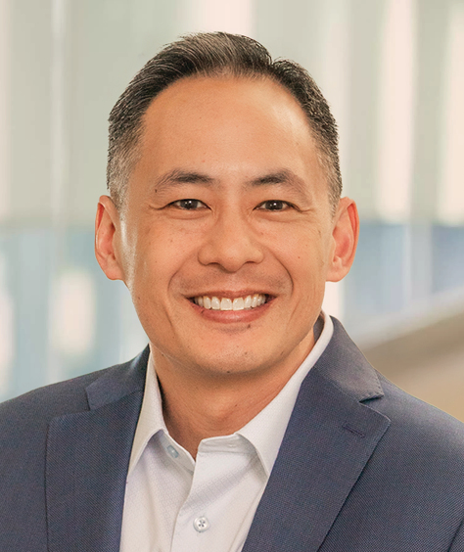
 |  |  |  |  |  | David V. Goeckeler   |  |  |  |  |  |  |  |  |  |  |  | Luis F. Visoso   |  |  |  |  |  |  |  |  |  |  |  | Alper Ilkbahar   |  |  |  |  |  |  |  |  |  |  |  | Bernard Shek  
Contents
Fiscal 2026 Overview |  |  | 39
Executive Compensation Philosophy; Policies, Practices, and Design |  |  | 40
Fiscal 2026 Executive Compensation Program Decisions and Outcomes |  |  | 46
Fiscal 2027 Compensation Program Design and Decisions |  |  | 52
Other Program Features and Policies |  |  | 54

 |  |  | EXECUTIVE COMPENSATION |  |  | PG. 039
Fiscal 2026 Overview
Business Highlights
During fiscal 2026, we focused on disciplined execution across our business and strengthening our position across our three core end markets. Amidst a dynamic macroeconomic and industry environment, shaped by continued growth in data, increasing adoption of artificial intelligence, and evolving device demand, we delivered exceptional performance and stockholder value creation, reflecting exceptional execution on and advancement of our strategic priorities. The charts below summarize our financial results with respect to certain key metrics.
Revenue ($B)
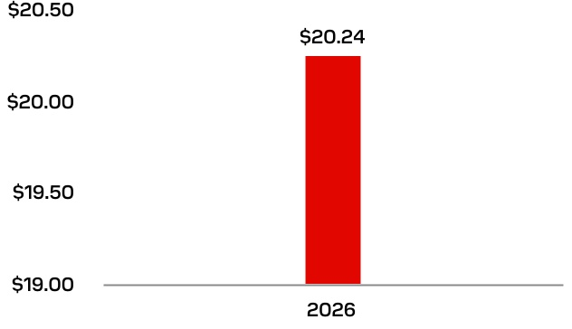
Non-GAAP Operating Income ($B)(1)
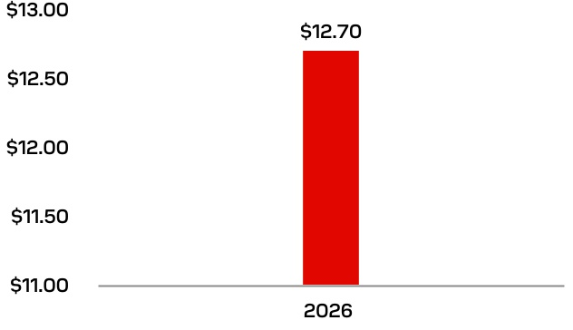

Adjusted Free Cash Flow ($B)(2)
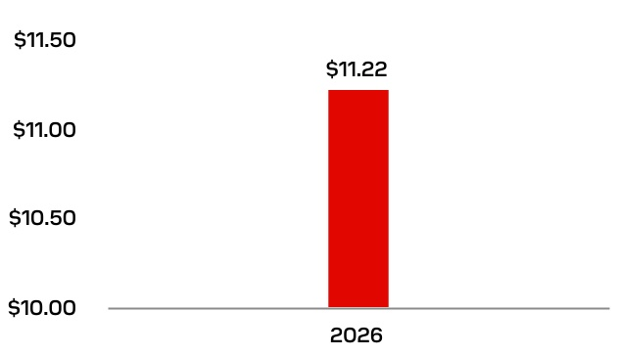
Non-GAAP EPS(1)
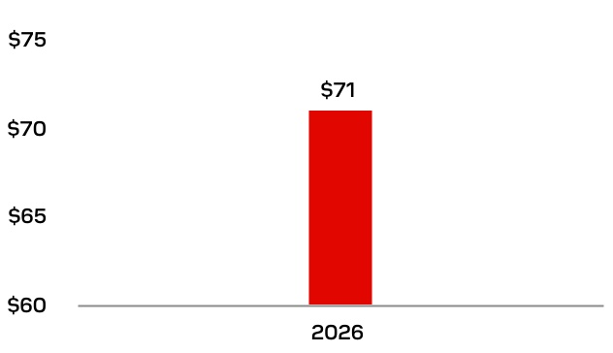
(1)Non-GAAP Operating Income and non-GAAP EPS are Non-GAAP financial measures. See Appendix A to this Proxy Statement for GAAP to Non-GAAP reconciliations.
(2)Adjusted free cash flow is a Non-GAAP financial measure, which is defined in this Proxy Statement in a manner consistent with the financial targets set by our Compensation and Talent Committee at the beginning of fiscal 2026. See Appendix A to this Proxy Statement for a GAAP to Non-GAAP reconciliation.

PG. 040 |  |  | 2026 PROXY STATEMENT
Fiscal 2026 Performance
Maximum achievement rates under our incentive compensation plans reflect our exceptional financial performance in fiscal 2026, our first full year as a standalone company. Our fiscal 2026 short-term incentive (“STI”) program achieved 200% of target. The first tranche of our fiscal 2026-2028 performance stock units (“PSUs”) under our long-term incentive (“LTI”) also achieved 200% of target. Maximum achievement under the executive incentive compensation plans aligns with the Compensation and Talent Committee’s pay-for-performance philosophy.
During fiscal 2026, the company also achieved maximum performance with respect to the performance-based Launch Grants (as defined below) approved by the committee in May 2025. Our stock price increased by 3,600% from the end of fiscal 2025 through the end of fiscal 2026 relative to a 21% increase in the S&P 500 Index over the same period, representing substantial value creation for our stockholders compared to the broader market. Maximum performance with respect to the Launch Grants resulted in maximum achievement of 300% of target for each named executive officer. Our named executive officers generally must remain employed with the company until February 2028 to vest in the Launch Grant.

Executive Compensation Philosophy; Policies, Practices, and Design
The summary below provides the key objectives of our executive compensation program:
 |  |  | Our compensation programs are designed to attract, retain, and motivate key talent necessary to accelerate our growth and drive financial, operational, and market performance. |  |  |  |  |  |  |  |  | We have a pay-for-performance approach, with the most significant portion of pay based on enterprise performance. These include both annual and long-term rewards. Our programs reinforce shared accountability across the leadership team and align with the interests of our stockholders. |  |  |  |  |  |  |  |  | We target total compensation opportunities at or near median for similar roles in the technology industry in which we compete for business and talent, with flexibility to position higher for exceptional talent in critical roles.
Our Compensation Policies and Practices
WHAT WE DO |  |  |  |  |  | WHAT WE DON’T DO
 Pay for performance by tying a substantial portion of executive compensation to the achievement of rigorous performance goals  Commit to engage with our stockholders on an ongoing basis and consider their feedback in the future design of our executive compensation program  Link our executive compensation program to our corporate strategy and sustainable stockholder value creation  Use a mix of performance measures, cash- and equity-based vehicles, and short-and long-term incentive compensation opportunities  Cap maximum vesting or payout levels under our incentive compensation awards, which are aligned with competitive market practices  Engage an independent compensation consultant to evaluate and advise the Compensation and Talent Committee on our executive compensation program design and pay decisions  Evaluate executive compensation data and practices of our proxy peer group companies and broader market, with guidance from the independent compensation consultant  Limit payouts under our Change in Control Severance Plan to “double-trigger” events  Maintain and adhere to executive stock ownership guidelines  Maintain and adhere to our robust compensation recovery (“clawback”) policy  Provide only limited executive perquisites |  |  |  |  |  | •No tax gross-up payments in connection with severance or change in control payments  •No repricing of stock options without stockholder approval (other than equitable adjustments permitted under our equity compensation plans)  •No hedging, pledging, or short-sale or derivative transactions by executive officers or directors  •No dividend equivalent payments on equity awards until they are earned and vested

 |  |  | EXECUTIVE COMPENSATION |  |  | PG. 041
Evolution of Our Executive Compensation Program
Fiscal 2026 was our first full fiscal year as an independent company, and our executive compensation program reflects that transition. Following the separation, our second-half fiscal 2025 program was intentionally streamlined to support a successful launch. For fiscal 2026, the Compensation and Talent Committee designed a comprehensive, market-aligned program built around our standalone strategy and informed by stockholder feedback gathered during our first year as a public company. The most significant changes are summarized below.
Program Element |  |  |  |  |  | Fiscal 2026 Changes |  |  |  |  |  | Compensation and Talent Committee Rationale
Short-Term Incentive |  |  |  |  |  | Replaced the transitional second-half fiscal 2025 design with a full-year program based on key metrics including non-GAAP Operating Income, non-GAAP Operating Margin, Adjusted Free Cash Flow, and other metrics aligned with corporate strategy, with achievement capped at 200%. |  |  |  |  |  | Aligns annual pay with the profitability, cash generation, and strategic priorities most important to our business and stockholders.
Long-Term Incentive Structure |  |  |  |  |  | Introduced a recurring equity program of PSUs and RSUs, with 75% of CEO and CFO long-term incentives delivered in PSUs (50% for other NEOs). |  |  |  |  |  | Establishes a sustainable, performance-weighted long-term program that ties the majority of senior executive pay to multi-year results and retention.
Long-Term Incentive Metrics |  |  |  |  |  | Designed fiscal 2026 to 2028 PSUs based on revenue and non-GAAP earnings per share, measured over annual periods and averaged across a three-year performance period, with continued-service vesting through the end of the period. |  |  |  |  |  | Focuses executives on the financial measures directly tied to our standalone operating plan while preserving multi-year retention. Performance period structure allows the committee to set rigorous performance goals annually in the context of the cyclical nature of our business, while the three-year average incentivizes the long-term focus and sustained performance.
Fiscal 2026 Executive Compensation Program Design
The Compensation and Talent Committee, with input from its independent compensation consultant, designed and implemented a fiscal 2026 executive compensation program to align pay outcomes with company performance and long-term stockholder value creation. Fiscal 2026 represents our first full fiscal year as a standalone company and the first full year in which the committee independently developed an end-to-end compensation program, anchored to our financial commitments and strategic priorities. Our fiscal 2026 compensation program includes base salaries, an STI plan, and an LTI plan. Our named executive officers are also eligible for limited perquisites and other indirect benefits, described further under “Other Program Features and Policies.”
Our financial metrics include non-GAAP financial metrics that exclude our stock-based compensation expense and other expenses that are not reflective of our core operating results. In instances in which our incentive plans incorporate non-GAAP metrics, Appendix A includes a reconciliation of GAAP to non-GAAP financials.

PG. 042 |  |  | 2026 PROXY STATEMENT
 |  |  |  |  |  | Elements of Fiscal 2026 Target Total Direct Compensation
 |  |  |  |  |  | CEO |  |  |  |  |  | Other Named  Executive  Officers |  |  |  |  |  | Characteristics |  |  |  |  |  | Purpose |  |  |  |  |  | Performance Link/  Key Benchmark
 |  |  |  |  |  | BASE SALARY |  |  |  |  |  |  |  |  |  |  |  | •Fixed compensation |  |  |  |  |  | •Attracts, retains, and develops highly qualified executive talent  •Compensates executive officers for sustained individual performance  •Maintains a stable executive management team |  |  |  |  |  | •Competitive with market and industry practices  •Adjusted for experience, skills, responsibility, potential, and performance
 |  |  |  |  |  |  |  |  |  |  |  | 
 |  |  |  |  |  | SHORT-TERM INCENTIVE |  |  |  |  |  |  |  |  |  |  |  | •Annual variable, performance-based cash compensation |  |  |  |  |  | •Incentivizes executive officers to execute on annual financial and operational goals  •Rewards achievement of corporate strategic objectives that are aligned with long-term company success  •Aligns near-term goals with long-term stockholder value creation  •Plan achievement capped at 200% of target |  |  |  |  |  | •Profit Metrics: Higher performance of non-GAAP Operating Income and non-GAAP Operating Margin (50%)  •Adjusted Free Cash Flow (25%)  •Three corporate strategy metrics (8.33% each):  •Net debt  •Consumer net revenue  •Datacenter market share
 |  |  |  |  |  |  |  |  |  |  |  | 
 |  |  |  |  |  | LONG-TERM INCENTIVE |  |  |  |  |  |  |  |  |  |  |  | •Annual, variable equity component  •Vests with respect to 25% after one year and 6.25% quarterly thereafter |  |  |  |  |  | •Provides alignment with stockholder interests by focusing executive officers on creating long-term value  •Provides retention value  •Plan achievement capped at 200% of target |  |  |  |  |  | •Value tied to stock price performance
 |  |  |  |  |  | RSU
 |  |  |  |  |  |  |  |  |  |  |  | 
 |  |  |  |  |  | PSU |  |  |  |  |  |  |  |  |  |  |  | •3x1 annual performance targets; annual achievement percentage averaged for a final three-year vesting percentage, which enables rigorous target setting responsive to market conditions and cyclicality  •75% of our CEO’s and CFO’s LTI are PSUs; 50% of our other named executive officers’ LTI are PSUs |  |  |  |  |  | •Provides alignment with stockholder interests by focusing executive officers on sustainable long-term value creation |  |  |  |  |  | •Revenue (50%)  •Non-GAAP EPS (50%)
 |  |  |  |  |  |  |  |  |  |  |  | 
(1)Percentage of target total direct compensation calculated using the intrinsic dollar value of the LTI awards, as approved by the Compensation and Talent Committee. For information on the accounting value of the LTI awards, please see our fiscal 2026 Summary Compensation Table on page 56.
Looking ahead to fiscal 2027, the Compensation and Talent Committee continued to evolve the program in response to our company strategy, market practices and stockholder feedback. Beginning with our fiscal 2027 to 2029 awards, PSUs will include a relative total shareholder return modifier measured against the constituents of the PHLX Semiconductor Sector Index, to reflect performance relative to other large-capitalization semiconductor companies. The committee also refreshed our compensation peer group for fiscal 2027 to reflect the company’s growth in fiscal 2026. We describe these fiscal 2027 decisions in greater detail under "Fiscal 2027 Compensation Program Design and Decisions."

 |  |  | EXECUTIVE COMPENSATION |  |  | PG. 043
Process for Determining Executive Compensation
Annual Review and Oversight
The Compensation and Talent Committee sets a process to annually review and approve executive compensation design, including base salary, short-term incentives, long-term equity awards, and performance goals, to ensure that pay outcomes reflect company performance and individual contributions. The committee is devoted to evaluating executive performance against the conditions set within the compensation program on an annual basis and at the time of hiring, promotion or other changes in responsibilities. The committee is supported by an independent compensation consultant, regularly benchmarks compensation practices against a carefully selected peer group, and reviews succession and talent development strategies. The committee values the views and input of our stockholders and plans to solicit their feedback as a key input to its decision-making.
In August 2025, the committee established the fiscal 2026 compensation program to align our executives’ interests with our strategic objectives and the interests of our stockholders.
Committee Responsibilities and Governance Framework
The Compensation and Talent Committee is responsible for carrying out the Board’s oversight relating to the compensation of our company’s executive officers and our company’s broader talent strategy. In accordance with its charter, the committee’s responsibilities include:
•Oversight of executive and director compensation program design and related policies
•Evaluation of executive performance and resulting payouts
•Development of the CD&A for inclusion in the annual proxy statement
•Periodic review of our company’s people policies, practices, and programs
•Oversight of executive succession processes and senior leadership development
•Oversight of employee benefit plans (in accordance with the terms of the applicable employee benefit plans)
•Communicating to stockholders our company’s executive compensation philosophy, policies, and programs
The committee operates under a written charter approved by the Board, which is reviewed annually and available at investor.sandisk.com. Each member of the committee has been determined by the Board to be independent under applicable Nasdaq and SEC rules.

PG. 044 |  |  | 2026 PROXY STATEMENT
Process for Determining Executive Compensation
In determining our executive compensation program design, the Compensation and Talent Committee’s executive compensation decisions are informed by several factors, including:
External and Internal Factors
•Our pay positioning relative to our proxy peer group and broad compensation survey market data
•Each executive officer’s role, experience, performance, and contributions
•Our retention objectives
•Succession planning
•Company performance and strategic and financial goals
•Market performance and general economic conditions
Management
•Our CEO’s recommendations for select executive officers’ promotions, responsibilities, and performance expectations
•Our CFO’s input on financial targets for our performance-based incentive compensation program
•Internal and external compensation data provided by our human resources team
Compensation Consultant
•Independent insights on compensation program design
•Identifying and recommending benchmarking comparators for committee approval
•Compensation survey and proxy peer group data
Stockholders
•Feedback from our planned stockholder outreach and engagement program
Role of the Compensation Consultant
The Compensation and Talent Committee engaged Pay Governance LLC (“Pay Governance”) as its independent compensation consultant during fiscal 2026. Pay Governance reported directly to the committee and communicated with management to gather information and review management proposals as needed. Pay Governance attended all regularly scheduled meetings of the committee during fiscal 2026 and its responsibilities generally included:
•Reviewing and advising on executive compensation, including the performance metrics used under the executive compensation program
•Providing recommendations regarding the composition and selection of our proxy peer group companies
•Analyzing proxy peer group and survey compensation data
•Providing advice regarding executive compensation policies, practices and trends
The Compensation and Talent Committee assessed the independence of Pay Governance pursuant to applicable rules and regulations of the SEC and the Nasdaq Stock Market and concluded that the engagement of Pay Governance did not raise any conflicts of interest during fiscal 2026 and currently does not raise any conflicts of interest. No other fees were paid to Pay Governance except fees related to its services to the committee.

 |  |  | EXECUTIVE COMPENSATION |  |  | PG. 045
Comparative Market Data
The Compensation and Talent Committee determines the composition of our proxy peer group and will reevaluate this group on an annual basis with input from its independent compensation consultant.
The Compensation and Talent Committee, with the assistance of Pay Governance, conducted a thorough review of the peer group used for executive compensation benchmarking. The committee reviews proxy peer group executive compensation data provided by Pay Governance and independently published compensation survey data from the Aon Radford McLagan Compensation Database.
With input from its independent compensation consultant, the committee considers such market data and industry practices during its review of our executives’ compensation levels and mix of compensation elements.
Fiscal 2026 Proxy Peer Group Companies for Benchmarking Pay and Incentive Design
The proxy peer group companies that the Compensation and Talent Committee used for comparative pay and incentive design purposes for fiscal 2026 consisted of technology companies that compete with Sandisk for talent and are comparable to our company’s size, primarily based on revenue and market capitalization, and other relevant business characteristics. The committee believes that providing a compensation package that is competitive – particularly relative to our peer group – allows us to attract, motivate, reward, and retain the talent needed to drive long-term stockholder value.
The following criteria were inputs in developing a peer set:
•Size/scope: revenue 1/3x to 3x; market cap mainly in a range from 1/5x to 5x
•Competition: competes with Sandisk’s lines of businesses and/or for talent
•Industry: operates primarily in data storage or semiconductor industry (in SOX Index) or more broadly within the Information Technology industry
•Other Considerations: global footprint, listing on a major U.S. exchange with disclosed executive pay practices; CEO is non-founder; well-known technology and/or consumer brands
The committee worked with Pay Governance to develop a peer set that reflects our size, business, and market profile. The committee prioritized the inclusion of companies that are competitive in our talent market and have comparable revenue. Revenue is a commonly used proxy for organizational size and complexity and is typically stable from year-to-year, making it a valuable metric when selecting peers for executive compensation purposes. Market capitalization is generally aligned with shareholder interests and is closely associated with executive equity compensation, which typically represents the largest component of total executive pay. As part of its decision process, the committee also referenced other metrics for informational purposes, including comparative profitability metrics. Following its review, the Compensation and Talent Committee determined a peer set of 17 companies that is most relevant based on the above criteria.
SANDISK COMPARED TO 2026 PROXY PEER GROUP
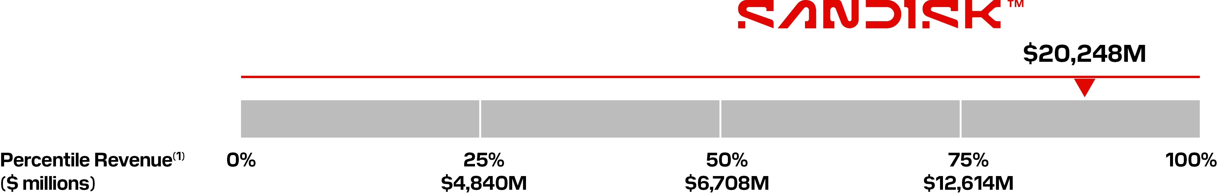
Amkor Technology, Inc.  Coherent Corp.  Intel Corporation  KLA Corporation  Lam Research Corporation  Logitech International S.A. |  |  | Marvell Technology  Microchip Technology Incorporated  Micron Technology, Inc.  NetApp, Inc.  NXP Semiconductors N.V.  ON Semiconductor Corporation |  |  | Pure Storage, Inc.  Qorvo, Inc.  Roku, Inc.  Skyworks Solutions, Inc.  Teledyne Technologies Incorporated
The peer group revenues represent annual revenue for the most recent fiscal year for which data was available through SEC filings as of August 31, 2026. Our revenue figure represents fiscal 2026 total revenue.

PG. 046 |  |  | 2026 PROXY STATEMENT
Fiscal 2026 Executive Compensation Program Decisions and Outcomes
Base Salary
The Compensation and Talent Committee closely reviews executive base salaries to ensure each is market-competitive, supports retention, and reflects our expectations for the role and performance. Effective August 1, 2025, the committee approved a market-based compensation adjustment for Bernard Shek. Mr. Shek’s base salary was raised from $425,000 to $500,000 on an annual basis.
Named Executive Officer |  |  | Base Salary Level(1) ($)
David V. Goeckeler |  |  |  |  |  | 1,300,000
Luis F. Visoso |  |  |  |  |  | 825,000
Alper Ilkbahar |  |  |  |  |  | 625,000
Bernard Shek |  |  |  |  |  | 500,000
(1)Table reflects annualized base salary in effect at the end of fiscal 2026 for each named executive officer; actual base salary in fiscal 2026 was slightly higher due to the occurrence of 27 payroll periods during the fiscal year, as reflected in the Summary Compensation Table.
Fiscal 2026 Executive STI
The committee made no changes to target annual incentive opportunities for our named executive officers in fiscal 2026.
Fiscal 2026 Target STI Opportunities
Named Executive Officer |  |  | Annual Target STI Opportunity(1)  (as Percentage of Base Salary)
David V. Goeckeler |  |  | 175 |  | %
Luis F. Visoso |  |  | 150 |  | %
Alper Ilkbahar |  |  | 100 |  | %
Bernard Shek |  |  | 80 |  | %
(1)Table reflects annual target STI opportunity at the end of fiscal 2026 for each named executive officer.

 |  |  | EXECUTIVE COMPENSATION |  |  | PG. 047
Fiscal 2026 Executive STI Design and Performance
For fiscal 2026, the Compensation and Talent Committee evolved our STI design to align with our strategic priorities and incorporated stockholder feedback on financial metrics they consider important for our success. The committee prioritized profitability, cash flow, and fiscal 2026 strategic priorities for the fiscal 2026 goals. The fiscal 2026 Executive STI plan applied to all named executive officers and provided cash payouts based on company-wide performance against targets established in August 2025.
 |  |  |  |  |  | Profit Metrics  50% Weighting |  |  |  |  |  | + |  |  |  |  |  | Free Cash Flow  25% Weighting |  |  |  |  |  |  |  |  | + |  |  |  |  |  | Corporate Strategy Metrics  25% Weighting |  |  |  |  |  | = |  |  |  |  |  | Funding  (Capped at 200%)
 |  |  | 0%-200% Performance Range
Fiscal 2026 Executive STI Performance
PROFIT METRICS (50% WEIGHTING)
The STI profit metric achieved 200% of target relative to metrics approved by our Compensation and Talent Committee. The profit metric included two separate metrics, with achievement under the profit metric based on the higher achievement between a non-GAAP Operating Income metric and a non-GAAP Operating Margin metric. The non-GAAP Operating Income metric provided a performance range based on management’s annual operating plan for fiscal 2026, with maximum achievement of 200% of target. The non-GAAP Operating Margin metric incentivized management to keep this margin positive in a downturn scenario, which management believed was a possible outcome when goals were set in August 2025, with a maximum achievement of 40% of target. Given the company’s strong financial performance in fiscal 2026, 200% of target achievement for this metric was determined using the non-GAAP Operating Income metric; using the non-GAAP Operating Margin metric would have resulted in achievement of 40% of target.
NON-GAAP OPERATING INCOME(1)
($M)
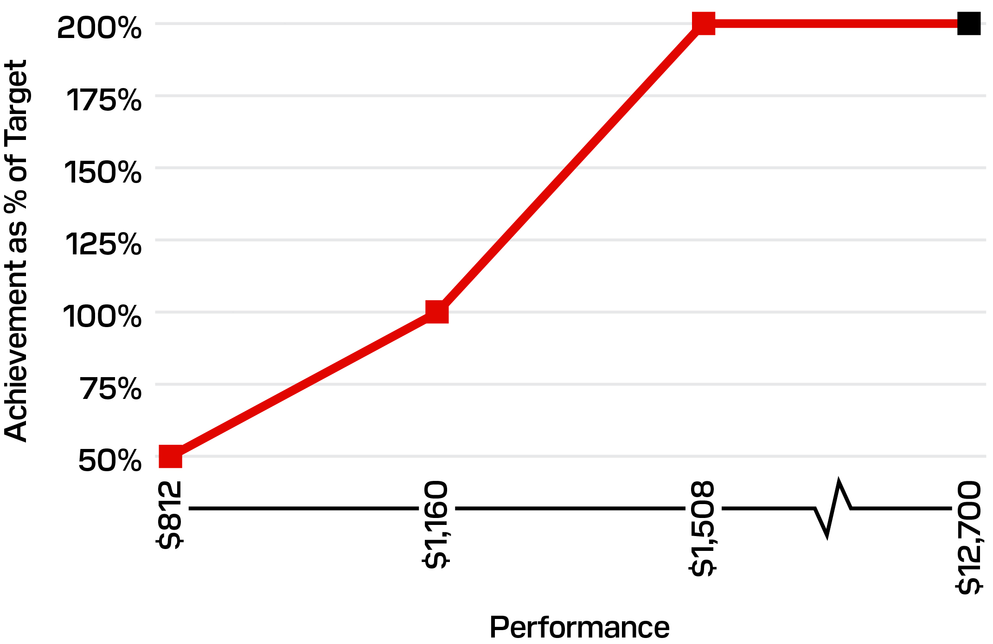
 |  |  | Actual
Non-GAAP Operating Income(1)
Performance |  |  |  |  |  | STI Achievement  (% Target) |  |  |  |  |  | Performance  ($ millions)
Maximum |  |  |  |  |  | 200 |  | % |  |  |  |  |  |  | 1,508
Target |  |  |  |  |  | 100 |  | % |  |  |  |  |  |  | 1,160
Minimum |  |  |  |  |  | 50 |  | % |  |  |  |  |  |  | 812
Actual |  |  |  |  |  | 200 |  | % |  |  |  |  |  |  | 12,700
(1)See Appendix A to this Proxy Statement for an explanation of how non-GAAP operating income is calculated and a GAAP to non-GAAP reconciliation for actual performance for fiscal 2026.

PG. 048 |  |  | 2026 PROXY STATEMENT
ADJUSTED FREE CASH FLOW (25% WEIGHTING)(2)
The Compensation and Talent Committee included Adjusted Free Cash Flow based on management’s annual operating plan for fiscal 2026. The Adjusted Free Cash Flow metric was subject to additional adjustment by the Compensation and Talent Committee in the event of material circumstances that were unforeseen at the time that the target was approved. For example, adjustments could have resulted from significant swings in timing of payments to vendors, timing of tax payments, currently unplanned separation or restructuring costs, and other extraordinary items. The Compensation and Talent Committee did not make any adjustments to the Adjusted Free Cash Flow metric for fiscal 2026.
($M)
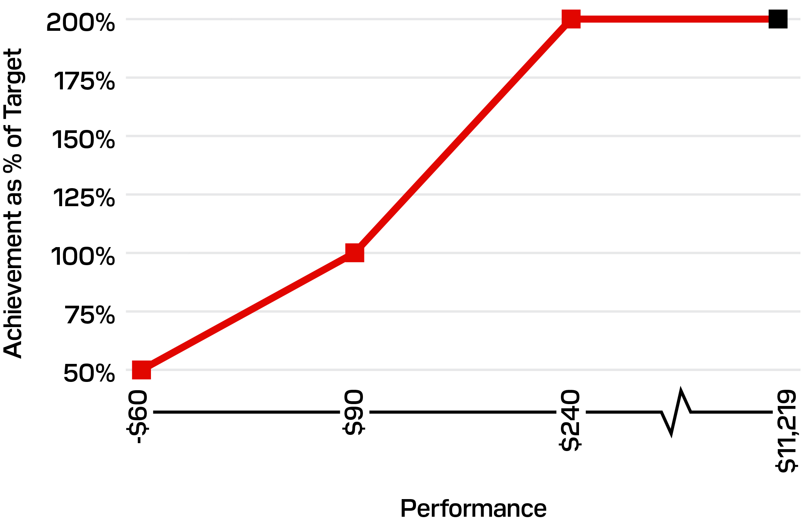
Actual
Adjusted Free Cash Flow(2)
Performance |  |  |  |  |  | STI Achievement  (% Target) |  |  |  |  |  | Performance  ($ millions)
Maximum |  |  |  |  |  | 200 |  | % |  |  |  |  |  |  | 240
Target |  |  |  |  |  | 100 |  | % |  |  |  |  |  |  | 90
Minimum |  |  |  |  |  | 50 |  | % |  |  |  |  |  |  | (60)
Actual |  |  |  |  |  | 200 |  | % |  |  |  |  |  |  | 11,219
(2)Adjusted free cash flow is a Non-GAAP financial measure, which is defined in this Proxy Statement in a manner consistent with the financial targets set by our Compensation and Talent Committee at the beginning of fiscal 2026. See Appendix A to this Proxy Statement for a GAAP to Non-GAAP reconciliation.
CORPORATE STRATEGY METRICS (25% WEIGHTING)
For fiscal 2026, 25% of the annual incentive opportunity was tied to corporate strategy metrics designed to align the management team’s goals with our strategic priorities. The corporate strategy component included equally weighted metrics (8.33% each): Net Debt, Consumer Net Revenue, and Datacenter Market Share. Each metric reflects an area of strategic importance as Sandisk continues to execute its growth strategy. The net debt metric reflected the company’s objective to reduce its post-separation debt, consumer net revenue focused the team on maintaining a strong market presence in the consumer segment, and datacenter market share reflected management’s goal of increasing our presence in that critical segment. To calculate datacenter market share, we averaged third-party estimates of exabytes shipped as projected by Forward Insights, Tech Insights, and IDC, and calculated Sandisk’s exabytes shipped as a percentage of the total.
NET DEBT
($M)
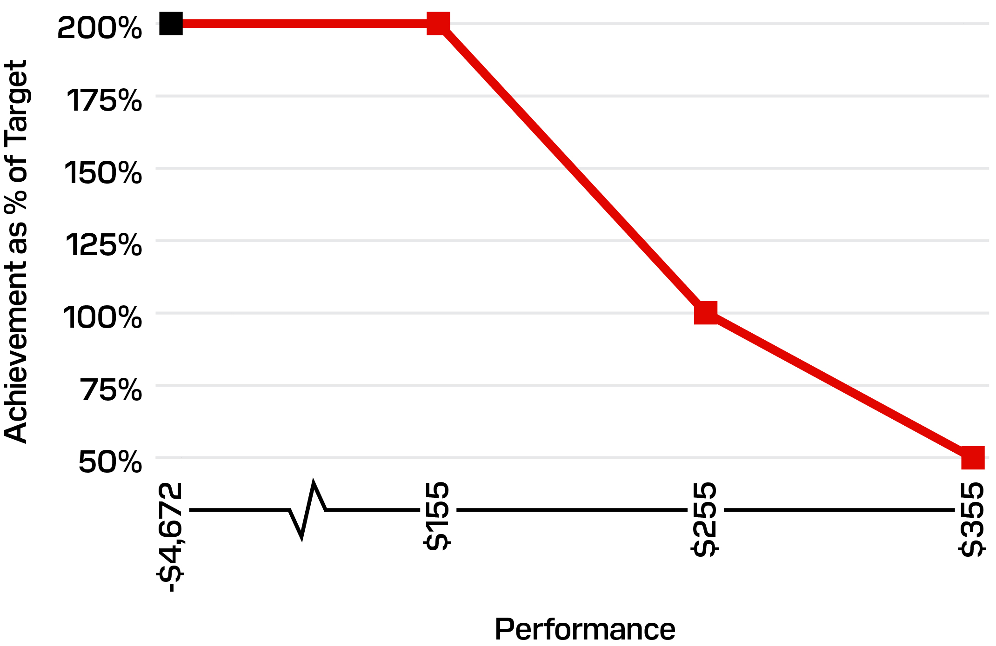
Actual
Net Debt (8.33%)
Performance |  |  |  |  |  | STI Achievement  (% Target) |  |  |  |  |  | Performance  ($ millions)
Maximum |  |  |  |  |  | 200 |  | % |  |  |  |  |  |  | 155
Target |  |  |  |  |  | 100 |  | % |  |  |  |  |  |  | 255
Minimum |  |  |  |  |  | 50 |  | % |  |  |  |  |  |  | 355
Actual |  |  |  |  |  | 200 |  | % |  |  |  |  |  |  | (4,672) |  |  | (1)
(1)Sandisk ended the fiscal year with no net debt and a positive cash balance

 |  |  | EXECUTIVE COMPENSATION |  |  | PG. 049
CONSUMER NET REVENUE
($M)
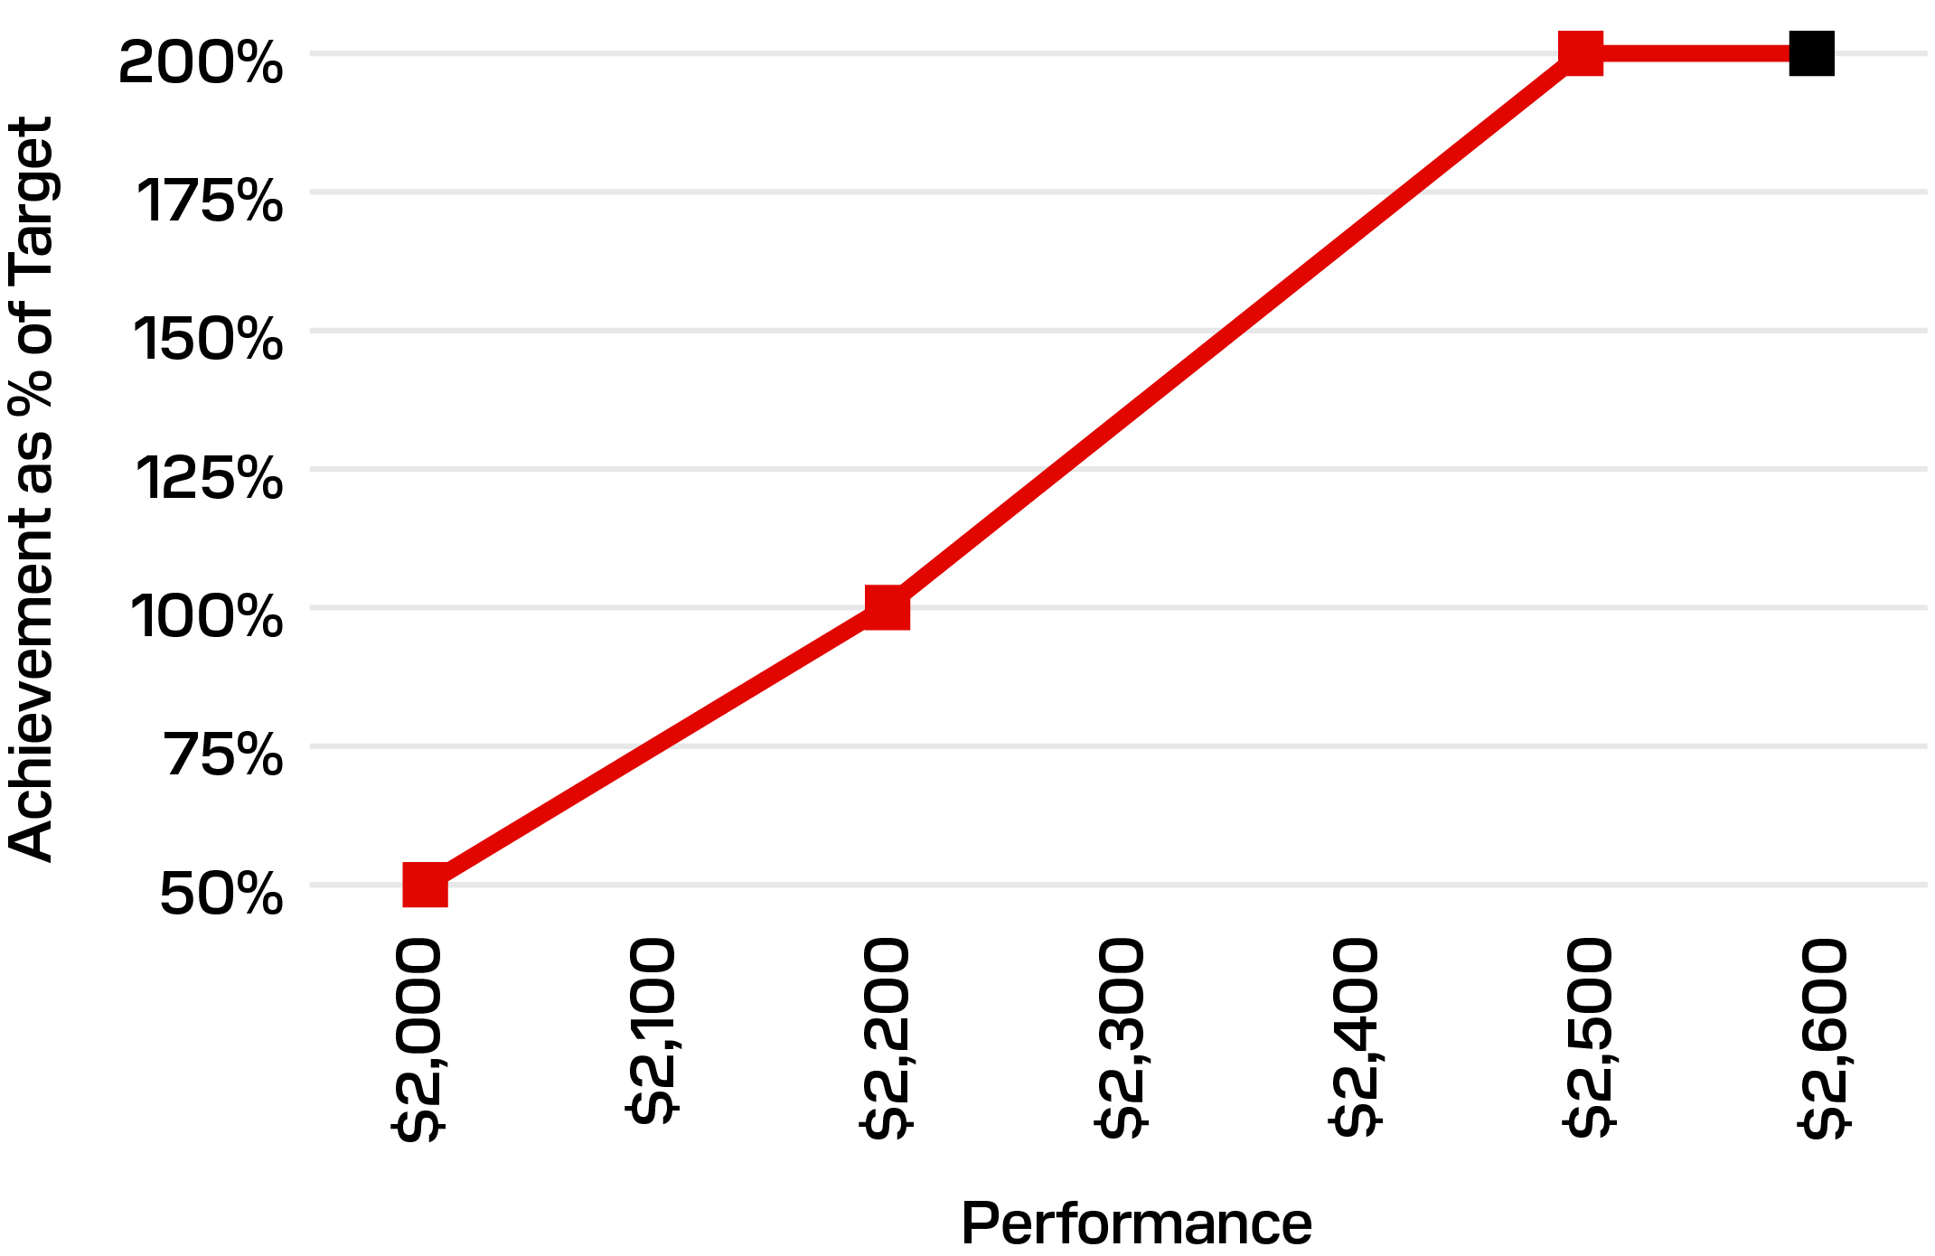
Actual
Consumer Net Revenue (8.33%)
Performance |  |  |  |  |  | STI Achievement  (% Target) |  |  |  |  |  | Performance  ($ millions)
Maximum |  |  |  |  |  | 200 |  | % |  |  |  |  |  |  | 2,448
Target |  |  |  |  |  | 100 |  | % |  |  |  |  |  |  | 2,225
Minimum |  |  |  |  |  | 50 |  | % |  |  |  |  |  |  | 2,003
Actual |  |  |  |  |  | 200 |  | % |  |  |  |  |  |  | 2,577
DATACENTER MARKET SHARE
(%)
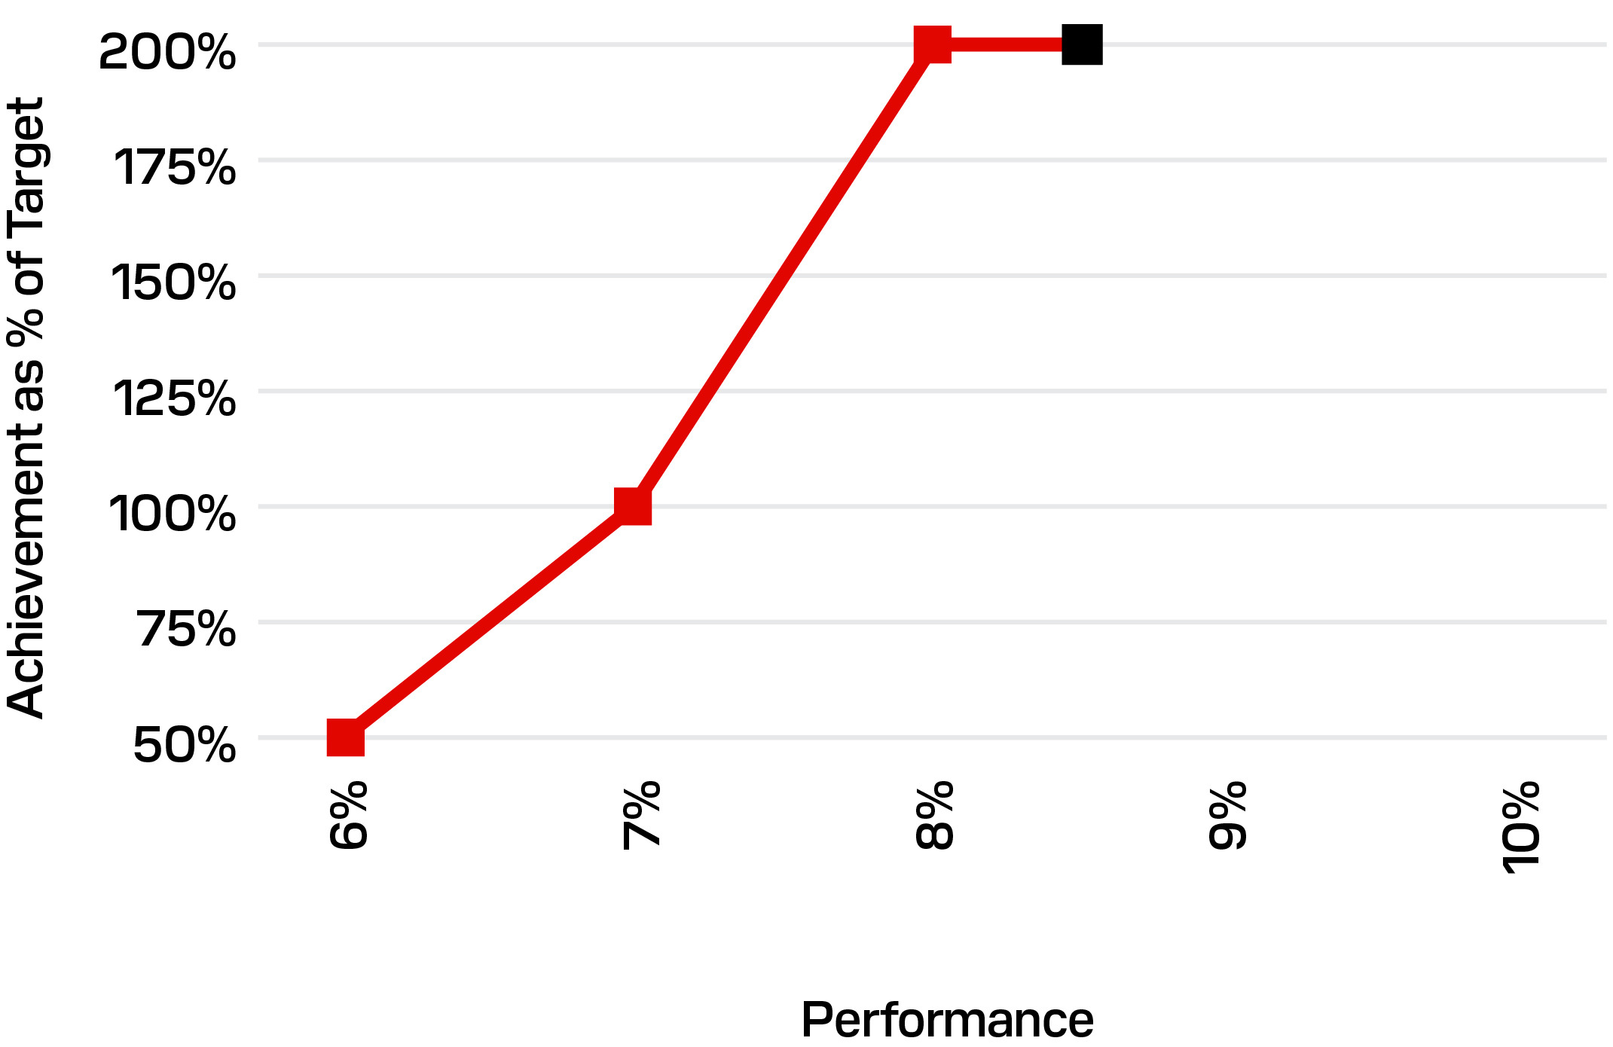
Actual
Datacenter Market Share (8.33%)
Performance |  |  |  |  |  | STI Achievement  (% Target) |  |  |  |  |  | Performance  (%)
Maximum |  |  |  |  |  | 200 |  | % |  |  |  |  |  |  | 8 |  | %
Target |  |  |  |  |  | 100 |  | % |  |  |  |  |  |  | 7 |  | %
Minimum |  |  |  |  |  | 50 |  | % |  |  |  |  |  |  | 6 |  | %
Actual |  |  |  |  |  | 200 |  | % |  |  |  |  |  |  | 8.4 |  | %
Fiscal 2026 Executive STI Payouts
Named Executive Officer |  |  | STI Achievement  (% of Target) |  |  | STI Payout  ($)
David V. Goeckeler |  |  | 200 |  | % | 4,725,000
Luis F. Visoso |  |  | 200 |  | % | 2,570,193
Alper Ilkbahar |  |  | 200 |  | % | 1,298,076
Bernard Shek |  |  | 200 |  | % | 817,384
(1)STI payout amounts reflect 27 payroll cycles in fiscal 2026.
Fiscal 2026 Executive LTI
The Compensation and Talent Committee designed the fiscal 2026 LTI to align with our long-term strategic objectives and drive sustainable stockholder value creation.
Fiscal 2026 LTI Awards
The Compensation and Talent Committee granted the following LTI awards to our named executive officers in fiscal 2026, as part of the annual LTI program. The named executive officers’ RSUs are scheduled to vest with respect to 25% of the award on the first anniversary of the grant date and with respect to 6.25% of the award quarterly such that the RSUs will be fully vested on the fourth anniversary of the grant date. The vesting provisions of the PSUs are described below.

PG. 050 |  |  | 2026 PROXY STATEMENT
 |  |  | Total LTI Target Grant Value(1)  ($) |  |  |  |  |  | LTI Vehicle Mix
Named Executive Officer |  |  |  |  |  |  |  |  | PSUs |  |  | RSUs
David V. Goeckeler |  |  | 16,250,000 |  |  |  |  |  | 75% |  |  | 25%
Luis F. Visoso |  |  | 9,000,000 |  |  |  |  |  | 75% |  |  | 25%
Alper Ilkbahar |  |  | 2,500,000 |  |  |  |  |  | 50% |  |  | 50%
Bernard Shek |  |  | 1,750,000 |  |  |  |  |  | 50% |  |  | 50%
(1)Table reflects intrinsic dollar value of fiscal 2026 LTI awards granted to each named executive officer by the Compensation and Talent Committee. The Summary Compensation Table includes the accounting values for these awards, which is lower than the intrinsic value. For information on the accounting value of the LTI awards, please see our fiscal 2026 Summary Compensation Table on page 56.
Fiscal 2026-2028 PSU Design
The fiscal 2026-2028 PSU design includes annual performance periods for two equally-weighted metrics, Revenue and non-GAAP EPS. Revenue focuses our executive officers on sustainable long-term growth and non-GAAP EPS measures the effectiveness of our capital allocation strategy. Annual achievement percentages are calculated at the end of each one-year period, with the annual achievement percentages averaged to determine a three-year vesting percentage. This performance period structure enables rigorous targets responsive to market conditions and cyclicality. Our executive officers generally must remain employed through the entire three-year performance period to earn and vest in the awards.
Grant Date to End of Year 1
FY27 Targets:  •1-Year Revenue  •1-Year non-GAAP EPS |  |  |  |  |  | Year 1 to Year 2
 |  |  |  |  |  | FY28 Targets:  •1-Year Revenue  •1-Year non-GAAP EPS |  |  |  |  |  | Year 2 to Year 3
FY29 Targets:
•1-Year Revenue
•1-Year non-GAAP EPS
Fiscal 2026-2028 PSU Performance (Year One of Three)
The fiscal 2026 PSUs include three one-year revenue and EPS goals. The first year of the fiscal 2026 PSUs achieved 200% of target for revenue and 200% of target for EPS relative to metrics approved by the Compensation and Talent Committee. At the end of fiscal 2028, the annual achievement percentages for each of fiscal years 2026, 2027, and 2028 will be averaged to determine the three-year vesting percentage.
Financial Metrics |  |  | Threshold  (50%)  ($) |  |  | Target  (100%)  ($) |  |  | Maximum  (200%)  ($) |  |  | Actual  Performance  ($) |  |  | Actual Performance  Rate (%) |  |  | Year One  Achievement (%)
One-Year Revenue (50%) (in millions) |  |  | 7,650 |  |  | 8,500 |  |  | 9,350 |  |  | 20,248 |  |  | 238 |  |  | 200
One-Year Non-GAAP EPS (50%)(1) |  |  | 3.50 |  |  | 5.00 |  |  | 6.50 |  |  | 71.00 |  |  | 1,420 |  |  | 200
Weighted Vesting: |  |  | — |  |  | — |  |  | — |  |  | — |  |  | — |  |  | 200
(1)See Appendix A to this Proxy Statement for reconciliation of GAAP EPS to non-GAAP EPS.
Fiscal 2026  Achievement (%) |  |  | Fiscal 2027  Achievement (%) |  |  | Fiscal 2028  Achievement (%) |  |  | Three-Year Average  Vesting %
200 |  |  | TBD |  |  | TBD |  |  | TBD
Fiscal 2025 Performance-Based Launch Grant Performance
Granted in connection with our becoming an independently traded company, the Compensation and Talent Committee designed the Launch Grants to incentivize executives to deliver substantial and sustained value to stockholders. The awards were designed and granted in fiscal 2025 and received broad shareholder support as reflected through last year’s say on pay support of 98%. The awards are 100% performance-based, requiring stock price appreciation of +125% above our post-separation baseline of $47.07 to reach maximum achievement of 300% of target. Stock price appreciation of +125% required management to deliver stock prices well above market and analyst consensus at the time of grant, execute on the company’s strategy, and successfully navigate a transition and introduction to the market.

 |  |  | EXECUTIVE COMPENSATION |  |  | PG. 051
PERFORMANCE-BASED LAUNCH GRANT
Stock Price Performance (Increase from $47.07) |  |  | % Increase |  |  | Achievement  (% of Target # of PSUs)
$58.84 |  |  | +25% |  |  | 50%
$70.61 |  |  | +50% |  |  | 100%
$82.37 |  |  | +75% |  |  | 200%
$94.14 |  |  | +100% |  |  | 250%
$105.91 |  |  | +125% |  |  | 300%
Given the company's exceptional performance as a standalone business, the awards reached the maximum stock price hurdle on a 90-trading-day rolling average in fiscal 2026. From the end of fiscal 2025 through the end of fiscal 2026 our stock price increased by 3,600% relative to 21% for the S&P 500 Index. Our company significantly outperformed the market during this timeframe. Maximum achievement under the awards reflects management's execution on our strategy to expand in the datacenter segment and grow our share of the critical AI infrastructure market through our technology roadmap and close partnership with our customers.
While the award’s performance criteria were achieved in fiscal 2026, the awards continue to be subject to service-based vesting through the end of the performance period in February 2028. The multi-year service requirement aligns with our retention goals and ongoing alignment with our stockholders.
Named Executive Officer |  |  | Target Units |  |  | Max Units
David V. Goeckeler |  |  | 317,965 |  |  | 953,895
Luis F. Visoso |  |  | 119,236 |  |  | 357,708
Alper Ilkbahar |  |  | 49,682 |  |  | 149,046
Bernard Shek |  |  | 19,707 |  |  | 59,121

PG. 052 |  |  | 2026 PROXY STATEMENT
Fiscal 2027 Compensation Program Design and Decisions
Evolving Our Peer Group and Compensation Levels
In May 2026, the Compensation and Talent Committee modified our peer group for fiscal 2027 to reflect our increased size and scale, utilizing the criteria outlined above for the fiscal 2026 peer group as inputs. Following discussion with its independent consultant, the committee approved the following changes to the 2026 peer group in approving a fiscal 2027 peer group:

•Removed: Amkor Technology, Inc.; Qorvo, Inc.; and Skyworks Solutions, Inc.
•Added: Advanced Micro Devices, Inc. (AMD); Analog Devices, Inc.; Applied Materials, Inc.; QUALCOMM, Inc.
SANDISK COMPARED TO 2027 PROXY PEER GROUP
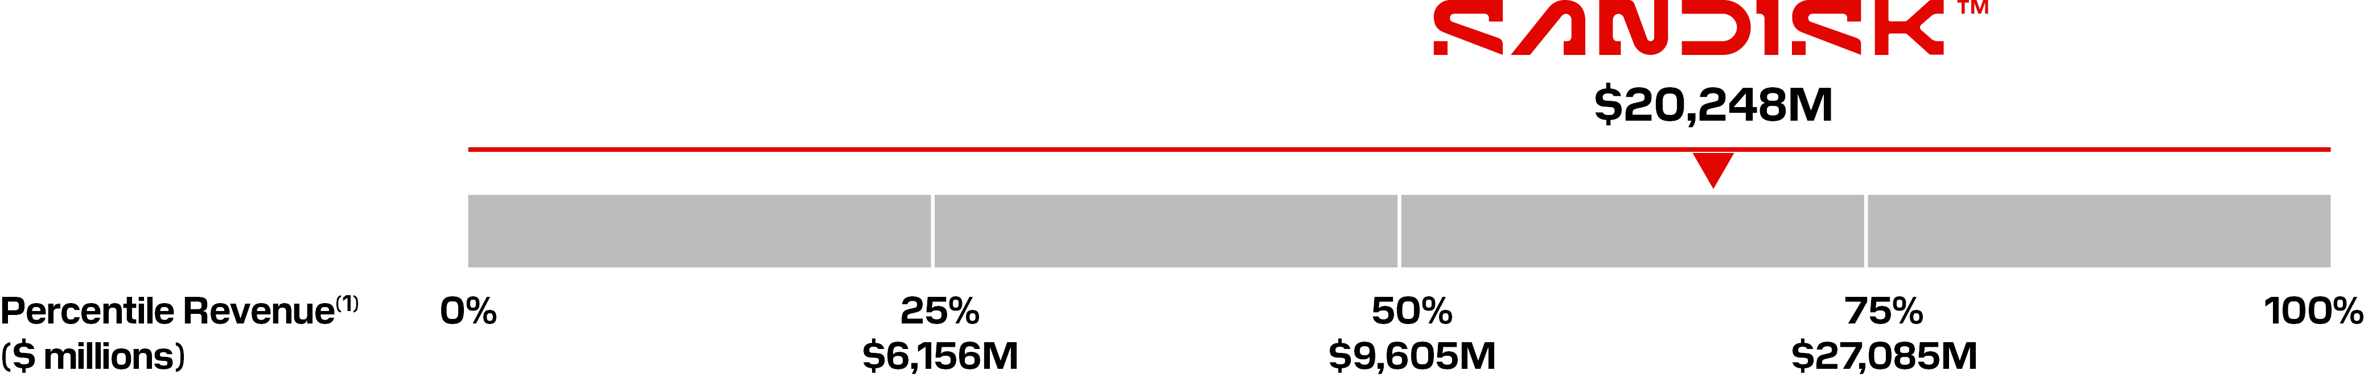

The 2027 peer group revenues represent annual revenue for the most recent fiscal year for which data was available through SEC filings as of August 31, 2026. Our revenue figure represents fiscal 2026 total revenue.
In August 2026, the Compensation and Talent Committee adjusted compensation for our named executive officers to align with market as informed by the fiscal 2027 peer group. The committee intends to adjust our named executive officers’ compensation over two years to align with market positioning. The table below outlines fiscal 2027 target compensation for each of our named executive officers:
Named Executive Officer |  |  |  |  |  | Base Salary Level ($) |  |  | Annual Target STI Opportunity  (as Percentage of Base) Salary) |  |  | Total LTI Target Grant Value ($) |  |  | Target Total Direct Compensation ($)
David V. Goeckeler |  |  |  |  |  | 1,300,000 |  |  | 200 |  | % | 20,150,000 |  |  | 24,050,000
Luis F. Visoso |  |  |  |  |  | 875,000 |  |  | 150 |  | % | 10,000,000 |  |  | 12,188,000
Alper Ilkbahar |  |  |  |  |  | 755,000 |  |  | 100 |  | % | 5,500,000 |  |  | 7,010,000
Bernard Shek(1) |  |  |  |  |  | 618,000 |  |  | 100 |  | % | 3,400,000 |  |  | 4,635,000
(1)The company promoted Mr. Shek to the role of Executive Vice President, Chief Legal Officer and Secretary, effective as of October 1, 2026. Mr. Shek’s compensation enhancements reflect market data for that role.
The Compensation and Talent Committee’s approved fiscal 2027 compensation reflects base salary enhancements for Messrs. Visoso, Ilkbahar, and Shek. The committee approved increased STI target opportunities as a percentage of base salary for Messrs. Goeckeler and Shek. The committee also approved enhanced Fiscal 2027 target LTI opportunities for each of the named executive officers. In approving enhanced target LTI opportunities, the committee increased the PSU/RSU mix for Messrs. Ilkbahar and Shek from 50% PSUs / 50% RSUs to 55% PSUs / 45% RSUs, to reflect market data provided by the committee’s independent compensation consultant.
Fiscal 2027 Incentive Plan Updates
Fiscal 2027 STI Design
For fiscal 2027, the Compensation and Talent Committee will retain the fiscal 2026 STI design with a few modifications:
•The profit metric (50% weighting) is based solely on our performance relative to a non-GAAP Operating Income performance range. There is no secondary metric to cover a downside financial scenario.
•Our strategic corporate metrics (25% weighting across three equally-weighted metrics) were updated to incorporate objective metrics incentivizing performance under our new business model contracts and to execute on our technology roadmap. The company does not anticipate disclosing the actual targets and payouts given the competitive harm that could result from disclosing our strategic goals, but we do anticipate providing general guidance on our goals and performance relative to the objective goals set by the committee.

 |  |  | EXECUTIVE COMPENSATION |  |  | PG. 053
Fiscal 2027 LTI Design
For the fiscal 2027-2029 PSUs, the Compensation and Talent Committee updated the design to include a relative TSR modifier with a +/-20% weighting. The relative TSR modifier compares our stock-price performance to the constituent companies in the Philadelphia Semiconductor Index (PHLX), as measured over three sequential one-year periods and a three-year period.
The inclusion of a relative modifier ensures that PSU payouts are determined in part based on our market performance relative to large-cap semiconductor companies over a series of measurement periods. A relative modifier using multiple measurement periods reflects market volatility within the semiconductor industry and our limited insight into stock-price correlation between Sandisk and the PHLX constituent companies given our limited trading history. Multiple measurement periods mitigate these risks while ensuring that PSU payouts reflect our relative market performance.
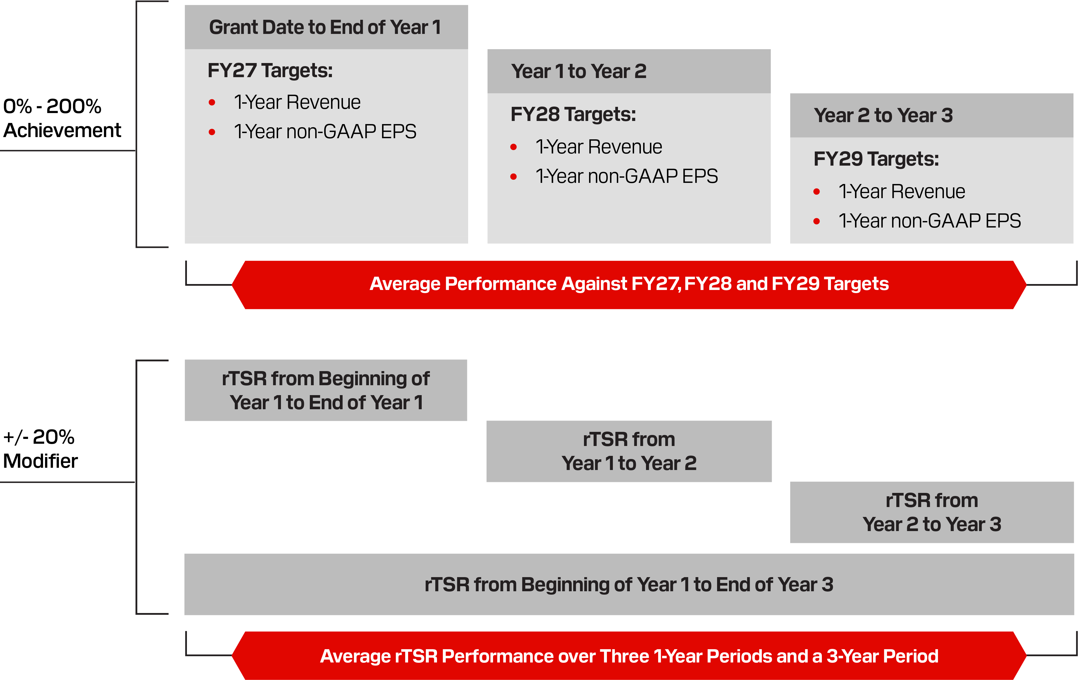
Fiscal 2027 LTI Awards
The Compensation and Talent Committee granted the following LTI awards to our named executive officers in fiscal 2027, as part of our annual LTI program:
Named Executive Officer |  |  | Total LTI Target  Grant Value  ($)
David V. Goeckeler |  |  | 20,150,000
Luis F. Visoso |  |  | 10,000,000
Alper Ilkbahar |  |  | 5,500,000
Bernard Shek |  |  | 3,400,000

PG. 054 |  |  | 2026 PROXY STATEMENT
Other Program Features and Policies
Perquisites
We provide our executive officers with only limited perquisites and other personal benefits, consisting principally of a $5,000 annual allowance for financial planning services (net of taxes).
Security-Related Perquisites
In fiscal 2026, the Compensation and Talent Committee authorized a general "security program" for Mr. Goeckeler to address safety concerns arising directly as a result of his position as our CEO and in view of the company’s high visibility. We require these security measures for the company's benefit because of the importance of Mr. Goeckeler to the company and to address specific threats and safety concerns, and we believe that the scope and costs of this security program are appropriate and necessary.
In determining whether to authorize this security program, the Compensation and Talent Committee evaluated the need to respond to specific incidents and threats and reviewed a security assessment and recommendations from a leading, independent, third-party security firm.
Under Mr. Goeckeler’s security program and as recommended by the security assessment, the Compensation and Talent Committee authorized payment for costs related to personal security arrangements for Mr. Goeckeler, including the costs of security personnel and residential security measures. The committee believes these costs are appropriate and necessary in light of the security recommendations and has established a policy to evaluate this security program at least annually, including a review of periodic security assessments of safety threats and recommendations for the security program, and to assess its continued business rationale, appropriate scope, and alignment with market practice.
As part of the security program and as recommended by the assessment, Mr. Goeckeler is also required to use private aircraft for all business and personal travel where feasible. As a result, the Compensation and Talent Committee has authorized payment of travel-related expenses incurred by Mr. Goeckeler pursuant to a written travel policy overseen by the committee. On certain occasions, Mr. Goeckeler may also be accompanied by guests when using private aircraft for personal travel at de minimis incremental cost to the company. Mr. Goeckeler recognizes imputed taxable income and is not provided with a tax reimbursement for personal use of the private aircraft.
Although we do not consider Mr. Goeckeler’s security program to be a perquisite for his benefit for the reasons described above, pursuant to SEC guidance, the costs related to certain personal security arrangements that are part of his security program are reported in the "All Other Compensation" column of the "Fiscal 2026 Summary Compensation Table" below. The costs of Mr. Goeckeler’s security program vary from year to year depending on requisite security measures, his travel schedule, and other factors. The Compensation and Talent Committee believes that these costs are appropriate and necessary considering the threat landscape Mr. Goeckeler faces.
401(k) Plan Benefits
Our executive officers are eligible to participate in our 401(k) Plan. Eligible employees may contribute up to 85% of their annual cash compensation up to a maximum amount allowed by the Internal Revenue Code, and are also eligible for any matching contributions. Our executive officers participate in our 401(k) Plan on substantially the same terms as our other participating employees. We do not maintain any defined benefit or supplemental retirement plans for our executive officers.
Deferred Compensation Opportunities
Our executive officers who are subject to U.S. federal income taxes are eligible to participate in our Deferred Compensation Plan. Under the plan, participants can elect to defer certain compensation without regard to the tax code limitations applicable to tax-qualified plans.
Severance Protections
Our executive officers are eligible to participate in our Executive Severance Plan. Outside a change in control context, we view severance protections as only appropriate in the event the employment of an executive officer is involuntarily terminated without “cause.”
Change in Control Protections
To encourage our executive officers to remain employed during an important time when their prospects for continued employment following a change in control transaction are often uncertain, we provide our executive officers with additional severance protections under our change in control severance plan (the “Sandisk CIC Severance Plan”). Benefits under the Sandisk CIC Severance Plan require a “double-trigger” (a qualifying termination in connection with a change in control) for payment and the plan does not provide any tax gross-up payments for participants.
Clawback Policy
The Board of Directors adopted a compensation recovery (“clawback”) policy consistent with the requirements of Rule 10D-1 under the Exchange Act and Nasdaq Listing Standards, a copy of which is publicly filed with our 2026 Annual Report on Form 10-K.
Misconduct Policies
We maintain several policies relating to employee misconduct. In the event an executive officer’s employment is terminated for cause due to their misconduct or violation of company policy, among other reasons, they forfeit all outstanding incentives, including unearned or unvested LTI and STI awards. In addition, the executive officer would not be eligible for severance payments or benefits.

 |  |  | EXECUTIVE COMPENSATION |  |  | PG. 055
Policies Prohibiting Hedging, Pledging and Short Sale or Derivative Transaction
Our insider trading policy prohibits our executive officers (as well as our other employees and members of our Board of Directors) from engaging in hedging transactions or speculative transactions involving Sandisk’s securities and from pledging company securities. Prohibited transactions include hedging or monetization transactions, such as prepaid variable forwards, equity swaps, collars, and exchange funds, that are designed to hedge or offset any decrease in the market value of Sandisk’s securities, short sales, transactions in derivative securities, such as publicly traded options, related to Sandisk’s securities, and margining Sandisk’s securities in a margin account or otherwise pledging Sandisk securities as collateral for a loan.
Executive Stock Ownership Guidelines
We maintain executive stock ownership guidelines covering our executive officers, including our named executive officers, to help link the interests of our stockholders with those of our executive officers. The guidelines provide that each executive officer must achieve ownership of a number of “qualifying shares” with a market value equal to the multiple of the officer’s base salary in effect upon the date he or she first becomes subject to the guidelines, as shown below.
Position |  |  | Multiple
CEO |  |  | 6 x Salary
CFO |  |  | 3 x Salary
Executive Vice Presidents |  |  | 2 x Salary
Senior Vice Presidents |  |  | 1 x Salary
Each executive officer must achieve ownership of the required market value of shares within five years of becoming subject to the guidelines. In fiscal 2026, the Compensation and Talent Committee updated the guidelines to extend the compliance period (previously three years) and to exclude outstanding PSUs from the ownership calculation. Common stock (including common stock beneficially owned by the executive officer) and RSUs count towards the requirement.
Equity Grant Timing
Annual equity awards are generally made in late August or early September each year and the Compensation and Talent Committee may also consider and approve interim or mid-year grants from time to time based on business needs. We do not currently grant stock options to our employees. The committee does not take material non-public information into account when determining the timing and terms of LTI awards and has not timed the disclosure of material non-public information for the purpose of affecting the value of executive compensation.

PG. 056 |  |  | 2026 PROXY STATEMENT
Executive Compensation Tables and Narratives

Fiscal 2026 Summary Compensation Table
The following table presents information regarding compensation earned for fiscal 2026 by our named executive officers.
Name and Principal  Position |  |  | Fiscal  Year |  |  | Salary  ($)(1) |  |  | Bonus  ($)(2) |  |  |  |  |  | Stock  Awards  ($)(3) |  |  | Non-Equity  Incentive Plan  Compensation  ($)(4) |  |  | All Other  Compensation  ($)(5) |  |  | Total  ($)
David V. Goeckeler  Chief Executive Officer |  |  | 2026 |  |  | 1,350,000 |  |  | — |  |  |  |  |  | 9,014,351 |  |  | 4,725,000 |  |  | 91,810 |  |  | 15,181,160
 |  |  | 2025 |  |  | 450,000 |  |  | 2,600,000 |  |  |  |  |  | 18,845,786 |  |  | 1,023,750 |  |  | — |  |  | 22,919,536
Luis F. Visoso  Executive Vice President  and Chief Financial Officer |  |  | 2026 |  |  | 856,731 |  |  | — |  |  |  |  |  | 4,992,535 |  |  | 2,570,193 |  |  | 10,950 |  |  | 8,430,409
 |  |  | 2025 |  |  | 285,577 |  |  | — |  |  |  |  |  | 7,067,118 |  |  | 584,719 |  |  | 6,542 |  |  | 7,943,956
Alper Ilkbahar  Executive Vice President  and Chief Technology Officer |  |  | 2026 |  |  | 649,038 |  |  | — |  |  |  |  |  | 1,849,095 |  |  | 1,298,076 |  |  | 11,442 |  |  | 3,807,651
 |  |  | 2025 |  |  | 213,462 |  |  | 862,500 |  |  |  |  |  | 2,944,652 |  |  | 298,904 |  |  | 6,404 |  |  | 4,325,921
Bernard Shek  Chief Legal Officer  and Secretary |  |  | 2026 |  |  | 510,865 |  |  | — |  |  |  |  |  | 1,294,398 |  |  | 817,384 |  |  | 7,816 |  |  | 2,630,464
 |  |  | 2025 |  |  | 144,231 |  |  | 682,500 |  |  | (6) |  |  | 1,168,034 |  |  | 152,654 |  |  | 3,606 |  |  | 2,151,025
(1)Salaries in fiscal 2026 reflect salary paid over 27 payroll periods. Salaries in fiscal 2025 reflect salary paid from the date of the separation from WDC (February 21, 2025) through the end of fiscal 2025.
(2)Amounts in fiscal 2025 reflect Transaction Completion Awards to certain named executive officers, as approved and funded by WDC. Please see our 2025 proxy statement for further information about the Transaction Completion Awards.
(3)The amounts shown reflect the aggregate grant date fair value of stock awards granted in the applicable fiscal year computed in accordance with ASC Topic 718. These amounts were calculated based on the assumptions described in Note 12 in the Notes to Consolidated Financial Statements included in our 2026 Annual Report on Form 10-K. For PSU awards, amounts reflect the grant date fair value of the 2026-2028 PSU awards as related to fiscal 2026 performance period because only the annual targets for this performance period were established in fiscal 2026, and thus, only such portion of the award is deemed granted for financial accounting purposes during fiscal 2026. The grant date value of the remaining portion of the 2026-2028 PSU awards will be reflected in the Summary Compensation Table in future fiscal years, corresponding to when the associated annual targets are established and such portions of the award are deemed granted for financial accounting purposes.
The following amounts represent the grant date fair value of PSU awards granted to our named executive officers during fiscal 2026. We considered the probable outcome of the awards and assumed maximum performance under the awards for fiscal 2026 based on a Monte Carlo simulation. The dollar value of the awards included in the Summary Compensation Table for the year of grant is based on the probable outcome of the awards on the grant date and does not reflect actual payouts.
 |  |  | Grant Date Fair Value of  PSU Awards at Maximum  Performance for: |  |  | Grant Date Fair Value of  PSU Awards Based on  Probable Outcome on the  Grant Date for: |  |  | Grant Date Fair Value of  PSU Awards at Maximum  Performance for:
Named Executive Officer |  |  | 2025 |  |  | 2026  ($) (2026-2028 PSUs)
David V. Goeckeler |  |  | 56,537,357 |  |  | 4,507,175 |  |  | 9,014,351
Luis F. Visoso |  |  | 21,201,353 |  |  | 2,496,294 |  |  | 4,992,588
Alper Ilkbahar |  |  | 8,833,956 |  |  | 462,300 |  |  | 924,600
Bernard Shek |  |  | 3,504,102 |  |  | 323,626 |  |  | 647,252
(4)Reflects each named executive officer’s STI payout for the corresponding fiscal year. For fiscal 2026, represents 27 payroll periods. For 2025, it represents the STI payout for the second half of fiscal 2025, post-separation from WDC.

 |  |  | EXECUTIVE COMPENSATION |  |  | PG. 057
(5)The table below summarizes the amounts reported in the “All Other Compensation” column for each of our named executive officers for fiscal 2026:
Name |  |  | Perquisites  ($) |  |  | 401(k) Plan  Company  Matching  Contributions  ($)
David V. Goeckeler |  |  | 80,860(a) |  |  | 10,950
Luis F. Visoso |  |  | — |  |  | 10,950
Alper Ilkbahar |  |  | — |  |  | 11,442
Bernard Shek |  |  | — |  |  | 7,816
(a)The amount shown reflects $45,860 for personal security. Due to Mr. Goeckeler’s public profile, the company provides him with security protection in accordance with the findings of a security assessment study. In fiscal 2026, Mr. Goeckeler’s security arrangements included personal travel on the company’s private aircraft in the amount of $31,996, which represents the incremental cost to the company for Mr. Goeckeler’s personal use, including his guest, of private aircraft based on hourly flight charges and other variable costs incurred by the company for such use, including variable fuel charges and other fees, and the value of personal use of the company’s secure vehicle in the amount of $13,864. We believe these arrangements and costs are reasonable, appropriate, necessary, and in the best interests of the company and its stockholders, as they mitigate risks to our business. We do not consider these additional security arrangements to be a personal benefit to Mr. Goeckeler because they arise from the nature of his employment responsibilities. This amount also reflects fees paid by the company on Mr. Goeckeler’s behalf for a Hart-Scott-Rodino filing in the amount of $35,000.
(6)WDC granted a cash bonus to Mr. Shek of $200,000 in connection with the separation from WDC. For more information about such bonus, see our 2025 proxy statement.

Fiscal 2026 Grants of Plan-Based Awards Table
The following table presents information regarding all grants of plan-based awards made to our named executive officers during fiscal 2026.
 |  |  |  |  |  |  |  |  |  |  |  |  |  |  |  |  |  |  |  |  |  |  |  |  |  |  |  |  |  |  |  |  | All Other  Stock  Awards:  Number of  Shares of  Stock or  Units  (#) |  |  | Grant  Date Fair  Value of  Stock and  Option  Awards  ($)(1)
 |  |  |  |  |  |  |  |  | Estimated Possible Payouts  Under Non-Equity Incentive  Plan Awards |  |  |  |  |  |  |  |  |  |  |  | Estimated Future Payouts  Under Equity Incentive  Plan Awards
Name |  |  | Award  Type |  |  | Grant  Date |  |  | Threshold  ($) |  |  | Target  ($) |  |  | Maximum  ($) |  |  |  |  |  | Threshold  (#) |  |  | Target  (#) |  |  | Maximum  (#)
David V.  Goeckeler |  |  | 2026 STI |  |  |  |  |  | 826,875 |  |  | 2,362,500 |  |  | 4,725,000 |  |  |  |  |  | — |  |  | — |  |  | — |  |  |  |  |  | — |  |  | —
 |  |  | 2026-2028 PSUs(2) |  |  | 9/3/25 |  |  | — |  |  | — |  |  | — |  |  |  |  |  | 42,513 |  |  | 85,025 |  |  | 170,050 |  |  |  |  |  | — |  |  | 4,507,175
 |  |  | RSUs(3) |  |  | 9/3/25 |  |  | — |  |  | — |  |  | — |  |  |  |  |  | — |  |  | — |  |  | — |  |  |  |  |  | 85,025 |  |  | 4,507,175
Luis F.  Visoso |  |  | 2026 STI |  |  |  |  |  | 449,784 |  |  | 1,285,097 |  |  | 2,570,193 |  |  |  |  |  | — |  |  | — |  |  | — |  |  |  |  |  | — |  |  | —
 |  |  | 2026-2028 PSUs(2) |  |  | 9/3/25 |  |  | — |  |  | — |  |  | — |  |  |  |  |  | 23,546 |  |  | 47,091 |  |  | 94,182 |  |  |  |  |  | — |  |  | 2,496,294
 |  |  | RSUs(3) |  |  | 9/3/25 |  |  | — |  |  | — |  |  | — |  |  |  |  |  | — |  |  | — |  |  | — |  |  |  |  |  | 47,090 |  |  | 2,496,241
Alper  Ilkbahar |  |  | 2026 STI |  |  |  |  |  | 227,163 |  |  | 649,038 |  |  | 1,298,076 |  |  |  |  |  | — |  |  | — |  |  | — |  |  |  |  |  | — |  |  | —
 |  |  | 2026-2028 PSUs(2) |  |  | 9/3/25 |  |  | — |  |  | — |  |  | — |  |  |  |  |  | 4,361 |  |  | 8,721 |  |  | 17,442 |  |  |  |  |  | — |  |  | 462,300
 |  |  | RSUs(3) |  |  | 9/3/25 |  |  | — |  |  | — |  |  | — |  |  |  |  |  | — |  |  | — |  |  | — |  |  |  |  |  | 26,161 |  |  | 1,386,795
Bernard  Shek |  |  | 2026 STI |  |  |  |  |  | 143,042 |  |  | 408,692 |  |  | 817,384 |  |  |  |  |  | — |  |  | — |  |  | — |  |  |  |  |  | — |  |  | —
 |  |  | 2026-2028 PSUs(2) |  |  | 9/3/25 |  |  | — |  |  | — |  |  | — |  |  |  |  |  | 3,053 |  |  | 6,105 |  |  | 12,210 |  |  |  |  |  | — |  |  | 323,626
 |  |  | RSUs(3) |  |  | 9/3/25 |  |  | — |  |  | — |  |  | — |  |  |  |  |  | — |  |  | — |  |  | — |  |  |  |  |  | 18,313 |  |  | 970,772
(1)The amounts shown reflect the grant date fair value of the award computed in accordance with ASC 718. These amounts were calculated based on the assumptions described in Note 12 in the Notes to Consolidated Financial Statements included in our 2026 Annual Report on Form 10-K. The grant date fair value for the PSU awards, at the probable outcome, is based on the value of our common stock on September 3, 2025 using a Monte Carlo simulation, which resulted in a simulated award value of $53.01 per share based on certain assumptions.
(2)Represents the fiscal 2026 annual performance period portion of the LTI PSU award granted to the named executive officer for the three-year performance period covering fiscal 2026 through 2028, subject to cliff vesting on September 3, 2028, based on our achievement of specified revenue and non-GAAP EPS performance goals that correspond to specific payout percentages ranging between 0% and 200% of the target number of stock units subject to the award. Under financial accounting rules, an award is not deemed granted and the grant date fair value for a PSU award is not determined until the fiscal year in which the performance metrics are established. The performance metrics are annually determined by the Compensation and Talent Committee for each of fiscal years 2026, 2027 and 2028. Accordingly, only the grant date fair value for the portion attributable to fiscal 2026 annual targets is reflected.
(3)Represents an annual LTI RSU award granted to the named executive officer, which is scheduled to vest with respect to 25% on the first anniversary of the grant date and 6.25% quarterly thereafter for three years.

PG. 058 |  |  | 2026 PROXY STATEMENT
Description of Compensation Arrangements for Named Executive Officers
Non-Equity Incentive Plan Compensation and Awards
Our named executive officers are eligible to receive cash incentive awards on an annual basis under the STI plan. See the section entitled “Executive Compensation—Compensation Discussion and Analysis” for a more detailed description of the STI plan.
Equity-Based Awards
Each RSU and PSU award reported in the “Fiscal 2026 Grants of Plan-Based Awards Table” was granted by the Compensation and Talent Committee under, and is subject to, the terms of our 2025 Long-Term Incentive Plan.
Our named executive officers are not entitled to voting rights with respect to their stock units (PSUs and RSUs). However, if we pay an ordinary cash dividend on our outstanding shares of common stock, the named executive officer will have the right to receive a dividend equivalent with respect to any unpaid stock unit (whether vested or not) held as of the record date for the dividend payment, which will not be payable until the award vests.
Additional information regarding the vesting acceleration provisions applicable to equity awards granted to our named executive officers is included in the section entitled “Potential Payments upon Termination or Change in Control” below.

Outstanding Equity Awards at Fiscal 2026 Year-End Table
The following table presents information regarding the current holdings of stock options and stock awards (and corresponding dividend equivalents) held by each of our named executive officers as of July 3, 2026. The amount shown for the market value of the stock awards is based on the closing price of our common stock on July 3, 2026 ($1,745).
 |  |  |  |  |  |  |  |  |  |  |  | Stock Awards
Name |  |  | Grant  Date |  |  |  |  |  |  |  |  | Number of  Shares or Units of  Stock That Have  Not Vested  (#) |  |  |  |  |  | Market Value of  Shares or Units of  Stock That Have  Not Vested  ($) |  |  | Equity Incentive  Plan Awards:  Number of Unearned  Shares, Units or Other  Rights That Have  Not Vested  (#) |  |  |  |  |  | Equity Incentive  Plan Awards:  Market or Payout  Value of Unearned  Shares, Units or Other  Rights That Have  Not Vested  ($)
David V. Goeckeler |  |  | 2/21/2025 |  |  | (1) |  |  |  |  |  | 18,741 |  |  | (2) |  |  | 32,703,045 |  |  | — |  |  |  |  |  | —
 |  |  |  |  |  |  |  |  |  |  |  | 15,827 |  |  | (3) |  |  | 27,618,115 |  |  | — |  |  |  |  |  | —
 |  |  |  |  |  |  |  |  |  |  |  | 2,622 |  |  | (4) |  |  | 4,575,390 |  |  | — |  |  |  |  |  | —
 |  |  |  |  |  |  |  |  |  |  |  | 97,238 |  |  | (5) |  |  | 169,680,310 |  |  | — |  |  |  |  |  | —
 |  |  |  |  |  |  |  |  |  |  |  | 49,976 |  |  | (6) |  |  | 87,208,120 |  |  | — |  |  |  |  |  | —
 |  |  | 5/9/2025 |  |  |  |  |  |  |  |  | — |  |  |  |  |  | — |  |  | 953,895 |  |  | (7) |  |  | 1,664,546,775
 |  |  | 9/3/2025 |  |  |  |  |  |  |  |  | 85,025 |  |  | (8) |  |  | 148,368,625 |  |  | 340,100 |  |  | (9) |  |  | 593,474,500
Luis F. Visoso |  |  | 2/21/2025 |  |  | (1) |  |  |  |  |  | 28,833 |  |  | (2) |  |  | 50,313,585 |  |  | — |  |  |  |  |  | —
 |  |  |  |  |  |  |  |  |  |  |  | 51,744 |  |  | (10) |  |  | 90,293,280 |  |  | — |  |  |  |  |  | —
 |  |  | 5/9/2025 |  |  |  |  |  |  |  |  | — |  |  |  |  |  | — |  |  | 357,708 |  |  | (7) |  |  | 624,200,460
 |  |  | 9/3/2025 |  |  |  |  |  |  |  |  | 47,090 |  |  | (8) |  |  | 82,172,050 |  |  | 188,363 |  |  | (9) |  |  | 328,693,435
Alper Ilkbahar |  |  | 2/21/2025 |  |  | (1) |  |  |  |  |  | 5,801 |  |  | (2) |  |  | 10,122,745 |  |  | — |  |  |  |  |  | —
 |  |  |  |  |  |  |  |  |  |  |  | 6,593 |  |  | (3) |  |  | 11,504,785 |  |  | — |  |  |  |  |  | —
 |  |  |  |  |  |  |  |  |  |  |  | 327 |  |  | (11) |  |  | 570,615 |  |  | — |  |  |  |  |  | —
 |  |  | 5/9/2025 |  |  |  |  |  |  |  |  | — |  |  |  |  |  | — |  |  | 149,046 |  |  | (7) |  |  | 260,085,270
 |  |  | 9/3/2025 |  |  |  |  |  |  |  |  | 26,161 |  |  | (8) |  |  | 45,650,945 |  |  | 34,882 |  |  | (9) |  |  | 60,869,090
Bernard Shek |  |  | 2/21/2025 |  |  | (1) |  |  |  |  |  | 1,946 |  |  | (2) |  |  | 3,395,770 |  |  | — |  |  |  |  |  | —
 |  |  |  |  |  |  |  |  |  |  |  | 2,130 |  |  | (3) |  |  | 3,716,850 |  |  | — |  |  |  |  |  | —
 |  |  |  |  |  |  |  |  |  |  |  | 648 |  |  | (12) |  |  | 1,130,760 |  |  | — |  |  |  |  |  | —
 |  |  |  |  |  |  |  |  |  |  |  | 710 |  |  | (13) |  |  | 1,238,950 |  |  | — |  |  |  |  |  | —
 |  |  |  |  |  |  |  |  |  |  |  | 222 |  |  | (11) |  |  | 387,390 |  |  | — |  |  |  |  |  | —
 |  |  | 5/9/2025 |  |  |  |  |  |  |  |  | — |  |  |  |  |  | — |  |  | 59,121 |  |  | (7) |  |  | 103,166,145
 |  |  | 9/3/2025 |  |  |  |  |  |  |  |  | 18,313 |  |  | (8) |  |  | 31,956,185 |  |  | 24,418 |  |  | (9) |  |  | 42,609,410

 |  |  | EXECUTIVE COMPENSATION |  |  | PG. 059
(1)These are Sandisk awards that were received in connection with the separation from WDC from the conversion of WDC awards using the Basket Approach.
(2)This RSU award is scheduled to vest as to 25% of the underlying shares on the first anniversary of the original WDC grant date (the “WDC Grant Date”) of August 21, 2024, and as to an additional 6.25% of the underlying shares at the end of each three-month period thereafter until the award is fully vested on the fourth anniversary of the WDC Grant Date.
(3)This RSU award is scheduled to vest as to 25% of the underlying shares on the first anniversary of the WDC Grant Date of August 25, 2023, and as to an additional 6.25% of the underlying shares at the end of each three-month period thereafter until the award is fully vested on the fourth anniversary of the WDC Grant Date.
(4)This RSU award is scheduled to vest as to 25% of the underlying shares on the first anniversary of the WDC Grant Date of August 25, 2022, and as to an additional 6.25% of the underlying shares at the end of each three-month period thereafter until the award is fully vested on the fourth anniversary of the WDC Grant Date.
(5)Reflects a WDC PSU award that was converted to a time-based Sandisk RSU in connection with the separation from WDC and is no longer subject to performance-based vesting conditions. This award vested on August 25, 2026.
(6)Reflects a WDC PSU award that was converted to a time-based Sandisk RSU in connection with the separation from WDC and is no longer subject to performance-based vesting conditions. This award is scheduled to vest on August 21, 2027.
(7)This PSU award is scheduled to vest on February 24, 2028 based on achievement of stock price goals, as determined by the Compensation and Talent Committee, set for the performance period beginning on March 3, 2025 and ending on February 24, 2028. The awards will be payable in shares of our common stock on the vesting date based on our achievement of the specified stock price goals that correspond to specific payment percentages ranging between 0% and 300% of the target number of stock units subject to the awards. The numbers above reflect payment at maximum level, which is 300% of the target number of stock units of the full award, as the award achieved maximum performance in fiscal 2026.
(8)This RSU award is scheduled to vest as to 25% of the underlying shares on the first anniversary of the grant date, and as to an additional 6.25% of the underlying shares at the end of each three-month period thereafter until the award is fully vested on the fourth anniversary of the grant date.
(9)This PSU award is scheduled to vest on September 3, 2028 based on achievement of revenue and non-GAAP EPS annual targets set for the three-year performance period covering fiscal 2026 through 2028. The awards will be payable in shares of our common stock on the vesting date based on the achievement of the specified goals that correspond to specific payment percentages ranging between 0% and 200% of the target number of stock units subject to the awards. Although the fiscal 2027 and 2028 performance targets were not set during or prior to fiscal 2026 (and thus such portion was not yet deemed granted as of the end of fiscal 2026), the stock units relating to such portions have been included. The numbers above reflect payment at maximum level for the fiscal 2026 tranche, which is 200% of the target number of stock units of the full award, based on the achievement of fiscal 2026 targets. Because the performance metrics for fiscal 2027 and 2028 were not set as of the end of fiscal 2026, the numbers above reflect target performance for the fiscal 2027 and 2028 tranches.
(10)This RSU award is scheduled to vest as to 50% of the underlying shares on the first and second anniversaries of the WDC Grant Date of August 20, 2024.
(11)This RSU award is scheduled to vest as to 25% of the underlying shares on the first anniversary of the WDC Grant Date of August 20, 2022, and as to an additional 6.25% of the underlying shares at the end of each three-month period thereafter until the award is fully vested on the fourth anniversary of the WDC Grant Date.
(12)This RSU award is scheduled to vest as to 33.33% of the underlying shares on each of the first, second, and third anniversaries of the WDC Grant Date of October 20, 2023.
(13)This RSU award is scheduled to vest as to 25% of the underlying shares on the first anniversary of the WDC Grant Date of March 20, 2023, and as to an additional 6.25% of the underlying shares at the end of each three-month period thereafter until the award is fully vested on the fourth anniversary of the WDC Grant Date.

Fiscal 2026 Option Exercises and Stock Vested Table
The following table presents information regarding the amount realized upon the exercise of stock options and the vesting of stock unit awards for our named executive officers during fiscal 2026. There were no stock option award exercises in fiscal 2026.
 |  |  | Stock Awards
Name |  |  | Number of Shares  Acquired on Vesting  (#) |  |  |  |  |  | Value Realized  on Vesting  ($)(1)
David V. Goeckeler |  |  | 107,668 |  |  |  |  |  | 21,987,655
Luis F. Visoso |  |  | 74,168 |  |  |  |  |  | 10,545,282
Alper Ilkbahar |  |  | 17,528 |  |  |  |  |  | 9,776,307
Bernard Shek |  |  | 6,191 |  |  |  |  |  | 3,074,479
(1)The value realized on the vesting of stock awards is based on the closing price of our common stock on the applicable vesting date of the awards.

PG. 060 |  |  | 2026 PROXY STATEMENT
Potential Payments upon Termination or Change in Control
Change in Control—Termination without Cause or For Good Reason
Our named executive officers may be entitled to severance benefits under the Sandisk CIC Severance Plan. Generally, the severance benefits are payable if we terminate the named executive officer’s employment without “cause” or the named executive officer voluntarily terminates employment for “good reason” within 12 months after a change in control.
For these purposes:
•“Change in control” generally means an acquisition by any person or group of more than one-third of our stock, certain majority changes in our Board of Directors over a period of not more than two years, mergers and similar transactions that result in a 50% or greater change in our ownership, and certain liquidations and dissolutions of our company
•“Cause” generally means the commission of certain crimes by the executive officer, the executive officer’s willful engagement in fraud or dishonest conduct, refusal or failure to perform certain duties, breach of fiduciary duty, or breach of certain other violations of company policy
•“Good reason” generally means a material diminution in the executive officer’s authority, duties or responsibilities, a material diminution in the executive officer’s base compensation, certain relocations of the executive’s employment, or a material breach by us (or our successor) with respect to our obligations under the Sandisk CIC Severance Plan
For each of our named executive officers, the severance benefits generally consist of the following as a “Tier 1” participant:
•A lump sum payment equal to two times the sum of the executive officer’s annual base compensation plus the target STI as in effect immediately prior to the change in control or as in effect on the date of notice of termination of the executive officer’s employment with us, whichever is higher, plus any earned but not yet paid STI payments in respect of completed performance periods
•100% vesting of any unvested outstanding equity awards granted to the executive officer by us, with any performance-based equity awards as to which the applicable performance period has not ended becoming vested at the target level (or, if more favorable, as otherwise provided in the agreement providing for a change in control)
•A lump sum payment equal to the applicable COBRA premium payments for a period of 24 months following the executive officer’s termination
Involuntary Termination without Cause—No Change in Control
Our Executive Severance Plan, in conjunction with the terms and conditions of our equity awards, provides the following severance benefits to our named executive officers as Tier 1 participants in the event their employment is terminated without “cause” (generally as defined above).
•A lump sum cash payment of the executive officer’s monthly base salary multiplied by 24 months
•Any earned but not yet paid STI payments in respect of completed performance periods and a pro rata STI payment based on the number of days in the applicable performance period during which the executive officer was employed, assuming target performance
•For PSU awards, a prorated portion of the PSUs subject to the award will remain outstanding and vest, if at all, based on actual achievement of the performance goals over the entire performance period
•For RSU awards, acceleration of vesting of a prorated amount of RSUs
•Outplacement services at our expense for 12 months following the executive officer’s termination of employment
•A lump sum payment equal to the applicable COBRA premium payments for a period of 18 months following the executive officer’s termination
Payment of severance benefits under the Sandisk CIC Severance Plan and Executive Severance Plan is conditioned upon the executive officer’s execution of a valid and effective release of claims. In addition, no executive officer is entitled to a duplication of benefits under our Executive Severance Plan and any other severance plan, including the Sandisk CIC Severance Plan.
Qualified Retirement
To be eligible for retirement, the executive officer must have five years of credited service with us and must also be at least age 55 at the time of retirement and his or her age plus total years of credited service must be at least 70.
In the event of a qualified retirement, a pro rata portion of the PSUs will remain outstanding and eligible to vest based on actual achievement of the performance goals over the performance period.
No RSUs contain an acceleration benefit for an eligible retirement.
Death
In the event of an executive officer’s death, 50% of the outstanding RSUs will accelerate.
For RSUs and PSUs assumed from WDC in connection with the separation from WDC: (1) the vesting of a pro rata portion of WDC RSUs granted prior to its fiscal 2025 grant and a pro rata portion of WDC PSUs will accelerate; and (2) 50% of the outstanding RSUs will accelerate upon an executive officer’s death for WDC fiscal 2025 grants.
The executive officer would also be eligible for a pro rata STI payout based on the number of days in the applicable performance period during which the executive officer was employed, subject to actual corporate performance and no individual modification.
Termination for Cause/Misconduct
In the event an executive officer’s employment is terminated for cause due to, among other reasons, the executive officer’s misconduct or violation of company policy, the executive officer will forfeit all outstanding incentives, including unearned or unvested LTI and STI awards. In addition, the executive officer would not be eligible for severance benefits.

 |  |  | EXECUTIVE COMPENSATION |  |  | PG. 061
Calculation of Potential Payments upon Termination or Change in Control
The table below presents our estimate of the benefits payable to Messrs. Goeckeler, Visoso, Ilkbahar, and Shek under the arrangements described above based on the following assumptions:
•Qualifying termination of employment and/or change in control occurred on July 3, 2026
•The price per share of our common stock is equal to the closing price of our common stock on July 3, 2026 ($1,745), the last trading day in fiscal 2026
•In the case of a change in control, our company does not survive the change in control, and all outstanding incentive awards are cashed out and terminated in the transaction
•Not included in the table below are payments each named executive officer earned or accrued prior to termination, such as previously vested equity and non-equity incentive awards, which are more fully described and quantified in the tables and narratives above
Name |  |  | Compensation Element |  |  | Change in  Control-No  Termination  (Awards Not  Assumed)  ($)(1) |  |  | Change in  Control-With  Termination  Without  Cause or For  Good Reason  ($) |  |  | Involuntary  Termination  Without  Cause-No  Change in  Control  ($)(2) |  |  | Qualified  Retirement  ($)(3) |  |  | Death  ($)(2)
David V. Goeckeler |  |  | Cash Severance |  |  | — |  |  | 7,150,000 |  |  | 4,875,000 |  |  | — |  |  | —
 |  |  | RSU Acceleration(4) |  |  | 213,265,175 |  |  | 213,265,175 |  |  | 37,044,605 |  |  | — |  |  | 95,046,660
 |  |  | PSU Acceleration(5) |  |  | 2,514,909,705 |  |  | 2,514,909,705 |  |  | 1,174,364,060 |  |  | 1,174,364,060 |  |  | 1,174,364,060
 |  |  | Continuation of Benefits(6) |  |  | — |  |  | 54,671 |  |  | 36,687 |  |  | — |  |  | —
 |  |  | Value of Outplacement Services |  |  | — |  |  | — |  |  | 3,200 |  |  | — |  |  | —
 |  |  | TOTAL |  |  | 2,728,174,880 |  |  | 2,735,379,551 |  |  | 1,216,323,552 |  |  | 1,174,364,060 |  |  | 1,269,410,720
Luis F. Visoso |  |  | Cash Severance |  |  | — |  |  | 4,125,000 |  |  | 2,887,500 |  |  | — |  |  | —
 |  |  | RSU Acceleration(4) |  |  | 222,778,915 |  |  | 222,778,915 |  |  | 98,110,880 |  |  | — |  |  | 144,677,078
 |  |  | PSU Acceleration(5) |  |  | 952,893,895 |  |  | 952,893,895 |  |  | 390,670,600 |  |  | — |  |  | 390,670,600
 |  |  | Continuation of Benefits(6) |  |  | — |  |  | 46,317 |  |  | 31,081 |  |  | — |  |  | —
 |  |  | Value of Outplacement Services |  |  | — |  |  | — |  |  | 3,200 |  |  | — |  |  | —
 |  |  | TOTAL |  |  | 1,175,672,810 |  |  | 1,179,844,127 |  |  | 491,703,261 |  |  | — |  |  | 535,347,678
Alper Ilkbahar |  |  | Cash Severance |  |  | — |  |  | 2,500,000 |  |  | 1,875,000 |  |  | — |  |  | —
 |  |  | RSU Acceleration(4) |  |  | 67,849,090 |  |  | 67,849,090 |  |  | 11,258,740 |  |  | — |  |  | 29,134,520
 |  |  | PSU Acceleration(5) |  |  | 320,954,360 |  |  | 320,954,360 |  |  | 137,094,180 |  |  | 137,094,180 |  |  | 137,094,180
 |  |  | Continuation of Benefits(6) |  |  | — |  |  | 89,651 |  |  | 60,160 |  |  | — |  |  | —
 |  |  | Value of Outplacement Services |  |  | — |  |  | — |  |  | 3,200 |  |  | — |  |  | —
 |  |  | TOTAL |  |  | 388,803,450 |  |  | 391,393,101 |  |  | 150,291,280 |  |  | 137,094,180 |  |  | 166,228,700
Bernard Shek |  |  | Cash Severance |  |  | — |  |  | 1,800,000 |  |  | 1,400,000 |  |  | — |  |  | —
 |  |  | RSU Acceleration(4) |  |  | 41,825,905 |  |  | 41,825,905 |  |  | 8,168,345 |  |  | — |  |  | 19,028,353
 |  |  | PSU Acceleration(5) |  |  | 145,775,555 |  |  | 145,775,555 |  |  | 60,610,830 |  |  | — |  |  | 60,610,830
 |  |  | Continuation of Benefits(6) |  |  | — |  |  | 79,017 |  |  | 53,025 |  |  | — |  |  | —
 |  |  | Value of Outplacement Services |  |  | — |  |  | — |  |  | 3,200 |  |  | — |  |  | —
 |  |  | TOTAL |  |  | 187,601,460 |  |  | 189,480,477 |  |  | 70,235,400 |  |  | — |  |  | 79,639,183
(1)None of our named executive officers’ equity awards will automatically vest because a change in control event occurs. The amounts shown represent the estimated value of the acceleration of outstanding equity incentive compensation under our incentive compensation plans in connection with a change in control (regardless of whether a termination of employment also occurs) assuming that the awards were to be terminated in connection with the change in control and the Compensation and Talent Committee had not provided for the assumption, substitution, or other continuation of the awards.
(2)For the PSU awards, where applicable, the amounts are prorated and assume achievement at 100% of the target level of performance for the performance period or, if applicable, the credited amount.
(3)As of July 3, 2026, Messrs. Goeckeler and Ilkbahar met the requirements for a “qualified retiree” with respect to PSUs.
(4)The amounts shown are based on the intrinsic value of the portion of the RSU award that would have accelerated as of July 3, 2026. These intrinsic values were based on the closing price of our common stock on July 3, 2026 ($1,745).
(5)The amounts shown represent the target number of PSUs subject to the award that would have remained outstanding and eligible to vest in connection with the termination event and are based on the intrinsic value of those stock units as of July 3, 2026. These intrinsic values were calculated by multiplying (i) the closing price of our common stock on July 3, 2026 ($1,745), by (ii) the target number of PSUs or, if applicable, the credited amount, that would have remained outstanding and eligible to vest as of July 3, 2026. The amounts shown represent the Launch Grants at maximum performance (300% of target).
(6)For purposes of these calculations, expected costs have not been adjusted for any actuarial assumptions related to mortality, likelihood that the named executive officer will find other employment, or discount rates for determining present value.

PG. 062 |  |  | 2026 PROXY STATEMENT
CEO Pay Ratio
Item 402(u) of Regulation S-K requires us to disclose the annual total compensation of our CEO, an estimate of the median annual total compensation for our worldwide employee population (excluding the CEO) (such employee, the “Median Compensated Employee”), and the ratio of the annual total compensation of our CEO to the annual total compensation of the Median Compensated Employee.
The CEO pay ratio reported below is a reasonable estimate calculated in good faith in a manner consistent with Item 402(u) of Regulation S-K, based on our payroll records and the methodology described below.
To determine the Median Compensated Employee for fiscal 2026, we referenced our global employee population as of April 1, 2026 (the “Determination Date”). As of the Determination Date, our employee population consisted of 11,195 employees, with approximately 74% of those employees located in Asia (including approximately 33% in Malaysia, 19% in India and 12% in Japan), approximately 7% of those employees located in Europe, the Middle East, and Africa and approximately 19% of those employees located in the Americas (including approximately 18% in the U.S.). This total includes all regular employees (approximately 99% of the employee population), as well as part-time employees (approximately 0.25%) and supplemental and temporary employees (collectively less than 1%), with no exclusions.
In identifying the Median Compensated Employee for purposes of calculating the CEO pay ratio for fiscal 2026, we used “Target Total Cash,” which includes each employee’s base salary or base wage as in effect on the Determination Date and target cash incentives for fiscal 2026. For hourly employees, we calculated base wages using a reasonable estimate of hours worked during fiscal 2026. We annualized Target Total Cash for all permanent employees who did not work for the Company for the entirety of fiscal 2026. We identified the Median Compensated Employee for fiscal 2026 by consistently applying this methodology to all of our employees included in this analysis.
With respect to the annual total compensation for our CEO for fiscal 2026, we used the amount reported for fiscal 2026 in the “Total” column in the “Fiscal 2026 Summary Compensation Table” above.
Using the methodology described above, the fiscal 2026 annual total compensation for the Median Compensated Employee was calculated as $56,823, and our CEO’s annual total compensation was $15,181,160 (as described further in footnotes to the “Fiscal 2026 Summary Compensation Table”). Based on this information, the ratio of annual total compensation of our CEO compared to the Median Compensated Employee for fiscal 2026 was 267 to 1.

Pay Versus Performance
As required by Section 953(a) of the Dodd-Frank Wall Street Reform and Consumer Protection Act, and Item 402(v) of Regulation S-K under the Exchange Act, we are providing the following information about the relationship between executive “compensation actually paid” (as computed in accordance with SEC rules) and certain financial performance measures. For further information concerning our pay-for-performance philosophy and how we align executive compensation with our performance, please see the section entitled “Compensation Discussion and Analysis” beginning on page 38.
The following tables and related disclosures provide information about (i) the total compensation of our principal executive officer (“PEO”) and our non-PEO named executive officers (collectively, the “Other NEOs”) as presented in the “Fiscal 2026 Summary Compensation Table” above; (ii) the “compensation actually paid” to our PEO and our Other NEOs, as calculated pursuant to Item 402(v) of Regulation S-K under the Exchange Act; (iii) certain financial performance measures; and (iv) the relationship between the “compensation actually paid” and those financial performance measures.
Value of Initial Fixed
$100 Investment
Based on:
Fiscal  Year |  |  | Summary  Compensation  Table Total for  PEO  ($)(1) |  |  |  |  |  | Compensation  Actually Paid to  PEO  ($)(2) |  |  |  |  |  | Average  Summary  Compensation  Table for Other  NEOs  ($)(1) |  |  |  |  |  | Average  Compensation  Actually Paid to  Other NEOs  ($)(2) |  |  |  |  |  |  |  |  | Sandisk  TSR  ($)(3) |  |  |  |  |  |  |  |  | PHLX  Semiconductor  Sector  Total Return  Index  ($)(4) |  |  |  |  |  |  |  |  | Net Income  (in millions)  ($)(5) |  |  |  |  |  | Revenue  (in millions)  ($)(6)
2026 |  |  |  |  |  | 10,456,161 |  |  |  |  |  | 2,696,511,780 |  |  |  |  |  | 3,394,290 |  |  |  |  |  | 566,184,934 |  |  |  |  |  |  |  |  | 3,464 |  |  |  |  |  |  |  |  | 249 |  |  |  |  |  |  |  |  | 11,433 |  |  |  |  |  | 20,248
2025 |  |  |  |  |  | 22,919,536 |  |  |  |  |  | 40,783,700 |  |  |  |  |  | 4,802,826 |  |  |  |  |  | 8,503,714 |  |  |  |  |  |  |  |  | 94 |  |  |  |  |  |  |  |  | 108 |  |  |  |  |  |  |  |  | (1,641) |  |  |  |  |  | 7,355
(1)The PEO was Mr. Goeckeler for all fiscal years above. The Other NEOs were: Messrs. Visoso, Ilkbahar, and Shek. The dollar amounts reported are the amounts reported for the PEO, or the average of the amounts reported for the Other NEOs, in the “Total” column in our applicable Summary Compensation Table.
(2)The following table describes the adjustments, each of which is prescribed by the SEC rules, to calculate the “compensation actually paid” amounts from the Summary Compensation Table. The Summary Compensation Table amounts and the “compensation actually paid” amounts do not reflect the actual amount of compensation earned by or paid to our executives, but rather are amounts determined in accordance with Item 402 of Regulation S-K under the Exchange Act. As reflected in the table below, pursuant to the applicable rules, the amounts in the “Stock Awards” column in the applicable Summary Compensation Table are subtracted from the amounts in the “Total” column and the values reflected in the table below are added or subtracted, as applicable.

 |  |  | EXECUTIVE COMPENSATION |  |  | PG. 063
 |  |  |  |  |  | Fiscal 2026
 |  |  |  |  |  | PEO  ($) |  |  |  |  |  | Other NEOs  ($)
Summary Compensation Table Total ($)(a) |  |  |  |  |  | 10,456,161 |  |  |  |  |  | 3,394,290
(Minus): Grant Date Fair Value of Equity Awards Granted in Fiscal Year |  |  |  |  |  | (9,014,351) |  |  |  |  |  | (2,712,009)
(Minus): Change in Pension Value |  |  |  |  |  | — |  |  |  |  |  | —
Plus: Pension Service Cost and Associated Prior Service Cost |  |  |  |  |  | — |  |  |  |  |  | —
Plus: Fair Value at Fiscal Year End of Outstanding and Unvested Equity Awards Granted in the Fiscal Year |  |  |  |  |  | 445,105,875 |  |  |  |  |  | 125,289,837
Plus/(Minus): Change in Fair Value of Outstanding and Unvested Equity Awards Granted in Prior Fiscal Years |  |  |  |  |  | 2,212,887,537 |  |  |  |  |  | 426,713,228
Plus: Fair Value at Vesting of Equity Awards Granted and Vested in the Fiscal Year |  |  |  |  |  | — |  |  |  |  |  | —
Plus/(Minus): Change in Fair Value as of the Vesting Date of Equity Awards Granted in Prior Fiscal Years that Vested in the Fiscal Year |  |  |  |  |  | 37,076,558 |  |  |  |  |  | 13,499,588
(Minus): Fair Value as of the Prior Fiscal Year End of Equity Awards Granted in Prior Fiscal Years that Failed to Meet Vesting Conditions in the Fiscal Year |  |  |  |  |  | — |  |  |  |  |  | —
Plus: Value of Dividends or Other Earnings Paid on Equity Awards Not Otherwise Reflected in Total Compensation |  |  |  |  |  | — |  |  |  |  |  | —
“Compensation Actually Paid” Amounts (as calculated) |  |  |  |  |  | 2,696,511,780 |  |  |  |  |  | 566,184,934
(a)Equity values are calculated in accordance with FASB ASC Topic 718, and the valuation assumptions used to calculate fair values did not materially differ from those disclosed at the time of the grant. The amounts shown with respect to our Other NEOs are the average amounts for such Other NEOs, as a group.
(3)TSR is calculated by dividing (a) the sum of (i) the cumulative amount of dividends for the measurement period, assuming dividend reinvestment, and (ii) the difference between our share price at the end of each fiscal year shown and the beginning of the measurement period by (b) our share price at the beginning of the measurement period.
(4)The peer group used for this purpose is the PHLX Semiconductor Sector Total Return Index.
(5)The dollar amounts reported represent the amount of net income reflected in our audited financial statements for the applicable fiscal year.
(6)The dollar amounts reported represent the amount of revenue reflected in our audited financial statements for the applicable fiscal year.
Financial Performance Measures
As described in greater detail under “Compensation Discussion and Analysis,” the metrics that we use for our 2026 STI program were selected to incentivize our named executive officers to create value for our stockholders. The most important financial performance measures used to link executive compensation actually paid to our named executive officers to our company’s performance for fiscal 2026 are as follows:
•Revenue
•Non-GAAP Operating Income
Description of Certain Relationships between Information Presented in the Pay versus Performance Table
As described in greater detail under “Compensation Discussion and Analysis,” our executive compensation programs reflect strong pay-for-performance alignment. A significant portion of our fiscal 2026 target compensation awarded to our named executive officers was at-risk, contingent on both company and individual performance against rigorous goals set under our Executive STI and LTI plans.
While we utilize several performance measures to align executive compensation with our performance, all those measures are not presented in the Pay versus Performance table. Moreover, we generally seek to incentivize long-term performance, and therefore do not specifically align our performance measures with compensation that is actually paid (as computed in accordance with SEC rules) for a particular fiscal year. In accordance with SEC rules, we are providing the following descriptions of the relationships between information presented in the Pay versus Performance table.

PG. 064 |  |  | 2026 PROXY STATEMENT
Compensation Actually Paid Versus Company TSR and Peer Group TSR
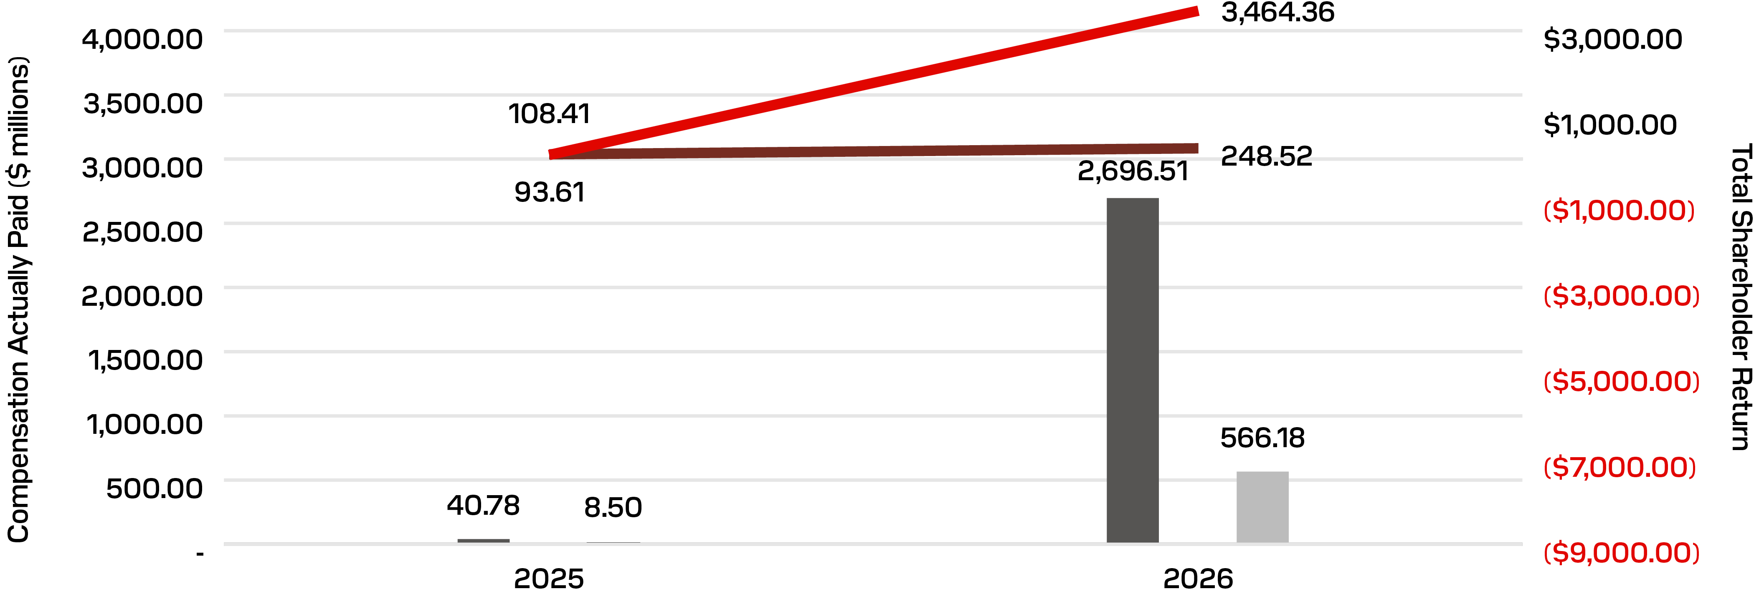
 |  |  |  |  |  | CAP to PEO ($) |  |  |  |  |  |  |  |  | Average CAP to Non-PEO NEOs ($) |  |  |  |  |  |  |  |  | Company TSR ($) |  |  |  |  |  |  |  |  | Peer Group TSR ($)
Compensation Actually Paid Versus Net Income (Loss)
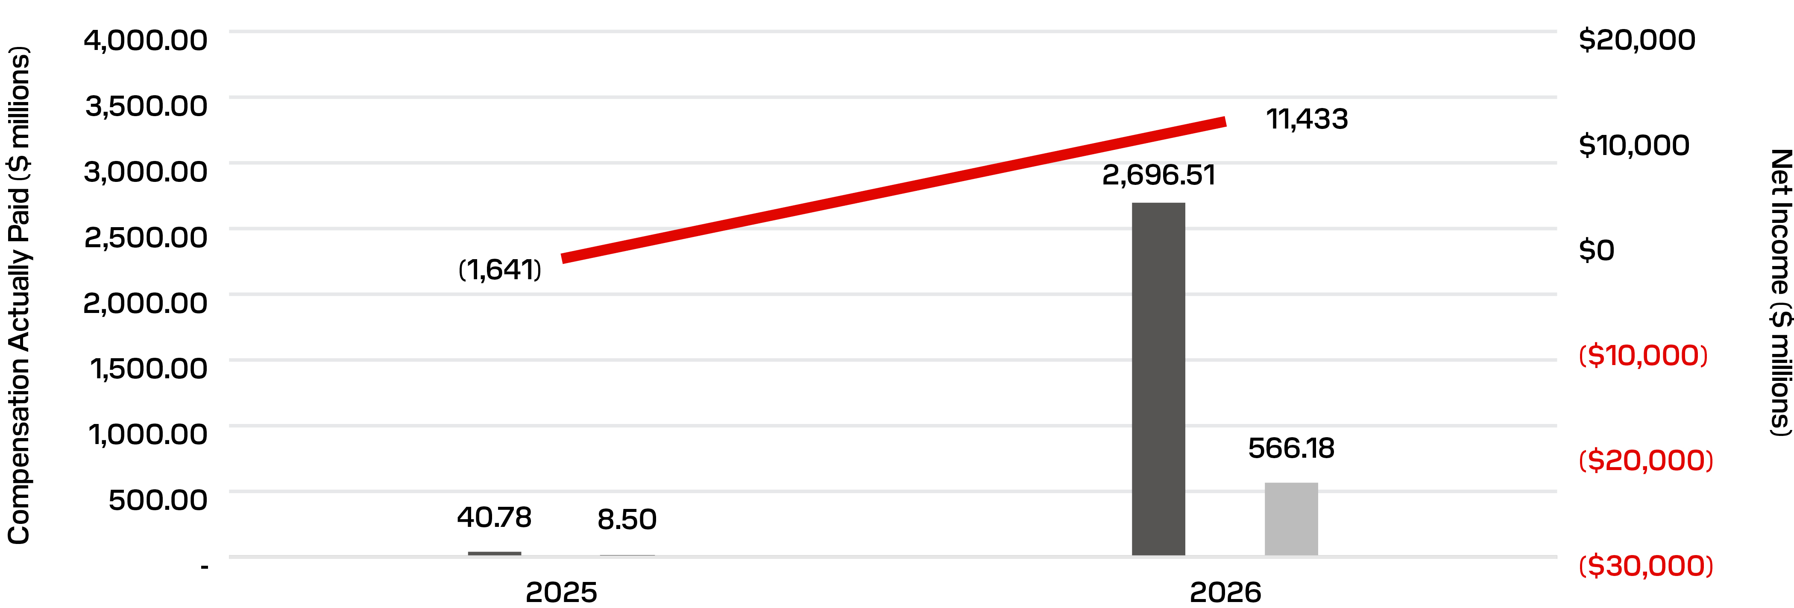
 |  |  |  |  |  | CAP to PEO ($) |  |  |  |  |  |  |  |  | Average CAP to Non-PEO NEOs ($) |  |  |  |  |  |  |  |  | Net Income Loss ($ millions)
Compensation Actually Paid Versus Revenue
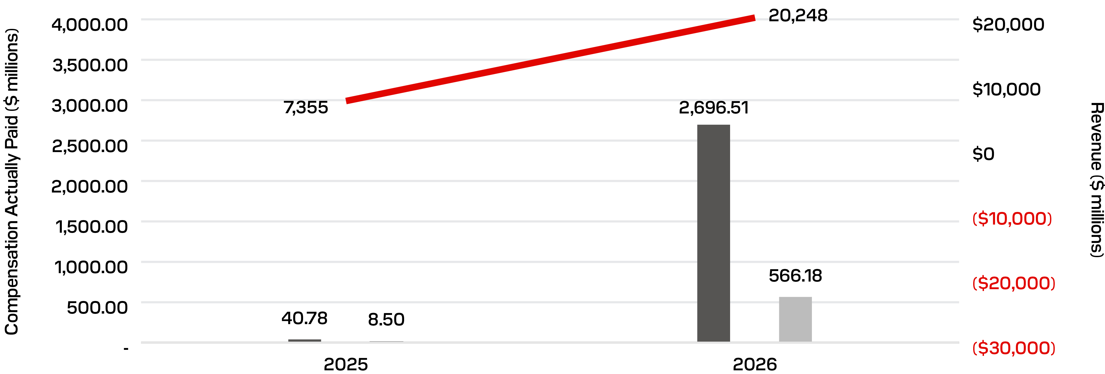
 |  |  |  |  |  | CAP to PEO ($) |  |  |  |  |  |  |  |  | Average CAP to Non-PEO NEOs ($) |  |  |  |  |  |  |  |  | Revenue ($ millions)

PG. 065
EQUITY COMPENSATION PLAN INFORMATION
The following table gives information with respect to our equity compensation plans as of July 3, 2026. These plans include our 2025 Long-Term Incentive Plan and our 2025 Employee Stock Purchase Plan, each of which was approved by WDC prior to the separation when it was our sole stockholder.
 |  |  | (a) |  |  |  |  |  |  |  |  | (b) |  |  |  |  |  | (c)
Plan Category |  |  | Number of  Securities to  be Issued Upon  Exercise of  Outstanding  Options, Warrants  and Rights |  |  |  |  |  |  |  |  | Weighted-Average  Exercise Price of  Outstanding Options,  Warrants and Rights  ($) |  |  |  |  |  | Number of Securities  Remaining Available  for Future Issuance  Under Equity  Compensation  Plans (Excluding  Securities Reflected  in Column(a))
Equity compensation plans approved by security holders |  |  | 8,941,611 |  |  | (1) |  |  |  |  |  | — |  |  |  |  |  | 14,746,560 |  |  | (2)
Total |  |  | 8,941,611 |  |  |  |  |  |  |  |  | — |  |  |  |  |  | 14,746,560
(1)This amount includes: (i) 5,635,846 shares of our common stock subject to outstanding RSUs awarded under our 2025 Long-Term Incentive Plan; (ii) a maximum of 3,305,756 PSUs (including a target number of 1,297,714 PSUs) subject to open performance-based vesting conditions under our 2025 Long-Term Incentive Plan; and (iii) 0 shares of our common stock subject to deferred stock units.
(2)Of these shares, as of July 3, 2026, 11,918,722 remained available for future issuance under our 2025 Long-Term Incentive Plan and 2,827,838 remained available for future issuance under our 2025 Employee Stock Purchase Plan, including 1,342,060 shares subject to purchase during the purchase period in effect as of July 3, 2026. No new awards may be made under any other equity compensation plans.

PG. 066
STOCK OWNERSHIP INFORMATION
Security Ownership by Principal Stockholders and Management
The following table sets forth certain information regarding the beneficial ownership of our common stock, as of September 4, 2026, by: (i) each person known by us to own beneficially more than 5% of our outstanding common stock; (ii) each director and each nominee for election as a member of our Board of Directors; (iii) each of our named executive officers; and (iv) all current directors and executive officers as a group. This table is based on information supplied to us by our executive officers, directors, and principal stockholders or included in a Schedule 13G or Schedule 13D filed with the SEC.
 |  |  | Common Stock
Beneficial Owner |  |  | Amount and Nature of  Beneficial Ownership(1) |  |  |  |  |  | Percent of  Class(2)
Greater than 5% Stockholders:
Vanguard Capital Management (3)  100 Vanguard Blvd., Malvern, PA 19355 |  |  | 11,000,476 |  |  |  |  |  | 7.6
BlackRock, Inc.(4)  50 Hudson Yards, New York, NY 10001 |  |  | 8,825,007 |  |  |  |  |  | 6.1
FMR LLC(5)  245 Summer Street, Boston, MA 02210 |  |  | 7,861,064 |  |  |  |  |  | 5.4
Jane Street Group, LLC(6)  250 Vesey Street 3rd Floor, New York, NY 10281 |  |  | 7,409,437 |  |  |  |  |  | 5.1
Directors:
Alexander Bradley |  |  | — |  |  |  |  |  | *
Richard B. Cassidy |  |  | 3,771 |  |  |  |  |  | *
Thomas Caulfield(7) |  |  | 6,167 |  |  |  |  |  | *
Devinder Kumar |  |  | 3,790 |  |  |  |  |  | *
Necip Sayiner |  |  | 1,921 |  |  |  |  |  | —
Ellyn J. Shook |  |  | 3,771 |  |  |  |  |  | *
Miyuki Suzuki |  |  | 8,928 |  |  |  |  |  | *
Named Executive Officers:
David V. Goeckeler(8) |  |  | 304,184 |  |  |  |  |  | *
Luis F. Visoso |  |  | 71,030 |  |  |  |  |  | *
Alper Ilkbahar |  |  | 10,439 |  |  |  |  |  | *
Bernard Shek(9) |  |  | 9,972 |  |  |  |  |  | *
All Directors and Current Executive Officers as a group (11 persons)(10) |  |  | 423,973 |  |  |  |  |  | *
* Represents less than 1% of the outstanding shares of our common stock.
(1)Shares subject to RSU awards scheduled to vest within 60 days after September 4, 2026 are deemed outstanding for purposes of computing the share amount and the percentage ownership of the person holding such awards, but are not deemed outstanding for purposes of computing the percentage ownership of any other person. We also deem shares representing deferred stock units credited to accounts in our Deferred Compensation Plan as of September 4, 2026 as outstanding for purposes of computing the share amount and the percentage ownership of the person to whose account those stock units are credited, but we do not deem them outstanding for purposes of computing the percentage ownership of any other person. As of September 4, 2026, no director or executive officer had deferred stock units.
(2)Except as otherwise noted below, we determine applicable percentage ownership based on 145,327,682 shares of our common stock outstanding as of September 4, 2026. To our knowledge, except as otherwise indicated in the footnotes to this table and subject to applicable community property laws, each stockholder named in the table has sole voting and investment power with respect to the shares set forth opposite such stockholder’s name.
(3)Beneficial ownership information is based on information contained in a Schedule 13G filed with the SEC on April 30, 2026, by Vanguard Capital Management. According to the schedule, as of March 31, 2026, Vanguard Capital Management has sole voting power with respect to 1,474,357 shares of our common stock and sole dispositive power with respect to 11,000,476 shares of our common stock.
(4)Beneficial ownership information is based on information contained in a Schedule 13G/A filed with the SEC on January 21, 2026 by BlackRock, Inc. According to the schedule, as of December 31, 2025, BlackRock has sole voting power with respect to 8,460,901 shares of our common stock and sole dispositive power with respect to 8,825,007 shares of our common stock.

 |  |  | STOCK OWNERSHIP INFORMATION |  |  |  |  |  |  |  |  | PG. 067
(5)Beneficial ownership information is based on information contained in a Schedule 13 filed with the SEC on August 6, 2026 by FMR LLC. According to the schedule, as of June 30, 2026, FMR LLC has sole voting power with respect to 7,436,509.64 shares and sole dispositive power with respect to 7,861,064.22 shares of our common stock, and Abigail P. Johnson has sole dispositive power with respect to 7,861,064.22 shares of our common stock.
(6)Beneficial ownership information is based on information contained in a Schedule 13G filed with the SEC on August 5, 2026, by Jane Street Group, LLC. According to the schedule, as of July 30, 2025, Jane Street Group, LLC has shared voting power with respect to 7,409,437 shares of our common stock and shared dispositive power with respect to 7,409,437 shares of our common stock, Jane Street Capital, LLC has shared voting power with respect to 5,886,992 shares of our common stock and shared dispositive power with respect to 5,886,992 shares of our common stock, Jane Street Global Trading, LLC has shared voting power with respect to 1,284,343 shares of our common stock and shared dispositive power with respect to 1,284,343 shares of our common stock, and Leonard Street Holdings, LP has shared voting power with respect to 238,102 shares of our common stock and shared dispositive power with respect to 238,102 shares of our common stock.
(7)Includes 4,834 shares held in Mr. Caulfield’s spouse’s trust account in which Mr. Caulfield has voting and/or investment power.
(8)Mr. Goeckeler is both a named executive officer and a director.
(9)Includes 884 shares of our common stock that may be acquired by Mr. Shek within 60 days after September 4, 2026 through the vesting of RSUs.
(10)Includes 884 shares of our common stock that may be acquired within 60 days after September 4, 2026 through the vesting of RSUs by one of our current executive officers.

PG. 068
AUDIT COMMITTEE MATTERS

Proposal 3
Ratification of Appointment of Our Independent Registered Public Accounting Firm
(→) |  |  | •Our Board of Directors is seeking stockholder ratification of the Audit Committee’s appointment of KPMG LLP as our independent registered public accounting firm for fiscal 2027  •We expect representatives of KPMG LLP to be present at the Annual Meeting, and they will have an opportunity to make a statement if they desire to do so and will be available to respond to appropriate questions
(→) |  |  | Our Board of Directors recommends a vote FOR the appointment of KPMG LLP as our independent registered public accounting firm for fiscal 2027
KPMG LLP has served as our independent auditor since 2025. The Audit Committee has again appointed KPMG LLP to serve as our independent registered public accounting firm for the fiscal year ending July 2, 2027. We are not required to submit the appointment of KPMG LLP for stockholder approval, but our Board of Directors has elected to seek ratification of the appointment of our independent registered public accounting firm by our stockholders. If holders of a majority of the outstanding shares of common stock represented at the Annual Meeting and entitled to vote do not ratify this appointment, the committee will reconsider its appointment of KPMG LLP and will either continue to retain KPMG LLP or appoint a different firm. In addition, even if stockholders ratify the committee’s selection, the committee, in its discretion, may still appoint a different independent registered public accounting firm if it believes that such a change would be in the best interests of our company and our stockholders.
The following table presents the fees paid by us to KPMG LLP for fiscal years 2025 and 2026:
Description of Professional Service |  |  | Fiscal 2026  ($) |  |  | Fiscal 2025  ($)
Audit Fees — professional services rendered for the audit of our annual financial statements and the review of the financial statements included in our Quarterly Reports on Form 10-Q or services that are normally provided in connection with statutory and regulatory filings or engagements(1) |  |  | 5,422,002 |  |  | 2,934,336*
Audit-Related Fees — assurance and related services reasonably related to the performance of the audit or review of our financial statements |  |  | — |  |  | —
Tax Fees — professional services rendered for tax compliance, tax advice and tax planning(2) |  |  | 547,861 |  |  | 137,405
All Other Fees — products and services other than those reported above |  |  | — |  |  | —
(1)Audit Fees in fiscal 2026 consisted of assurance and review services related to the integrated audit of the Company.
(2)Tax Fees consist of fees for tax compliance assistance, including global mobility/expatriate tax compliance services, and general tax consulting services.
* Audit fees for fiscal 2025 have been updated from the previously reported amount of $2,202,292 to $2,934,336 to include $732,044 of fees associated with statutory audits of certain foreign subsidiaries that were finalized and billed subsequent to the filing of the Company’s prior year’s proxy statement.
The Audit Committee has adopted a policy regarding the pre-approval of audit and non-audit services to be provided by our independent registered public accounting firm. At least annually, KPMG LLP provides a description of all audit and permissible non-audit services expected to be performed during the year and specific fee estimates for each such service, which must be pre-approved by the committee. KPMG LLP periodically reports to the committee regarding the extent of services provided in accordance with this pre-approval and the fees for the services performed to date. The committee has also delegated to the Chair of the committee the authority to pre-approve audit and permissible non-audit services and associated fees that were not pre-approved by the committee, up to a maximum amount of fees per audit or permissible non-audit service. The Chair is required to report any decisions to pre-approve such audit or non-audit services and fees to the full committee at its next regular meeting. All services performed by KPMG LLP during fiscal 2026 were pre-approved by the committee in accordance with its pre-approval policy and as required by applicable SEC rules.
Vote Required for Approval
The affirmative vote of holders of a majority of the outstanding shares of common stock represented in person or by proxy at the Annual Meeting and entitled to vote on this Proposal 3 is required to ratify the appointment of KPMG LLP as our independent registered public accounting firm. You may vote FOR, AGAINST, or ABSTAIN on this proposal. Proxies received by our Board will be voted FOR this Proposal 3 unless specified otherwise.

 |  |  | AUDIT COMMITTEE MATTERS |  |  | PG. 069
Report of the Audit Committee
The following is the report of the Audit Committee with respect to our audited financial statements for the fiscal year ended July 3, 2026. This report shall not be deemed to be soliciting material or to be filed with the SEC or subject to Regulation 14A or 14C under the Securities Exchange Act of 1934, as amended (the “Exchange Act”), or to the liabilities of Section 18 of the Exchange Act, nor shall any information in this report be incorporated by reference into any past or future filing under the Securities Act of 1933, as amended (the “Securities Act”), or the Exchange Act, except to the extent we specifically request that it be treated as soliciting material or specifically incorporate it by reference into a filing under the Securities Act or the Exchange Act.
Dear Fellow Stockholders,
The Audit Committee represents our Board of Directors in discharging its responsibilities relating to the accounting, reporting and financial practices of Sandisk and its subsidiaries, and has general responsibility for oversight and review of the accounting and financial reporting practices, internal controls and accounting and internal and external audit activities of Sandisk and its subsidiaries. The Audit Committee is also responsible for overseeing our Enterprise Risk Management process on behalf of our Board. Accordingly, the Audit Committee oversees certain risk topics and allocates oversight responsibility for other risk topics among our Board and its other committees. The Audit Committee acts pursuant to a written charter. Our Board originally adopted the Audit Committee Charter on January 25, 2025 and approved an amendment to the charter on February 19, 2026. A copy of the amended charter is available on our website under “Governance” at investor.sandisk.com. Our Board has determined that each of the members of the Audit Committee is an “audit committee financial expert” as defined by the SEC and qualifies as an “independent” director under applicable rules of the Nasdaq Stock Market and the SEC.
Management is responsible for the preparation, presentation, and integrity of Sandisk’s financial statements, the financial reporting process, accounting principles and internal controls and procedures designed to assure compliance with accounting standards and applicable laws and regulations. KPMG LLP, Sandisk’s independent registered public accounting firm since 2025, is responsible for performing an independent audit of Sandisk’s consolidated financial statements and internal control over financial reporting in accordance with auditing standards of the Public Company Accounting Oversight Board (United States), issuing reports thereon.
The Audit Committee is solely and directly responsible for the appointment, compensation, retention and oversight of Sandisk’s independent registered public accounting firm and regularly solicits and evaluates feedback from both management and the auditor in carrying out this responsibility. In conjunction with the rotation of the independent registered public accounting firm’s lead engagement partner, which occurs at least every five years, the Audit Committee is involved in the selection of KPMG LLP’s lead engagement partner. The next mandatory rotation for KPMG LLP’s lead engagement partner is scheduled to occur following the fiscal 2030 audit.
The members of the Audit Committee are not professionally engaged in the practice of accounting or auditing and thus, its oversight does not provide an independent basis to determine that management has applied accounting principles generally accepted in the United States appropriately or maintained appropriate internal controls and disclosure controls and procedures designed to assure compliance with accounting standards and applicable laws and regulations.
During fiscal 2026, the Audit Committee met a total of seven times. During fiscal 2026, the Audit Committee also met and held discussions with management and KPMG LLP. The meetings were conducted so as to encourage communication among the members of the Audit Committee, management and the independent registered public accounting firm. The Audit Committee discussed with KPMG LLP the overall scope and plan for its audit. The Audit Committee met regularly with KPMG LLP, with and without management present, to discuss the results of its audit, Sandisk’s internal control over financial reporting and the overall quality of Sandisk’s accounting practices. As part of these discussions, the Audit Committee reviewed and discussed the audited consolidated financial statements of Sandisk for the fiscal year ended July 3, 2026 with management and KPMG LLP. The Audit Committee also discussed with KPMG LLP the matters required to be discussed by the applicable requirements of the Public Company Accounting Oversight Board and the SEC. Our Board, including the Audit Committee, received an opinion of KPMG LLP as to the conformity of such audited consolidated financial statements with GAAP and the effectiveness of internal control over financial reporting pursuant to Section 404 of the Sarbanes-Oxley Act.
The Audit Committee has also received the written disclosures and the letter from KPMG LLP as required by the applicable requirements of the Public Company Accounting Oversight Board regarding KPMG LLP’s communications with the Audit Committee concerning independence and has discussed with KPMG LLP its independence. The Audit Committee reviewed and evaluated KPMG LLP’s lead engagement partner and also reviewed, among other things, the amount of fees paid to KPMG LLP for audit and non-audit services. Based upon such reviews and discussions, the Audit Committee has recommended to our Board that the audited financial statements be included in Sandisk’s Annual Report on Form 10-K for the fiscal year ended July 3, 2026, for filing with the SEC. The Audit Committee also appointed KPMG LLP to serve as Sandisk’s independent registered public accounting firm for the fiscal year ending July 2, 2027. The members of the Audit Committee believe that the continued retention of KPMG LLP to serve as the independent registered public accounting firm is in the best interests of Sandisk and its stockholders.
THE AUDIT COMMITTEE
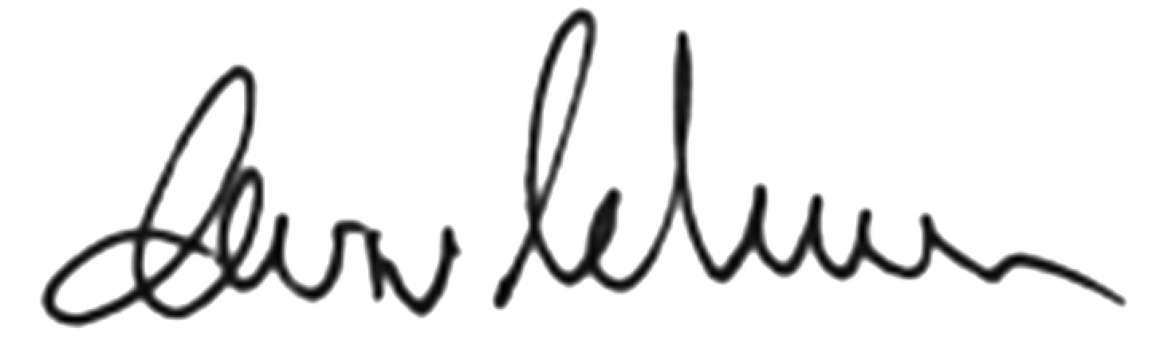  Devinder Kumar |  |  | 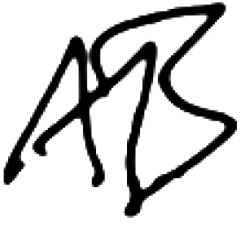  Alexander Bradley
Richard B. Cassidy

PG. 070
ADDITIONAL INFORMATION

General Information About the Annual Meeting

Virtual Annual Meeting
The Annual Meeting will be a completely virtual meeting of stockholders conducted via audio webcast to enable our stockholders to participate from any location around the world. You will be able to attend the Annual Meeting by visiting www.virtualshareholdermeeting.com/SNDK2026.
Attendance and Participation at the Virtual Annual Meeting
•We believe that the virtual annual meeting format gives stockholders the opportunity to exercise the same rights as if they had attended an in-person meeting and believe that these measures enhance stockholder access and encourage participation and communication with our Board of Directors and management by enabling all stockholders to participate fully, equally and without cost, using an Internet-connected device from any location around the world. In addition, the virtual annual meeting format increases our ability to engage with all stockholders, regardless of size, resources, or physical location.
•Attendance at the Annual Meeting is open to the public online at www.virtualshareholdermeeting.com/SNDK2026, but only stockholders of record or beneficial owners as of September 21, 2026, the record date, or those holding a valid legal proxy for the Annual Meeting are entitled to vote or ask questions via the online virtual annual meeting platform.
•To participate in the Annual Meeting by voting or asking questions, you will need the control number included on your Notice of Internet Availability of Proxy Materials, on your proxy card, or on the instructions that accompanied your proxy materials.
•We will have technicians ready to assist you with any technical difficulties you may have accessing the Annual Meeting. If you encounter any difficulties accessing or logging in to the Annual Meeting, please call the technical support number displayed on the login page of the online virtual annual meeting platform.
Questions at the Virtual Annual Meeting
During the Annual Meeting, we will answer as many stockholder-submitted questions related to the proposals as time permits, and any questions that we are unable to address during the Annual Meeting will be published and answered on our website following the meeting with the exception of any questions that are irrelevant to the purpose of the Annual Meeting or that contain inappropriate or derogatory references which are not in good taste. If we receive substantially similar questions, we will group such questions together and provide a single response to avoid repetition.
Who Can Vote
Only holders of record of shares of our common stock at the close of business on September 21, 2026, the record date, will be entitled to notice of and to vote at the Annual Meeting. We have one class of common stock, and each holder of our common stock is entitled to one vote per share of common stock held as of the record date. At the close of business on the record date, 144,527,564 shares of our common stock were outstanding. Shares of treasury stock are not entitled to vote at the Annual Meeting.
Voting Your Proxy
At the Annual Meeting
If your shares are registered directly in your name with our transfer agent, Equiniti Trust Company, LLC, you are considered the “stockholder of record” and you have the right to vote your shares electronically at the Annual Meeting. If you hold your shares through a broker, bank, trustee, or other nominee (that is, in “street name”) rather than directly in your own name, you are a “beneficial stockholder” and you may also vote your shares electronically at the Annual Meeting. If you choose to do so, you can vote by following the instructions provided when you log in to the online virtual annual meeting platform. Even if you plan to attend the Annual Meeting, we recommend that you submit your proxy or voting instructions in advance of the meeting as described below so that your vote will be counted if you later decide not to attend the Annual Meeting.
Without Attending the Annual Meeting
You may also direct how your shares are voted without attending the Annual Meeting. If you are a stockholder of record, you may submit a proxy to authorize how your shares are voted at the Annual Meeting. You can submit a proxy over the Internet by following the instructions provided in the “Notice of Internet Availability of Proxy Materials” (which we also refer to as the “Notice”), or, if you received a printed copy of the proxy materials, you can also submit a proxy by mail or telephone. If you are a beneficial stockholder, you may submit your voting instructions over the Internet by following the instructions provided in the Notice, or, if you received a printed copy of the proxy materials, you can also submit voting instructions by telephone or mail by following the instructions provided by your bank, broker, trustee, or other nominee.
Submitting your proxy or voting instructions via the Internet, by telephone or by mail will not affect your right to vote electronically should you decide to attend the Annual Meeting.
If you submit a signed proxy or voting instruction form but do not indicate your specific voting instructions on one or more of the proposals listed in the Notice of Annual Meeting of Stockholders, your shares will be voted as recommended by our Board of Directors on those proposals and as the proxyholders may determine in their discretion with respect to any other matters properly presented for a vote at the Annual Meeting.

 |  |  | ADDITIONAL INFORMATION |  |  | PG. 071
Voting Deadline
If you are a stockholder of record, please submit your proxy by telephone, the Internet, or mail by 11:59 p.m. Eastern time on November 16, 2026 in order for your shares to be voted at the Annual Meeting. If you are a beneficial stockholder, please follow the voting instructions provided by the bank, broker, trustee, or nominee who holds your shares.
Revoking Your Proxy
You have the power to revoke your proxy or voting instructions before your shares are voted at the Annual Meeting. If you are a stockholder of record, you may revoke your proxy by submitting a written notice of revocation to our Secretary (see page 73 for contact information), or, to change how your shares will be voted at the Annual Meeting, by mailing a duly executed written proxy bearing a date that is later than the date of your original proxy or by submitting a later dated proxy via the Internet or by telephone.
A previously submitted proxy will not be voted if the stockholder of record who executed it attends the Annual Meeting and votes the shares represented by the proxy electronically at the Annual Meeting. For shares you hold beneficially in street name, you may change your vote by submitting new voting instructions to your bank, broker, trustee, or nominee or by attending the Annual Meeting and voting electronically. Please note that attending the Annual Meeting will not by itself constitute revocation of a proxy. Any change to your proxy or voting instructions should be submitted by telephone, the Internet, or mail by 11:59 p.m. Eastern time on November 16, 2026.
Quorum
The holders of a majority of our shares of common stock outstanding on the record date and entitled to vote at the Annual Meeting, present or represented by proxy, will constitute a quorum for the transaction of business at the Annual Meeting and any postponements or adjournments thereof. If you submit a proxy or voting instructions, your shares will be counted for purposes of determining the presence or absence of a quorum, even if you abstain from voting your shares. If a broker indicates on a proxy that it lacks discretionary authority to vote your shares on a particular matter, commonly referred to as “broker non-votes,” those shares will also be counted for purposes of determining the presence of a quorum at the Annual Meeting. If a quorum is not present, the Annual Meeting will be adjourned until a quorum is obtained.
Abstentions and Broker Non-Votes
Abstentions
Shares voting “ABSTAIN” on any of the proposals at the Annual Meeting are treated differently depending on the specific proposal.
•Proposal 1: Abstentions will be entirely excluded from the vote and will have no effect in determining the outcome of a director nominee’s election.
•Proposals 2 and 3: We treat abstentions as shares present or represented and entitled to vote on these proposals, so abstaining has the same effect as a vote “against” these proposals.
Broker Non-Votes
If you are a beneficial stockholder that holds your shares through a brokerage account and you do not submit voting instructions to your broker, your broker may generally vote your shares in its discretion on routine matters. However, a broker cannot vote shares held for a beneficial stockholder on non-routine matters, unless the broker receives voting instructions from the beneficial stockholder. Proposal 3 (ratification of KPMG LLP as our independent registered public accounting firm) is considered routine and may be voted upon by your broker if you do not submit voting instructions. However, all other proposals to be voted on at the Annual Meeting are considered non-routine matters. Consequently, if you hold your shares through a brokerage account and do not submit voting instructions to your broker, your broker may exercise its discretion to vote your shares on Proposal 3 but will not be permitted to vote your shares on any of the other proposals at the Annual Meeting. If your broker exercises this discretion, your shares will be counted as present for purposes of determining the presence of a quorum at the Annual Meeting and will be voted on Proposal 3 in the manner directed by your broker, but your shares will constitute broker non-votes on each of the other proposals at the Annual Meeting. Because broker non-votes are not considered entitled to vote on these proposals, they will have no effect in determining the outcome of each such proposal.
Voting Results
We intend to announce preliminary voting results at the Annual Meeting and disclose final results in a Current Report on Form 8-K to be filed with the SEC no later than four business days following the date of the Annual Meeting.

PG. 072 |  |  | 2026 PROXY STATEMENT
Costs of Proxy Solicitation
The accompanying proxy is being solicited on behalf of our Board of Directors. The cost of preparing, assembling, and mailing the Notice of Annual Meeting of Stockholders, the Notice of Internet Availability of Proxy Materials, this Proxy Statement, and form of proxy and our 2026 Annual Report, the cost of making such materials available on the Internet and the cost of soliciting proxies will be paid by us. In addition to the use of the mails, we may solicit proxies in person or by telephone, facsimile, or other means of communication by certain of our directors, officers, and regular employees who will not receive any additional compensation for such solicitation. We will reimburse brokers or other persons holding our common stock in their names or the names of their nominees for the expenses of forwarding soliciting material to their principals.
Attending the Annual Meeting
Anyone may attend the Annual Meeting online at www.virtualshareholdermeeting.com/SNDK2026, but you are only entitled to participate in the Annual Meeting, including asking questions and voting at the meeting, if you were a stockholder of record or a beneficial stockholder as of the close of business on September 21, 2026, the record date, or you hold a valid legal proxy for the Annual Meeting. To participate in the Annual Meeting, you will need the control number included on your Notice of Internet Availability of Proxy Materials, on your proxy card, or on the instructions that accompanied your proxy materials.
Submission of Stockholder Proposals and Director Nominations
Proposals for Inclusion in Proxy Materials
For your proposal to be considered for inclusion in the proxy statement and form of proxy for our 2027 Annual Meeting, your written proposal must be received by our Secretary at our principal executive offices no later than June 8, 2027 and must comply with Rule 14a-8 of the Exchange Act regarding the inclusion of stockholder proposals in company-sponsored proxy materials. If we change the date of the 2027 Annual Meeting by more than 30 days from the anniversary date of this year’s Annual Meeting, your written proposal must be received by our Secretary at our principal executive offices a reasonable time before we begin to print and mail our proxy materials for our 2027 Annual Meeting.
Nomination of Director Candidates and Proposals Not Intended for Inclusion in Proxy Materials
If you intend to nominate an individual for election to our Board of Directors at our 2027 Annual Meeting or wish to present a proposal at the 2027 Annual Meeting but do not intend for such proposal to be included in the proxy statement for such meeting, our Bylaws require that stockholders give written notice of the nomination or proposal to our Secretary at our principal executive offices no earlier than the close of business on July 20, 2027 (the 120th day prior to the first anniversary of the Annual Meeting) and no later than the close of business on August 19, 2027 (the 90th day prior to the first anniversary of the Annual Meeting).
Notwithstanding the foregoing, in the event that we change the date of the 2027 Annual Meeting to a date that is more than 30 days before or more than 70 days after the anniversary of the Annual Meeting, written notice by a stockholder must be given no earlier than the close of business 120 days prior to the date of the 2027 Annual Meeting and no later than the close of business on the later of 90 days prior to the date of the 2027 Annual Meeting or the 10th day following the day on which public announcement of the date of the 2027 Annual Meeting is made.
The written notice must also satisfy the information and other specified requirements set forth in Section 2.11 of our Bylaws. In accordance with our Bylaws, the foregoing deadline and notice requirements set forth in Section 2.11 of our Bylaws are also intended to apply to and satisfy the deadline and notice requirements set forth in paragraph (b) of Rule 14a-19 under the Exchange Act with respect to notice by a stockholder who intends to solicit proxies in support of director nominees other than the company’s nominees at the 2027 Annual Meeting.
Written notice of any stockholder proposals not intended to be included in the proxy statement or nominations for director candidates that do not meet the notice requirements set forth above and further described in Section 2.11 of our Bylaws will be disregarded and not be acted upon at the 2027 Annual Meeting.

 |  |  | ADDITIONAL INFORMATION |  |  | PG. 073
Nomination of Director Candidates for Inclusion in Proxy Materials (Proxy Access)
If you intend to nominate a director candidate pursuant to the proxy access process set forth in Section 2.14 of our Bylaws, you, or a group of not more than 20 stockholders, must, among other requirements, have owned 3% or more of our outstanding common stock continuously for at least three years and give written notice of the nomination to our Secretary at our principal executive offices no earlier than the close of business on May 9, 2027 (the 150th day prior to the first anniversary of the date that proxy materials for the Annual Meeting were first released to stockholders) and no later than the close of business on June 8, 2027 (the 120th day prior to the first anniversary of the date that proxy materials for the Annual Meeting were first released to stockholders).
Notwithstanding the foregoing, in the event that we change the date of the 2027 Annual Meeting to a date that is more than 30 days before or more than 70 days after the anniversary of the Annual Meeting, written notice by a stockholder must be given no earlier than the close of business 150 days prior to the date of the 2027 Annual Meeting and no later than the close of business on the later of 120 days prior to the date of the 2027 Annual Meeting or the 10th day following the day on which public announcement of the date of the 2027 Annual Meeting is made.
Use of the proxy access process is subject to all eligibility, procedural, and disclosure requirements set forth in Section 2.14 of our Bylaws.
Eliminating Duplicative Proxy Materials
We have adopted a procedure called “householding,” which the SEC has approved. Under this procedure, stockholders of record who have the same address and last name and did not receive a Notice or otherwise receive their proxy materials electronically will receive only one copy of our proxy materials unless we receive contrary instructions from one or more of such stockholders. Upon oral or written request, we will deliver promptly a separate copy of the proxy materials to a stockholder at a shared address to which a single copy of proxy materials was delivered. If you are a stockholder of record at a shared address to which we delivered a single copy of the proxy materials and you desire to receive a separate copy of the proxy materials for the Annual Meeting or for our future meetings, or if you are a stockholder at a shared address to which we delivered multiple copies of the proxy materials and you desire to receive one copy in the future, please submit your request to the Householding Department of Broadridge Financial Solutions, Inc. at 51 Mercedes Way, Edgewood, New York 11717, or at 1-866-540-7095. If you are a beneficial stockholder, please contact your bank, broker, trustee, or other nominee directly if you have questions, require additional copies of the proxy materials, wish to receive multiple reports by revoking your consent to householding, or wish to request single copies of the proxy materials in the future.

Availability of Annual Report
Our 2026 Annual Report has been posted on our corporate website at investor.sandisk.com and on the Internet at www.proxyvote.com. For stockholders receiving a Notice of Internet Availability of Proxy Materials, the Notice will contain instructions on how to request a printed copy of our 2026 Annual Report. For stockholders receiving a printed copy of this Proxy Statement, a copy of our 2026 Annual Report will also be included. In addition, we will provide, without charge, a copy of our 2026 Annual Report (including the financial statements but excluding the exhibits thereto) upon the written request of any stockholder or beneficial owner of our common stock. Requests should be directed to our Secretary at our principal executive offices:
 |  |  | Secretary  Sandisk Corporation  951 Sandisk Dr.  Milpitas, California 95035

Communication with our Company
Stockholders or other interested parties who wish to communicate with us may do so by mail to our Secretary at our principal executive offices. The name of any specific intended management or Board recipient(s) should be noted in the communication, including whether the communication is intended only for our Chair of the Board, Lead Independent Director, or non-employee directors. See also the section entitled “Corporate Governance Matters—Board Processes and Policies—Communicating with Directors.”
Secretary
Sandisk Corporation
951 Sandisk Dr.
Milpitas, California 95035

PG. A-001
APPENDIX A—NON-GAAP FINANCIAL MEASURES
We have disclosed in this Proxy Statement financial measures that are not in accordance with U.S. generally accepted accounting principles (“GAAP”). These non-GAAP measures are not an alternative for measures prepared in accordance with GAAP and may be different from non-GAAP measures used by other companies. These measures should be considered in addition to financial measures prepared in accordance with GAAP, but should not be considered a substitute for, or superior to, GAAP results. We believe the presentation of these non-GAAP measures, when shown in conjunction with the corresponding GAAP measures, provides useful information to investors for measuring our performance and comparing it against prior periods. These non-GAAP measures are used by management for assessing our financial performance and as a measurement of our performance for incentive compensation purposes, but should not be considered a substitute for, or superior to, GAAP results.
The Compensation and Talent Committee used non-GAAP financial measures as a pre-established performance goal under the Company’s incentive compensation plans for fiscal 2026. In accordance with the pre-established terms of these plans, this non-GAAP performance measure excluded certain unusual items that we believe are not indicative of the underlying performance of our business, as detailed below.
Reconciliations of Non-GAAP Financial Measures
The following non-GAAP measure, non-GAAP operating income or loss, excludes certain expenses, gains and losses that we believe are not indicative of our core operating results or because they are consistent with the financial models and estimates published by many analysts who follow our company and our peers. As further detailed below, the expenses, gains, and losses excluded from the following non-GAAP measure primarily consist of stock-based compensation expense; business separation costs; employee termination and other; goodwill impairment; (gain) loss on business divestiture; and loss on debt extinguishment.
The following tables present reconciliations of our GAAP operating income/ (loss) to our non-GAAP operating income, diluted EPS, and adjusted free cash flow:
(in millions, except per share information, unaudited) |  |  | Year Ended  July 3, 2026 |  |  |  |  |  |  |  |  | Year Ended  June 27, 2025
Reconciliation of non-GAAP operating income (loss)
GAAP operating income (loss) |  |  |  |  |  | $ | 12,389 |  |  |  |  |  |  |  | $ | (1,377)
Stock-based compensation expense |  |  |  |  |  | 232 |  |  |  |  |  |  |  |  | 182
Business separation costs |  |  |  |  |  | 25 |  |  |  |  |  |  |  |  | 67
Employee termination and other |  |  |  |  |  | (2) |  |  |  |  |  |  |  |  | 21
Goodwill impairment |  |  |  |  |  | — |  |  |  |  |  |  |  |  | 1,830
(Gain) loss on business divestiture |  |  |  |  |  | 10 |  |  |  |  |  |  |  |  | (34)
Loss on debt extinguishment |  |  |  |  |  | 46 |  |  |  |  |  |  |  |  | —
Non-GAAP operating income |  |  |  |  |  | $ | 12,700 |  |  |  |  |  |  |  | $ | 689

 |  |  | APPENDIX A—NON-GAAP FINANCIAL MEASURES |  |  | PG. A-002
(in millions, except per share information, unaudited) |  |  | Year Ended  July 3, 2026 |  |  |  |  |  |  |  |  | Year Ended  June 27, 2025
Reconciliation of non-GAAP net income (loss)
GAAP net income (loss) |  |  |  |  |  | $ | 11,433 |  |  |  |  |  |  |  | $ | (1,641)
Stock-based compensation expense |  |  |  |  |  | 232 |  |  |  |  |  |  |  |  | 182
Business separation costs |  |  |  |  |  | 25 |  |  |  |  |  |  |  |  | 67
Employee termination and other |  |  |  |  |  | (2) |  |  |  |  |  |  |  |  | 21
Goodwill impairment |  |  |  |  |  | — |  |  |  |  |  |  |  |  | 1,830
(Gain) loss on business divestiture |  |  |  |  |  | 10 |  |  |  |  |  |  |  |  | (34)
Loss on debt extinguishment |  |  |  |  |  | 46 |  |  |  |  |  |  |  |  | —
(Gain) loss on equity securities, net |  |  |  |  |  | (808) |  |  |  |  |  |  |  |  | 2
Other, net |  |  |  |  |  | 111 |  |  |  |  |  |  |  |  | (9)
Income tax adjustments |  |  |  |  |  | (60) |  |  |  |  |  |  |  |  | 22
Non-GAAP operating income |  |  |  |  |  | $ | 10,987 |  |  |  |  |  |  |  | $ | 440
Diluted net income (loss) per share
GAAP |  |  |  |  |  | 73.76 |  |  |  |  |  |  |  |  | (11.32)
Non-GAAP |  |  |  |  |  | 70.88 |  |  |  |  |  |  |  |  | 2.99
Diluted weighted average shares outstanding:
GAAP |  |  |  |  |  | 155 |  |  |  |  |  |  |  |  | 145
Non-GAAP |  |  |  |  |  | 155 |  |  |  |  |  |  |  |  | 147
Cash flows
Cash flow from operating activities |  |  |  |  |  | 11,671 |  |  |  |  |  |  |  |  | 84
Purchases of property, plant and equipment, net |  |  |  |  |  | (177) |  |  |  |  |  |  |  |  | (204)
Free cash flow |  |  |  |  |  | 11,494 |  |  |  |  |  |  |  |  | (120)
Activity related to Flash Ventures, net |  |  |  |  |  | (275) |  |  |  |  |  |  |  |  | 358
Impact of NBM prepayments and deposits |  |  |  |  |  | (2,476) |  |  |  |  |  |  |  |  | —
Adjusted free cash flow |  |  |  |  |  | 8,743 |  |  |  |  |  |  |  |  | 238

PG. A-003 |  |  | 2026 PROXY STATEMENT
Explanations of Adjustments to Non-GAAP Measures
As detailed above, we exclude the following items from our non-GAAP financial measures:
Stock-based compensation expense. Because of the variety of equity awards used by companies, the varying methodologies for determining stock-based compensation expense, the subjective assumptions involved in those determinations and the volatility in valuations that can be driven by market conditions outside the Company’s control, the Company believes excluding stock-based compensation expense enhances the ability of management and investors to understand and assess the underlying performance of the business over time and compare it against the Company’s peers, a majority of whom also exclude stock-based compensation expense from their non-GAAP results.
Business separation cost. On October 30, 2023, Western Digital Corporation (“WDC”) announced that its board of directors (the “WDC Board of Directors”) authorized management to pursue a plan to separate the Company into an independent public company. The separation received final approval by the WDC Board of Directors and was completed on February 21, 2025. Prior to February 21, 2025, the Company was wholly owned by WDC. As a result of the plan, the Company incurred separation and transition costs through the completion of the separation of the companies. The separation and transition costs are recorded within Business separation costs in the Consolidated Statements of Operations. The Company believes these charges do not reflect the Company’s operating results and that they are not indicative of the underlying results of its business.
Employee termination and other. From time to time, in order to realign the Company’s operations with anticipated market demand, the Company may terminate employees and/or restructure its operations. From time to time, the Company may also incur charges from the impairment of long-lived assets. In addition, the Company may record credits related to gains upon sale of property due to restructuring or reversals of charges recorded in prior periods as well as from taking actions to reduce the amount of capital invested in facilities, including the sale-leaseback of facilities. These charges or credits are inconsistent in amount and frequency, and the Company believes they are not indicative of the underlying performance of its business.
Loss on debt extinguishment. From time to time, the Company incurs debt extinguishment charges consisting of the costs to call the existing debt and/or the write-off of any related unamortized debt issuance costs. These charges do not reflect the Company’s operating results, and the Company believes these charges are not indicative of the underlying performance of its business.
Goodwill impairment. After the completion of the separation, in the third quarter of fiscal 2025, the Company identified potential impairment indicators related to the trading price of the Company’s common stock and resulting market capitalization that warranted a quantitative impairment analysis of long-lived assets and goodwill. Management performed a quantitative impairment analysis and determined that the carrying value of the reporting unit exceeded its fair value, resulting in the recognition of a $1.8 billion impairment charge for the year ended June 27, 2025. The Company believes this charge does not reflect the Company’s operating results and is not indicative of the underlying performance of the business.
Gain on business divestiture. In connection with the Company’s strategic decision to outsource the manufacturing of certain components and assemblies, on September 28, 2024, the Company completed the sale of 80% of its equity interest in one of its manufacturing subsidiaries. On September 25, 2025, the Company entered into an Amendment No. 1 to the Amended and Restated Equity Purchase Agreement that included a $10 million provision for working capital support. The Company recognized the adjustment as a Loss on business divestiture during the first fiscal quarter of 2026. The overall transaction resulted in a discrete gain, which the Company believes is not indicative of the underlying performance of its ongoing business operations.
(Gain) loss on equity securities, net. (Gain) loss on equity securities, net consists of ongoing mark-to-market adjustments on the Company’s investments in marketable equity securities, the gains from the sale of equity investments and related impairment charges. These charges do not reflect the Company’s operating results, and the Company believes these charges are not indicative of the underlying performance of its business.
Other adjustments. From time to time, the Company incurs charges or gains that the Company believes are not a part of the ongoing operation of its business. For the year ended July 3, 2026, Other adjustments include charges for the settlement of certain previously existing legal matters. The resulting expense or benefit is inconsistent in amount and frequency.
Income tax adjustments. Income tax adjustments include the difference between income taxes based on a forecasted annual Non-GAAP tax rate and a forecasted annual GAAP tax rate as a result of the timing of certain Non-GAAP pre-tax adjustments. The income tax adjustments also include the re-measurement of certain unrecognized tax benefits primarily related to tax positions taken in prior quarters, including interest. These adjustments are excluded because the Company believes that they are not indicative of the underlying performance of its ongoing business.
Additionally, Free cash flow is defined as Cash Flow from operating activities less purchases of property, plant and equipment, net. Adjusted free cash flow is defined as Free cash flow plus the activity related to Flash Ventures, net less the impact of cash prepayments under New Business Model (“NBM”) agreements (the “NBM Prepayments”) and deposits received and returned under NBM agreements (the “NBM Deposits” and together with the NBM Prepayments, the “NBM Payments”). The Company is adjusting for the NBM Payments because the Company believes that these cash flows are not indicative of the core underlying cash flows of the Company’s business. The Company considers Free cash flow and Adjusted free cash flow generated in any period to be useful indicators of cash that is available for strategic opportunities, including, among others, investing in the Company’s business, making strategic acquisitions and strengthening the balance sheet.



